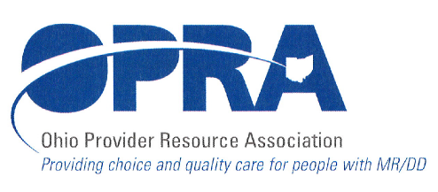
1152 Goodale Blvd.
Columbus, OH 432152
TELEPHONE: 614/224-6772
FAX: 614/224-3340
E-MAIL: opra@opra.org

Program Director’s Committee Agenda Thursday, June 10, 2010 10:30 am to 1:00 pm

Please note we will be meeting at our new location: 1152 Goodale Blvd. There is parking at the side of the building and in the back next to the building/across the alley. There is also free, on street parking.

- Rules and Legislative Updates

- Vacancy Registry

- Capital Project

- ADS Staff Training Requirements

- IAF Modification

- Upcoming Health Care Reform Training

- Internal QA Presentation/CRSI

- PATHS DSP Recognition Event

- National DSP Recognition

- DODD Contact Information

- Surveys

- Next Meeting (HR/QA)

- Other discussion items

Next scheduled meeting is Tuesday, July 13
This is a joint meeting with the HR Committee

