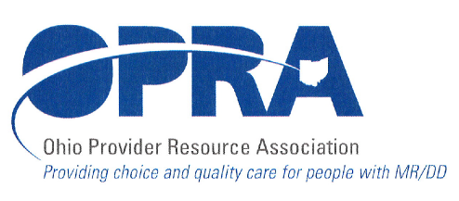
1152 Goodale Blvd.
Columbus, OH 432152
TELEPHONE: 614/224-6772
FAX: 614/224-3340
E-MAIL: opra@opra.org

Program Director’s Committee Agenda Thursday, August 12, 2010 10:30 am to 1:00 pm

Please note we will be meeting at our new location: 1152 Goodale Blvd. There is parking at the side of the building and in the back next to the building/across the alley. There is also free, on street parking.

There is construction along Route 315 that has closed some ramps. Go to: http://www.pavingtheway.org/sr-315/ for additional information.

- Rules and Legislative Updates

- Service Openings Directory (formally Vacancy Registry)

- ADS Staff Training Requirements

- DODD’s Money Management Recommendations

- OSOC

- IAF Modification

- MUI issues

- PATHS DSP Recognition Event – Video Essay

- Working America Activity

- NMT and Licensure

- Surveys

- Next Meeting

- Other discussion items

Next scheduled meeting is Thursday, September 9

