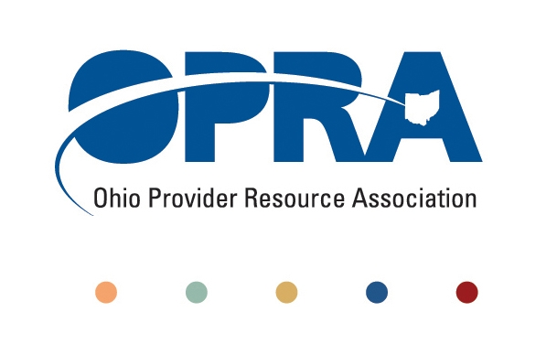

**OPRA Legislative Requests-2018**

1. **Exempt Developmental Disability Providers of Transportation from the Commercial Motor Vehicles Law.** DD transportation providers are regulated through DODD and Medicaid for the provision of services. They also fall under the CMV regulations. Same service, two separate regulatory agencies. This is redundant and regulatory excess.
2. **Require County Boards of Developmental Disabilities to inform families about the availability of ICF/IID services.** Oftentimes when families discuss residential service options with county board case managers, they are not notified about existing residential options under the ICF program. Given a choice families may choose an ICF instead of being put on a waiting list for waiver services.
3. **Support Passage of S.B. 221-JCARR Reform.** OPRA supports S.B. 221 originally introduced by Representative Mike Duffey in the previous General Assembly. The JCARR reform bill sponsored by Senator Uecker adds additional prongs that ensure integrity in the rule making process.
4. **Support Passage of S.B. 144-**OPRA supports S.B. 144 introduced to establish a state rehabilitation council known as the Opportunities for Ohioans with Disabilities Council. This is a reformed governing body for OOD and will add needed stakeholder input on OOD services.

Submitted by Jeff Davis, OPRA Director of Government Relations (614) 579-9957