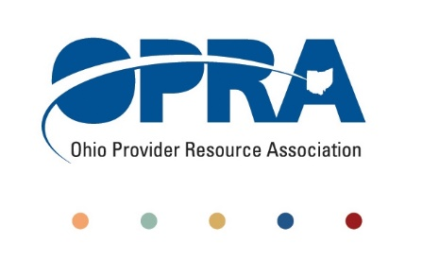

February 20, 2018

The Honorable Bill Coley

Chairman, Senate Government Oversight and Reform Committee

Ohio Senate

Statehouse

Re: OPRA Support of Senate Bill 221 (Uecker)

Dear Senator Coley:

My name is Jeff Davis and I am the Director of Government Relations with the Ohio Provider Resource Association (OPRA). OPRA is a statewide association representing private providers of service to individuals with developmental disabilities. Our members represent the full array of services to individuals served within Ohio’s developmental disabilities system.

I am writing in support of Senate Bill 221. SB 221 offers a practical and simple structured process for affected parties to have their concerns heard through an impartial third party that is already established and invested with both the authority and historical knowledge to arbitrate those concerns.

My comments are not targeted at any particular agency or administration. What I am arguing is that it is often the temptation or even the inherent nature of any government agency vested with immense powers to stray beyond their statutory or rule making authority. And those changes in policy can have a significant impact on those directly affected.

Providers in Ohio’s human service systems are often entirely dependent on state government for their funding and overarching regulation. Consistency and standardization of payment and regulation through statute and administrative rule is essential not just from a fairness standpoint but also critical to the delivery of the expected outcomes. Imagine compliance or licensure reviews without clear standards, audit reviews without protocol or rate setting by fiat.

Today if OPRA as a statewide member association has concerns with a state agency’s overreach our natural first step is to approach the respective department. If for one reason or another the department refuses to listen and the issue is significant enough then we have no option other than to invite a third party with the requisite authority into the discussion. The only two parties with legitimate enough authority to intervene are the legislature and the courts. One avoids the courts for obvious reasons unless it is an absolute necessity. The legislature is and has always been our natural next step. We are certainly not unique in this thought process.

SB221 offers a structured remedy and consistent venue for those situations serious enough to warrant review. We wholeheartedly support SB 221. In fact one could argue that it is long overdue. I thank you for your time and attention.

Sincerely,

Jeff Davis

Director of Government Relations

OPRA