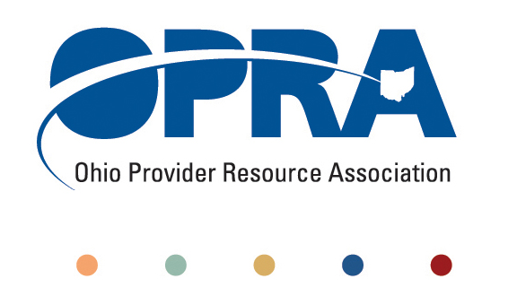
OPRA POLICY COMMITTEE AGENDA
Monday, January 14, 2013
10AM – 2PM
1152 Goodale Blvd, Columbus, Ohio 43212

- Emerging Policy Updates
  - DODD Budget 2013-2014
  - Waiver Reimbursement Pilot
  - Health Homes
  - Provider Compliance Rule and National Accreditation
  - Employment First
  - Quality Assurance
  - OHT Streamlining DODD licensure and ODH certification
    - Table Top
  - Money Management Guidelines
  - MUI Rule
  - Background Check Rule
  - December Revenue Report
  - IAF language, process and training
- HCBS Definition of Community
- DSP’s to DC
- Federal deficit reduction and debt ceiling
  - Medicaid
    - Provider tax
    - Per capita cap
    - Medicare
- Federal Issues
    - Target on DD HCBS
    - Managed care
    - State plan amendments to limit mandatory services
    - Maintenance of effort in HCBS waivers
    - Title 22 project
- Other Items
- Schedule:

Next Policy Committee Meeting – Monday, February 19th
- Program Directors Committee Meeting – Thursday, February 14th

