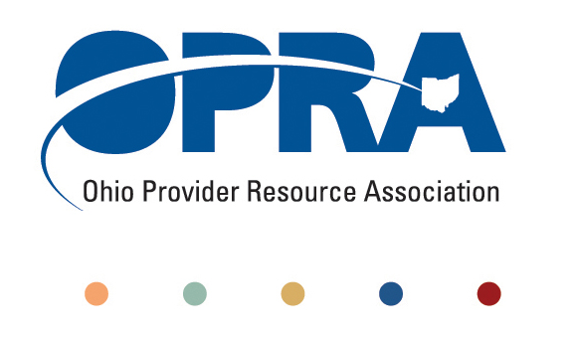

OPRA POLICY COMMITTEE AGENDA
Monday, December 10, 2012
10AM – 12PM
** Meeting will be by Conference Call **
To access the call: 800-582-3014 PIN 211 297 502#

- Emerging Policy Updates
  - DODD Budget 2013-2014
  - Waiver Reimbursement Pilot
  - Health Homes
  - Provider Compliance Rule and National Accreditation
  - Employment First
  - Quality Assurance
    - OHT Streamlining DODD licensure and ODH certification
    - Table Top
  - Money Management Guidelines
  - MUI Rule
  - Background Check Rule
  - November Revenue Report
  - IAF language and process
- DC Downsizing in SW Ohio
- HCBS Definition of Community
- OPRA Strategic Plan Status
- Other Items
- Schedule:

Next Policy Committee Meeting – Monday, January 14th
- Program Directors Committee Meeting – Thursday, January 10th

