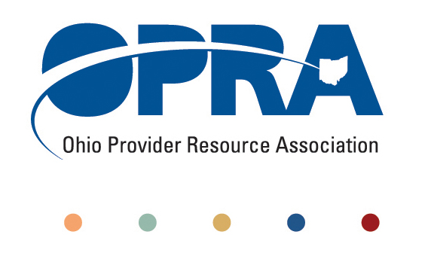
OPRA POLICY COMMITTEE AGENDA
Monday, September 19, 2011
10AM – 2PM
OPRA OFFICE
1152 Goodale Blvd, Columbus, OH 43212

You have several parking options: front of the building on the street, front parking lot adjacent to the right of the building, lot behind the building, lot across the alley behind the building, other legal street parking. Lunch options are a short drive from the office.

- Simplification and Efficiencies Strategic Focus Area
  - Adult Day Services Training Requirements
  - SSA and Program Management Functions Grant Report – Next Steps
  - Deeming
- Reimbursement and Direct Support Professional Wages Strategic Focus Area
  - Direct Support Professional Wages, Benefits, Training And Supervision
    - 2011 Compensation, Benefits and Turnover Survey Summary of Findings
    - Efficiency dividends and additional federal revenue distribution
  - Waiver Reimbursement Update
    - Remote monitoring implementation work group
    - Waiver reimbursement pilot
    - Waiver reimbursement federal financing
  - ICF
    - IAF Modernization
    - Outlier payment
    - Transition to DODD
- Waiting List and Unmet Needs
  - Health Homes and Accountable Care Organizations (ACO)
    - Autism, mental health, and access to psychiatric care
- Membership/Member Services
- State budget and Legislative Update
  - Revenue Report
- Rules Summary
- Federal Issues
  - Medicaid and the Joint Select Committee on Deficit Reduction
  - HCBS Regulations Comments and Process
  - CMS Region 5 Summit
- Other Items
- Schedule:

Next Policy Committee Meeting – Monday, October 17th
- Program Directors Committee Meeting – Thursday, October 13th
- Coleman Institute and ANCOR Technology Summit – October 12 – 14th (www.colemaninstitute.org)

OPRA 2011 Fall Conference, Embassy Suites Hotel, October 25th - 26th
- Ethics Law Training, December 7th
- Positive Culture Trainings in September – see website for specific dates – www.opra.org

