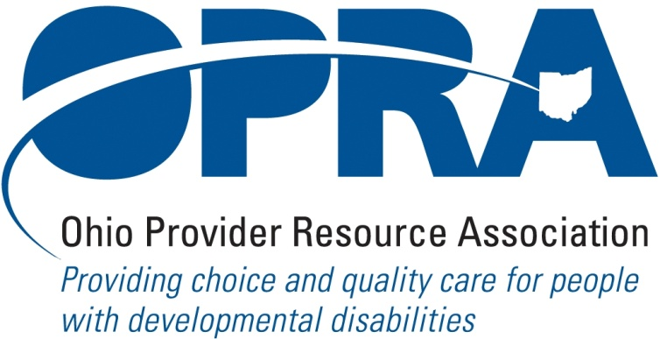

OPRA POLICY COMMITTEE AGENDA
MONDAY, August 16, 2010
OPRA OFFICE
10AM – 2PM

PLEASE NOTE: OPRA is now located at 1152 Goodale Blvd, Columbus, OH 43212 (in Grandview Heights). Our office is about 1 mile west of SR315 on Goodale Blvd. You have several parking options: front of the building on the street, front parking lot adjacent to the right of the building, lot behind the building, lot across the alley behind the building, other legal street parking. Lunch options are a short drive from the office.

There is construction along Route 315 that has closed some ramps. Go to: http://www.pavingtheway.org/sr-315/ for additional information.

- Convene Meeting **Please turn off cell phones or place on vibrate. Thanks.
- Reimbursement and Direct Support Professional Wages Strategic Focus Area
  - Direct Support Professional Wages, Benefits, Training And Supervision
  - Waiver Reimbursement Update
    - New waiver services
    - CPT status
    - OSOC
  - IAF Modernization
  - Capital Project
- Simplification and Efficiencies Strategic Focus Area
  - Adult Day Services Training Requirements
  - SSA and Program Management Functions Grant
  - Licensure Process
  - Member Services
    - Health insurance
    - Provider selection web site
    - Vacancy registry
  - Deeming
- Waiting List Strategic Focus Area
- Unmet and Emerging Needs Strategic Focus Area
  - Flexible Supports Waiver
- Rules Summary
- State Budget and Legislative Update
  - July state revenue report
  - Legislative Recess – contact with local legislators
  - State Budget Commission
- Federal Issues
  - E-FMAP Extension
- OPRA District Meetings
- OPRA Strategic Planning Process
- Other Items
- Schedule:

Next Policy Committee Meeting – Monday, September 20th
- Program Directors Committee Meeting – September 9th
- District Meetings –Dist 4 – August 20th, Dist 3 – August 24th , Dist 1 – August 26th

Behavior Support Trainings (Bob Bowen)

August 27, 2010 - Brecksville, Ohio Brecksville Community Center

August 30, 2010 - Columbus, Ohio OPRA Office

September 1, 2010 - Cincinnati, Ohio St Josephs Home

September 8, 2010 - Toledo, Ohio Anne Grady Center

Positive Culture Initiative Training
  - August 19, 2010 – Cambridge, Ohio Work Pro
  - September 16, 2010 – Columbus, Ohio OPRA Office
  - September 17, 2010 – Maumee, Ohio Sunshine Inc.
  - September 14, 2010 – Cincinnati, Ohio RHC

NE Ohio OPRA PAC Golf Outing – Wednesday, Sept. 29th

OPRA 2010 Fall Conference, Embassy Suites Hotel, October 19 – 20, 2010
- OPRA Committee Meetings (see OPRA Calendar under Events at www.opra.org)

