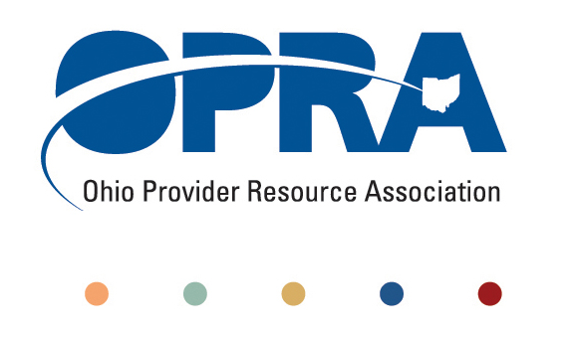
OPRA POLICY COMMITTEE AGENDA
Tuesday, January 17, 2012
10AM – 2PM
OPRA OFFICE
1152 Goodale Blvd, Columbus, OH 43212

You have several parking options: front of the building on the street, front parking lot adjacent to the right of the building, lot behind the building, lot across the alley behind the building, other legal street parking. Lunch options are a short drive from the office.

- Waiting List and Unmet Needs
  - Health Homes and Accountable Care Organizations (ACO)
    - Autism, mental health, and access to dental care - David Owsiany, Executive Director of the Ohio Dental Association and Dr. Paul Casamassimo will join the meeting at 10 AM
- Simplification and Efficiencies Strategic Focus Area
  - Adult Day Services Training Requirements
  - Deeming
  - Money Management Guidelines
  - MUI rule
- Reimbursement and Direct Support Professional Wages Strategic Focus Area
  - Direct Support Professional Wages, Benefits, Training And Supervision
    - Efficiency dividends and additional federal revenue distribution
  - Waiver Reimbursement Update
    - Waiver reimbursement and technology pilot
  - ICF
    - IAF Modernization
    - Outlier payment
    - Transition to DODD
    - MITS/payment issues
  - Federal Budget Issues
  - O/NADSP Involvement
  - Managed Care Trends
- Membership/Member Services
- State budget and Legislative Update
  - December Revenue Report
- Rules Summary
- Other Items
- Schedule:

Next Policy Committee Meeting – Tuesday, February 21st
- Program Directors Committee Meeting – Thursday, February 9th
- 2012 OPRA Spring Conference – April 17th & 18th

