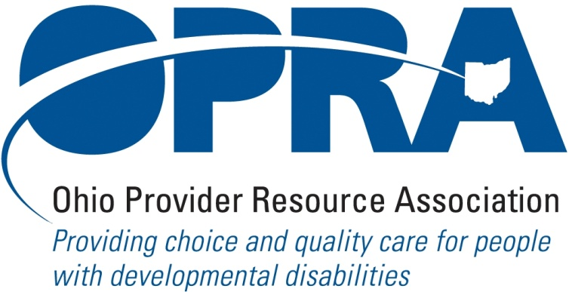

OPRA POLICY COMMITTEE AGENDA
MONDAY, MAY 17, 2010
OPRA OFFICE
10AM – 2PM

PLEASE NOTE: OPRA is now located at 1152 Goodale Blvd, Columbus, OH 43212 (in Grandview Heights). Our office is about 1 mile west of SR315 on Goodale Blvd. You have several parking options: front of the building on the street, front parking lot adjacent to the right of the building, lot behind the building, lot across the alley behind the building, other legal street parking. Lunch options are a short drive from the office.

- Convene Meeting **Please turn off cell phones or place on vibrate. Thanks.
- OPRA Strategic Planning Process
- Reimbursement and Direct Support Professional Wages Strategic Focus Area
  - Direct Support Professional wages, benefits, training and supervision
  - Waiver Reimbursement Update
    - New waiver services
    - CPT status
  - IAF Modernization
  - Capital project
- Rules Summary
  - DODD pre-clearance rules on respite and remote monitoring services for IO waiver
  - DODD/JFS rules to implement CPT
  - ICF/MR FPF rules
- Simplification and Efficiencies Strategic Focus Area
  - Adult Day Services Training Requirements
  - Best Practices Module - SSA and Program Management Functions
  - Member Services
    - Health Insurance
    - Provider Selection Web Site
- Waiting List Strategic Focus Area
  - ODODD’s priority work
  - ICF waiting lists
- Unmet and Emerging Needs Strategic Focus Area
  - House Bill 446 – out of state placements
- State Budget and Legislative Update
  - April state revenue report
  - HB 398 – Home First legislation
  - Remainder of legislative session
  - ICF/MR 12th payment and other FMAP possibilities
- Unified Long Term Care System Work Group and Subcommittees
- Federal Issues
  - E-FMAP extension
  - Health care reform
- Other items
- Schedule:

OPRA PAC Golf Outing – Tuesday, May 25th

Next Policy Committee Meeting – Monday, June 21st
- Program Directors Committee Meeting – Thursday, June 10th
- OPRA Committee Meetings (see OPRA Calendar under Events at www.opra.org

