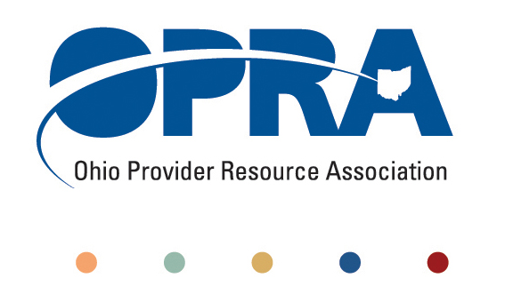
OPRA POLICY COMMITTEE AGENDA
MONDAY, November 15, 2010
10AM – 2PM
OPRA OFFICE
1152 Goodale Blvd, Columbus, OH 43212

You have several parking options: front of the building on the street, front parking lot adjacent to the right of the building, lot behind the building, lot across the alley behind the building, other legal street parking. Lunch options are a short drive from the office.

- Convene Meeting **Please turn off cell phones or place on vibrate. Thanks.
- State budget and Legislative Update
  - Election Results
  - October Revenue Report
  - Legislative Recess – contact with local legislators
  - Agency budget submitted in November
  - Policy issues for new administration
- Reimbursement and Direct Support Professional Wages Strategic Focus Area
  - Direct Support Professional Wages, Benefits, Training And Supervision
  - Waiver Reimbursement Update
    - CPT training
  - IAF Modernization
- Simplification and Efficiencies Strategic Focus Area
  - Adult Day Services Training Requirements
  - SSA and Program Management Functions Grant
  - Licensure Process
  - Med Admin/DN issues
  - Member Services
  - Deeming
- Waiting List Strategic Focus Area
- Unmet and Emerging Needs Strategic Focus Area
  - SELF Waiver
- Rules Summary
- Federal Issues
- Other Items
- Schedule:

Next Policy Committee Meeting – Monday, December 13th
- Program Directors Committee Meeting – WEDNESDAY, December 9th

OPRA 2011 Spring Conference, Embassy Suites Hotel, March 29 – 30, 2011
- Ethics Law for the DD, Mental Health and Health Care Professional, November 22nd
- OPRA Committee Meetings (see OPRA Calendar under Events at www.opra.org)

