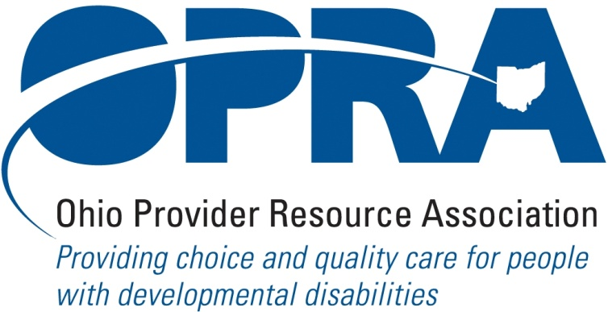

OPRA POLICY COMMITTEE AGENDA
MONDAY, July 19, 2010
OPRA OFFICE
10AM – 2PM

PLEASE NOTE: OPRA is now located at 1152 Goodale Blvd, Columbus, OH 43212 (in Grandview Heights). Our office is about 1 mile west of SR315 on Goodale Blvd. You have several parking options: front of the building on the street, front parking lot adjacent to the right of the building, lot behind the building, lot across the alley behind the building, other legal street parking. Lunch options are a short drive from the office.

There is construction along Route 315 that has closed some ramps. Go to: http://www.pavingtheway.org/sr-315/ for additional information.

- Convene Meeting **Please turn off cell phones or place on vibrate. Thanks.
- Reimbursement and Direct Support Professional Wages Strategic Focus Area
  - Direct Support Professional Wages, Benefits, Training And Supervision
  - Waiver Reimbursement Update
    - New waiver services
      - Remote monitoring assessment
    - CPT status
    - OSOC
  - IAF Modernization
  - Capital Project
- Simplification and Efficiencies Strategic Focus Area
  - Adult Day Services Training Requirements
  - SSA and Program Management Functions Grant
  - Licensure Process
  - Member Services
    - Health insurance
    - Provider selection web site
    - Vacancy registry
- Waiting List Strategic Focus Area
- Unmet and Emerging Needs Strategic Focus Area
- Rules Summary
  - ICF/MR FPF Rules
  - Rules On Access To Information By State Personnel
- State Budget and Legislative Update
  - July state revenue report
  - Legislative Recess – contact with local legislators
  - State Budget Commission
- Federal Issues
  - E-FMAP Extension
- Unified Long Term Care System Work Group and Subcommittees (Let me know if you have anything here. If not, we’ll remove it)
- OPRA District Meetings
- OPRA Strategic Planning Process
  - Draft strategic plan updates
  - Focus areas review
  - Draft goals review
  - Draft goals priorities
  - Plan process
- Other Items
- Schedule:

Next Policy Committee Meeting – Monday, August 16th
- Program Directors Committee Meeting – August 12th
- District Meetings –Dist 6 & 8 – July 26th, Dist 4 – August 20th , Dist 3 – August 24th,
Dist 1 – August 26th

NE Ohio OPRA PAC Golf Outing – Wednesday, Sept. 29th

Behavior Support Trainings (Bob Bowen)

August 27, 2010 - Brecksville, Ohio Brecksville Community Center

August 30, 2010 - Columbus, Ohio OPRA Office

September 1, 2010 - Cincinnati, Ohio St Josephs Home

September 8, 2010 - Toledo, Ohio Anne Grady Center

OPRA 2010 Fall Conference, Embassy Suites Hotel, October 19 – 20, 2010
- OPRA Committee Meetings (see OPRA Calendar under Events at www.opra.org

