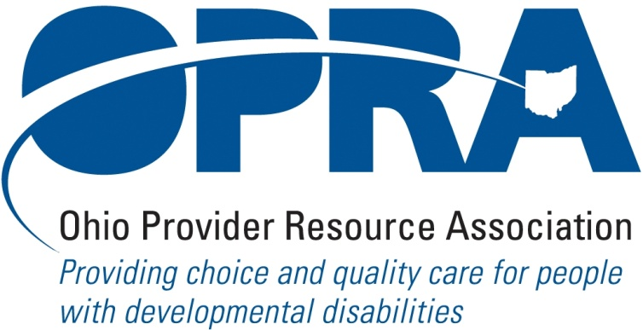

OPRA POLICY COMMITTEE AGENDA
MONDAY, June 21, 2010
OPRA OFFICE
10AM – 2PM

PLEASE NOTE: OPRA is now located at 1152 Goodale Blvd, Columbus, OH 43212 (in Grandview Heights). Our office is about 1 mile west of SR315 on Goodale Blvd. You have several parking options: front of the building on the street, front parking lot adjacent to the right of the building, lot behind the building, lot across the alley behind the building, other legal street parking. Lunch options are a short drive from the office.

There is construction along Route 315 that has closed some ramps. Go to: http://www.pavingtheway.org/sr-315/ for additional information.

- Convene Meeting **Please turn off cell phones or place on vibrate. Thanks.
- OPRA Strategic Planning Process
- Reimbursement and Direct Support Professional Wages Strategic Focus Area
  - Direct Support Professional Wages, Benefits, Training And Supervision
  - Waiver Reimbursement Update
    - New waiver services
      - Remote monitoring assessment
    - CPT status
  - IAF Modernization
  - Capital Project
- Simplification and Efficiencies Strategic Focus Area
  - Adult Day Services Training Requirements
  - Best Practices Module - SSA and Program Management Functions
  - Member Services
    - Health insurance
    - Provider selection web site
    - Vacancy registry
- Waiting List Strategic Focus Area
  - ICF Waiting Lists
- Unmet and Emerging Needs Strategic Focus Area
- IO Waiver Review
- Rules Summary
  - DODD/JFS Rules On County Board Risk Fund
  - New Waiver Services Rules – Status Update
  - DODD/JFS Rules To Implement CPT – Status Update
  - ICF/MR FPF Rules
  - Rules On Access To Information By State Personnel
- State Budget and Legislative Update
  - May state revenue report
  - Legislative Recess – contact with local legislators
  - State Budget Commission
  - ICF/MR 12th Payment
- Federal Issues
  - E-FMAP Extension
  - Health Care Reform
- Unified Long Term Care System Work Group and Subcommittees
- OPRA District Meetings
- Other Items
- Schedule:

Health Care Reform Training June 29th, 2010, OPRA office

Next Policy Committee Meeting – Monday, July 19th
- Program Directors Committee Meeting – Thursday, July 8th

NE Ohio OPRA PAC Golf Outing – Wednesday, Sept. 29th

OPRA 2010 Fall Conference, Embassy Suites Hotel, October 19 – 20, 2010
- OPRA Committee Meetings (see OPRA Calendar under Events at www.opra.org

