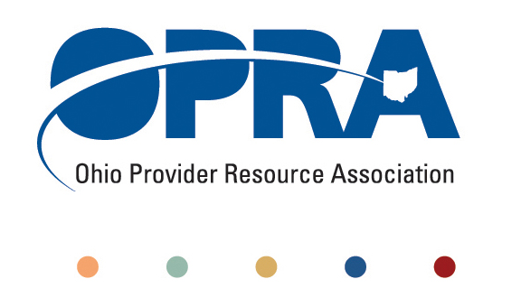
OPRA POLICY COMMITTEE AGENDA
Monday, December 12, 2011
10AM – 2PM
OPRA OFFICE
1152 Goodale Blvd, Columbus, OH 43212

You have several parking options: front of the building on the street, front parking lot adjacent to the right of the building, lot behind the building, lot across the alley behind the building, other legal street parking. Lunch options are a short drive from the office.

- Simplification and Efficiencies Strategic Focus Area
  - Adult Day Services Training Requirements
  - SSA and Program Management Functions Grant Report – Next Steps
  - Deeming
  - Money Management Guidelines
  - MUI rule
- Waiting List and Unmet Needs
  - Patrick Stephan – DODD – SELF Waiver and Agency of Choice at 10:30 AM
  - Health Homes and Accountable Care Organizations (ACO)
    - Autism, mental health, and access to psychiatric care
- Reimbursement and Direct Support Professional Wages Strategic Focus Area
  - Direct Support Professional Wages, Benefits, Training And Supervision
    - Efficiency dividends and additional federal revenue distribution
  - Waiver Reimbursement Update
    - Waiver reimbursement and technology pilot
  - ICF
    - IAF Modernization
    - Outlier payment
    - Transition to DODD
  - Federal Budget Issues
- Membership/Member Services
- State budget and Legislative Update
  - Revenue Report
- Rules Summary
- IADD HCBS Leadership Summit
- Alliance for Full Participation
- Other Items
- Schedule:

Next Policy Committee Meeting – Tuesday, January 17th
- Program Directors Committee Meeting – Thursday, January 12th
- 2012 OPRA Spring Conference – April 17th & 18th

