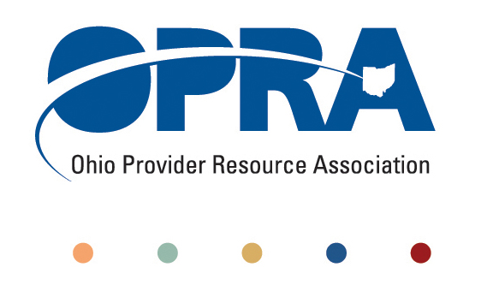
OPRA POLICY COMMITTEE AGENDA
Monday, November 05, 2012
10AM – 2PM
OPRA OFFICE
1152 Goodale Blvd, Columbus, OH 43212

You have several parking options: front of the building on the street, front parking lot adjacent to the right of the building, lot behind the building, lot across the alley behind the building, other legal street parking. Lunch options are a short drive from the office.

- Health Home Project Recommendation
- Emerging Policy Updates
  - DODD Budget 2013 – 2014
  - Waiver Reimbursement Pilot
  - Employment First
  - Quality Assurance
  - OHT streamlining: DODD licensure and ODH certification
  - Money Management Guidelines
  - MUI Rule
  - Background Check Rule
  - October Revenue Report
  - Level of Care
  - Constitutionally Mandated Minimum Wage Increases
  - IAF language and process
- OPRA Strategic Plan Review
  - Process
  - Revised Strategic Plan
  - Feedback
- Other Items
- Schedule:

Next Policy Committee Meeting – Monday, December 10th
- Program Directors Committee Meeting – Thursday, December 13th

