1. Welcome-Introductions
2. Priority: Workforce Update

The DD council provided grant funds to assist with initiation of a DSP Awareness campaign. OPRA has worked with many other stakeholders to create two different 30 second TV commercials. (reviewed commercials during meeting). In addition to this, some counties are initiating hiring assistance (paying for background checks, initial training, etc.) OPRA is also working on written materials, Radio advertisements, billboards, social media, etc. The next step is to decide how to get these commercials on TV, final edits, and where those viewing the commercial will be directed when interested. The next policy meeting will have a discussion session to provide feedback on this.

1. Efficiencies and Simplification Update—priorities

* MUI/UI Rule and Process Review-Update and Action plan:

Meeting held with DODD and all stakeholder groups on May 9th. Several areas addressed for discussion and revision of rule and MUI process. The entire member list of recommendations was shared with the group. Meeting scheduled for June 27th. (First category to address: Neglect)

* Provider Certification Rule and Process Review-Update and Action plan: OPRA amendment language in budget to address this. The Department opposed the language strongly. OPRA met with DODD on two more occasions to address and has made a commitment to the following:
  1. Automatic renewal for providers who submit prior to 45 day window
  2. Providers shall not be moved to the bottom of list if document missing or if ask question
  3. Help line staff increased so that there is someone to call who will be able to assist
  4. Certification staff increased to handle the volume at DODD
  5. PCW updated to be more efficient and simplified for providers (provider members are now involved in testing this software to provide feedback before roll out)
  6. Process being revised by DODD
  7. Promise to change Rule to match new process
* Timely and accurate authorizations; audit protocol (refer to budget information below---workgroup established with OACB)

1. Ohio State Biennial Budget Update---Refer to details on budget in powerpoint listed below in this document.

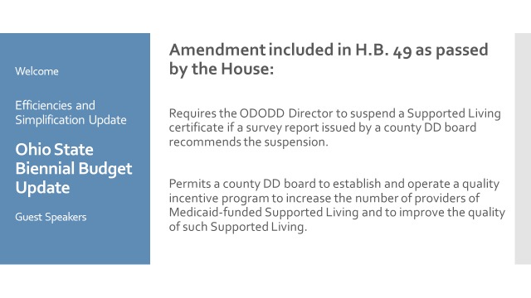

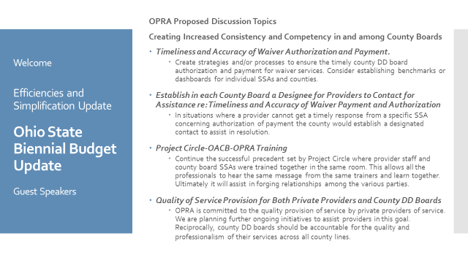

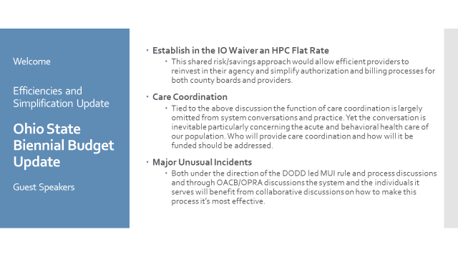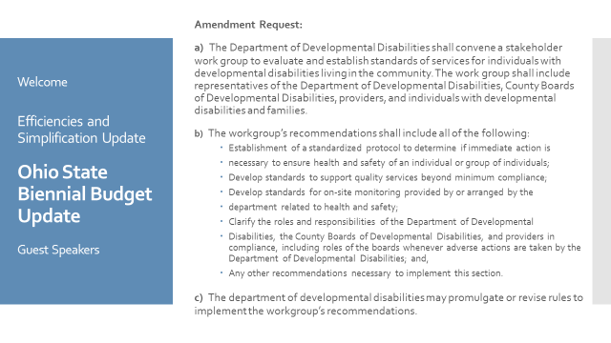

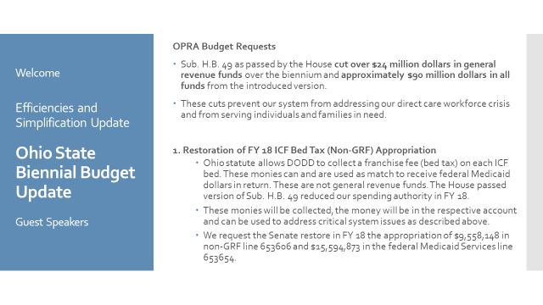

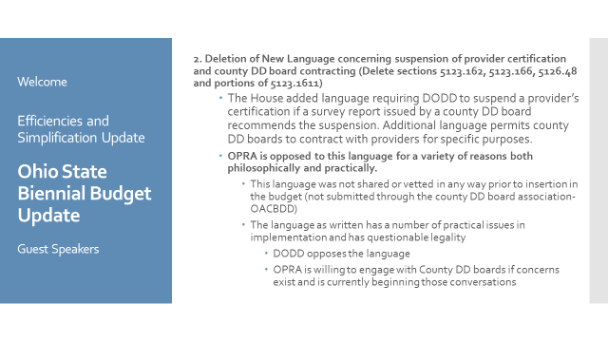

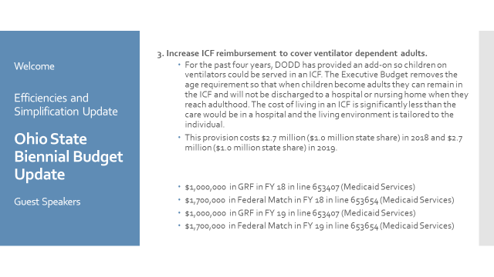

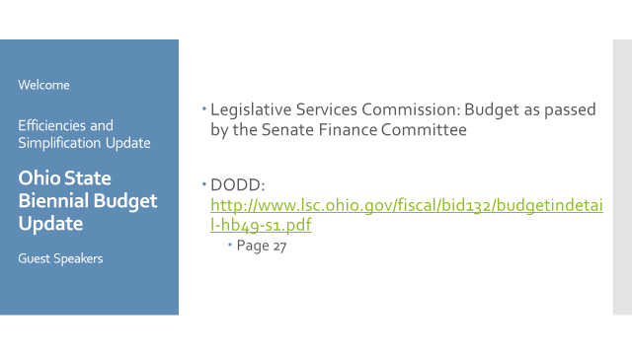

**Guest Speakers: Kelly Miller,Deputy Director, and Lisa M. Ahlersmeyer, Manager, Office of Provider Standards & Review (OPSR)**

Providers will experience a settings evaluation as part of the usual compliance review process now. During the review, the reviewers will be evaluating the setting of HCBS services. Each setting will be evaluated for location (is it near, adjacent to public facility/institution? Does it have institutional qualities? Does it have isolating qualities?) In addition, they will be reviewing each individual’s plan which must clearly outline what is important to them with specific outcomes that the day program should be working towards. The day program and all staff should be able to demonstrate that each individual’s plan, choices, and outcomes are being attained. The person centered planning process is crucial so that the plan is clear on expected outcomes, including what is important to the individual and what they want to do. County boards may also be cited during settings reviews.

**Red flags of things to evaluate further:** large amount of individuals going to large buildings who are next to facility, or county board previously owned; groups of people going to the same place-same vehicle-same staff-no choice; caution when one large calendar posted for activity/outings saying “TODAY’S outing is BOWLING.”; activities being scheduled in community when the business is closed to the broader community; many people with the same outcomes identified; discovery process should not be a long-term thing---appropriate for a short term-when identify interests should move to implementation

**POSITIVE EXAMPLES**: individual plan clearly indicates gardening as outcome-day program starts garden at location-individual assists and learns gardening; join community Garden club doing plant sharing with community members, visiting community gardens and inviting those from community to come visit day program garden….etc….

Individual outcome to learn to play board games to connect more with people---Chess club starts at day program where individual’s learn to play and then join community Chess Club every week with community members.

**FACTORS TO CONSIDER:** Person centered planning by the TEAM must include clear outcomes that promote community integration per the individual’s choice. This includes evaluating the resources needed to make this happen (staffing, acuity, vehicles-mileage, etc…). Many providers have had to redo their strategic plan to address these initiatives.

DODD is available for questions/concerns. Please feel free to direct these questions to Lisa A. Her contact information is as follows: [email-Lisa.Ahlersmeyer@dodd.ohio.gov](mailto:email-Lisa.Ahlersmeyer@dodd.ohio.gov) 614.813.9832 (cell)

614.644.6674 (fax) Please refer to attached document for HCBS Settings Evaluation form. This can also be found on DODD’s website.

**Guest Speaker: Bethany Toledo, Executive Director OADSP**

There are many DSP workforce initiatives that OADSP is working on currently:

1. C3P0-just held graduations for Franklin Heights, Median, Marion. Additional schools interested in starting programs: Licking Co, Foxfire, Lake Co, C-Tec, Pickaway/Ross, etc…
2. Adult education programs being offered through technical centers-open to all. Cost of $385 being paid by some county boards through scholarships. The 30 hours of training meets basic DSP training requirements.
3. Many county boards have began assisting with on-boarding process (ie: Licking County who is doing basic employment criteria tasks such as background checks, basic trainings, etc. to prepare them for the workforce) and then providing list of providers hiring.
4. DSP recognition event scheduled for Sept. 13th (registration is now open through OADSP)
5. OADSP offers DSP and Supervisor councils—if interested in nominating, please refer to Bethany
6. Proposal for alternate path for Adult Education for GED submitted. This proposal would provide a 12-minth waiver for all providers to be able to hire personnel without their GED and offer an additional alternate path to get GED. Bethany is currently working on this with DODD and will provide information when finalized.
7. **Next meeting proposed topics: Attorney General reviews, Joint discussion possibility with county reps on shared focus areas, OOD Summer transition experience---July 17th, 2017 10a-2pm**
8. **Open Discussion:**
   1. OOD-OPRA is inviting OOD providers to become members and starting to include OOD in committee discussions. Thank you to Greenleaf who joined recently. We look forward to adding new member services around the OOD providers, as well.
   2. Housing-there is a huge need to address this. Should we have alternate memberships/groups and networking opportunities for housing, OOD, and some of the areas that seem to need advocacy and resource efforts towards?