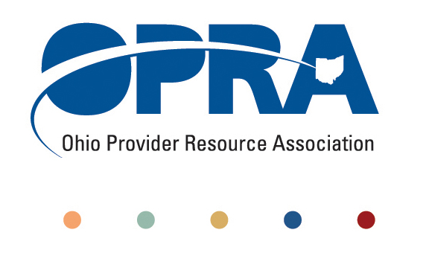
OPRA POLICY COMMITTEE AGENDA
Monday, October 15, 2012
10AM – 2PM
OPRA OFFICE
1152 Goodale Blvd, Columbus, OH 43212

You have several parking options: front of the building on the street, front parking lot adjacent to the right of the building, lot behind the building, lot across the alley behind the building, other legal street parking. Lunch options are a short drive from the office.

- Work Groups Updates
  - ICF White Paper
  - Employment First
  - Health Home draft strategy
- Emerging Policy Updates
  - Waiver Reimbursement and Technology Pilot
  - Quality Assurance
  - OHT streamlining: DODD licensure and ODH certification
  - Money Management Guidelines
  - MUI Rule
  - Background Check Rule
  - September Revenue Report
  - Level of Care
  - Constitutionally Mandated Minimum Wage Increases
- OPRA Strategic Plan Review
  - Process
  - Update
  - Relevance and Suggestions
- Other Items
  - Videoconference Meetings
- Schedule:

Next Policy Committee Meeting – Monday, November 5th
- Program Directors Committee Meeting – Thursday, November 9th

