# Introduction

Thank you for taking the time to review this summary of the outcome and implementation of the State of Ohio’s fiscal years 2024 and 2025 biennium budget. This document outlines the impact of the budget on Ohio’s developmental disability services system. In preparation for this budget which started nearly 2 years ago, it was obvious that there had to be a serious effort to address the system’s workforce challenges and stabilize our system post pandemic. With that being said the obvious focus was to address the wages of Direct Support Professionals (DSP) and other frontline professionals.

This document is designed to help OPRA members navigate conversations with their staff and other interested parties. It is important that we respect each provider’s situation and assist you with information that may explain the outcomes of the State’s budget. Each of the points presented represent tools in a toolbox and it is up to you whether or not the tool is helpful and/or should be used.

This document is broken down into 3 sections of information (General, For Your Staff, and For Your Boards and/or staff). We hope the information helps you and those around you gain a better understanding of the results and gives you the opportunity to use accurate information in your communications.

If there are any questions you can reach out to the OPRA Team for assistance.

# General Information

1. **When was the budget signed?**

Governor Mike DeWine signed the budget on XX. The budget impacts funding for state fiscal years 2024 and 2025 (state fiscal years start on July 1st and end on June 30th).

1. **How does increased budget funding impact the service I provider?**

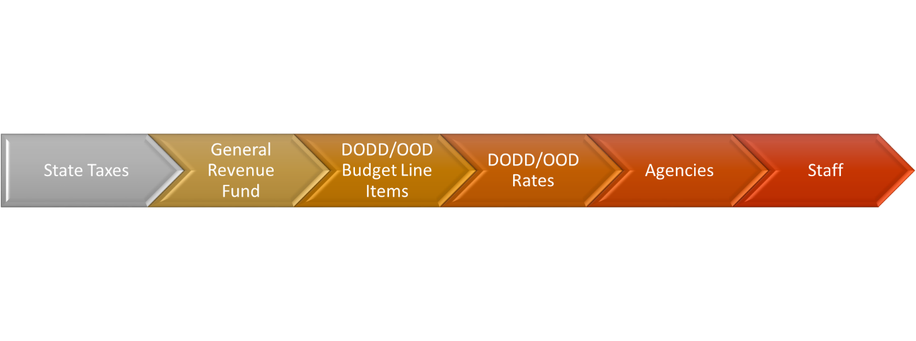

1. **What rates/services will receive increases?**
   1. Services provided in Intermediate Care Facilities (ICFs)
   2. *Certain Home and Community-Based Waiver Services*:

**Residential Services**

Homemaker/Personal Care and Participant-Directed Homemaker/Personal Care;

On-Site/On-Call;

Remote Support Services;

Respite Services;

Shared Living; and

Transportation

**Day Services**

Adult Day Support

Vocational Habilitation

Career Planning

Individual and Group Employment Support

Non-Medical Transportation

Self-Directed Transportation

1. **How exactly will the additional funding from the budget get to providers?**

* In the above waiver services, the reimbursement rate for each unit of delivered service will increase. Reimbursement rates for each service is different and can be found in the appendix of the service rule.
* In the ICF, each ICF will receive an add-on based on a set percentage of their previous year’s direct care cost center. For state fiscal year 2024 (7/1/23-6/30/24), this percentage is 13.55%. In state fiscal year 2025 (7/1/24-6/30/25), the percentage is 20.81%.

(these will need to be revised)

1. **Who contributes to the funding of services for people with developmental disabilities?**

*Home and Community-Based Waiver Services*

*Intermediate Care Facilities*

*Intermediate Care Facilities*

*Intermediate Care Facilities*

1. **How much additional money to the General Assembly give to the system?**

|  |  |  |
| --- | --- | --- |
| Service | TOTAL INCREASE for SFY 24 | TOTAL INCREASE for SFY 25 |
| Intermediate Care Facility |  |  |
| Waiver Residential Services |  |  |
| Waiver Day Services |  |  |

1. **What does the investment mean to the field?**

The goal of this budget effort was to ask the State of Ohio to invest in services to help providers attract and retain quality Direct Support Professionals (DSP) and Frontline Supervisors. The focus was obtaining funding that allows providers the opportunity to increase compensation for their front-line professionals. Each provider will design a strategy to compensate their staff and should communicate this with their staff.

# For Your Staff

1. **Over the past few years, my provider has increased DSP and frontline supervisor wages and compensation. Will I still see any increase in my pay?**

It depends. Many providers in this scenario relied on unsustainable or limited funding to pay for these wage or compensation increases in anticipation of this budget being passed. With this scenario, the provider may use the budget’s increased funding to cover the costs from increased wages so that wages do not have to be reduced. In this scenario, DSPs and Frontline supervisors may see no increases or may see small increases.

1. **Over the past few years, my provider increased wages a little or not at all. Will I see any increases in my pay?**

If your agency has not increased compensation, it likely because they did not have access to adequate funding to sustainably do so. The increased funding in the budget will help these providers increase their compensation levels to be more competitive in their communities.

**Again, agencies must work with their staff to understand what is happening in their communities to determine how the increased funding will impact their wages offered to DSPs and frontline supervisors. Providers should communicate with their staff on how the increased funding from the state budget will impact their organization.**

1. **What are some different ways providers may use the funding to increase compensation? This is a list of common ways providers may increase compensation. Providers may implement one or more of these strategies. There are other appropriate ways providers may increase compensation that are not listed here.** 
   1. Providers may offer a percentage increase or a specific dollar amount increase on wages
   2. Providers may increase wages for DSPs and Frontline Supervisors who hold certain certifications or other specialized training
   3. Providers may increase wages for DSPs and Frontline Supervisors who work less-desirable shifts such as overnight or weekends
   4. Providers may increase wages for DSPs and Frontline Supervisors who work with clients with more complex personal care, medical, and/or behavioral support needs
2. **Does this funding mean every DSP and frontline supervisor will make the same hourly wage across the state?**

No. Each agency has their own wage scale. Wages across the state may differ based on a number of factors included geographical location and cost of doing business category of the services, the specific types of services your agency providers, the size of the agency, and if your agency providers non-DODD services.

1. **Does this mean every DSP and Frontline Supervisor will make the same hourly wage within the organization?**

No. Each agency has their own wage scale. DSP and Frontline Supervisor wages may differ based on education and specialized training, the services each staff provides, employment longevity with the agency, the geographical location of the service, the shift worked, and other unlisted factors.

1. **When will agencies start to see the increased funding from the budget?**
   1. Waiver services: 1/1/24 with an additional funding increase on 7/1/24
   2. ICFs: 7/1/23 with an additional funding increase on 7/1/24
2. **Why don’t the increases start on the same days?**

There are a number of structural differences in how ICFs and waiver services are administered, regulated, and billed that make it difficult for the first increase to start on the same day.

1. **My agency offers waiver services and services in ICFs. I see the first increases start on different days. What does this mean for DSPs and Frontline Supervisors at these agencies?**

This is a complicated question and depends on the specific circumstances of the agency. Some agencies may have funding to increase wages of DSPs and Frontline Supervisors providing waiver services at the same time they increase wages for DSPs and Frontline Supervisors in ICFs and some may not. For agencies that do not have the funding, they will not have the funding to implement the same increases across the organization.

1. **Will I see increased wages on those specific dates?**

It depends. For the first increase set for 7/1/23, ICFs will need time to develop, communicate, and implement any wage increases. For all of the increases, providers may also need to wait till they are paid for services provided until they have enough funding to start any wage increase. This answer may also be limited by previous increases your agency given and other factors outlined in question 10. Your agency should communicate with you about if and when you can anticipate wage increase.

1. **Will I see two increases over the next 2 years?**

Again, it depends. This depends on what increases your agency has already implemented and the other factors outlined in question 10. Your agency should communicate with you about if and when you can anticipate wage increase.

1. **My agency is paying retention bonuses funded by the county board. Will these bonuses continue?**

No. The money from the county boards that fund the retention bonus is now being directed to waiver reimbursement rates to help increase wages for DSP and frontline supervisors providing waiver services. Some providers may still offer retention bonuses but they will not be a part of the formal program paid for by the county board.

# For Your Boards and/or Staff

1. **What are the expectations of the funders and the regulators (Governor, State Legislators, and the Department of Developmental Disabilities, and County Boards)?**

The advocacy for this budget focused heavily on the needs of Ohioans with developmental disabilities and a provider’s ability to provide quality services. Advocacy focused on the importance of Direct Support Professionals (DSP) and the crucial role they play in the lives of people with developmental disabilities and their families. Advocates argues that low service reimbursement rates do not allow providers the ability to pay their staff competitive wages, thus major investment is needed to give them the ability to invest in their staff. We made the case that increased rates, leading to increased compensation, are crucial to a provider’s survival.

* The legislators who voted for this investment and the county boards who contributed to the increased rates expect the average wage for front-line professionals/DSPs to increase across the state.
* In the above mentioned **waiver services**, the legislature appropriated funding to support a statewide average DSP wage to be at $18/hour starting 1/1/24 and then appropriated funding to support a statewide average of $19/hour starting on 7/1/24.
* In **Intermediate Care Facilities**, the legislature appropriated funding to support a statewide average DSP wage of $17/hour on 7/1/23 and then appropriated funding to support a statewide average DSP wage $18/hour on 7/1/24.

1. **How will the state monitor the statewide average wage?**

There are two mechanisms currently in place to monitor front-line professional/DSP wages.

* Homemaker/Personal Care (HPC) providers are required to complete a DODD-administered wage verification survey. This was developed based on a promise to the state legislature during the fiscal year 2020/2021 budget process.
  + Currently providers of Day, Vocational, Employment, and Transportation services are not required to complete the wage verification survey, but we believe it will become a requirement in 2024.
* ICFs cost reports which provides the data needed to show staff compensation.