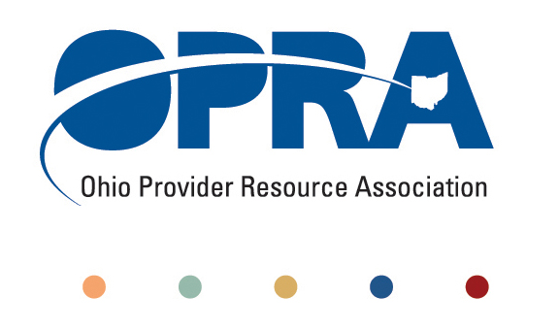
OPRA POLICY COMMITTEE AGENDA
Monday, June 18, 2012
10AM – 2PM
OPRA OFFICE
1152 Goodale Blvd, Columbus, OH 43212

You have several parking options: front of the building on the street, front parking lot adjacent to the right of the building, lot behind the building, lot across the alley behind the building, other legal street parking. Lunch options are a short drive from the office.

- Disabled Adult Child Benefit – Barry Jamieson
- Work Groups (separate into work groups for 45 minute discussion)
  - ICF Future and Development Rule (combined work groups for this month)
  - ADS/Employment First
  - Affordable Care Act/Health Homes Opportunities
- Emerging Policy Updates
  - Adult Day Services Training Requirements
  - Money Management Guidelines
  - MUI Rule
  - Waiver Reimbursement and Technology Pilot
  - June Revenue Report
  - Constitutionally Mandated Minimum Wage Increases
- Other Items
- Schedule:

Next Policy Committee Meeting – Monday, June 18th
- Program Directors Committee Meeting – Thursday, July 16th
- 2012 OPRA Fall Conference – September 25th & 26th

