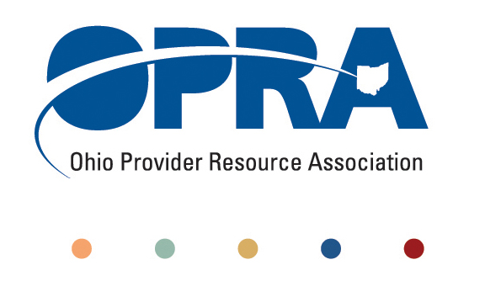
OPRA POLICY COMMITTEE AGENDA
Monday, May 14, 2012
10AM – 2PM
OPRA OFFICE
1152 Goodale Blvd, Columbus, OH 43212

You have several parking options: front of the building on the street, front parking lot adjacent to the right of the building, lot behind the building, lot across the alley behind the building, other legal street parking. Lunch options are a short drive from the office.

- Marilyn Weber - OSU’s Disabled Adult Child Benefit Project (dual eligible issue)
- Simplification and Efficiencies Strategic Focus Area
  - Adult Day Services Training Requirements
  - Money Management Guidelines
  - MUI rule
- Waiting List and Unmet Needs
  - Health Homes and Accountable Care Organizations (ACO)
    - Autism, mental health, and access to psychiatric care
- Reimbursement and Direct Support Professional Wages Strategic Focus Area
  - Direct Support Professional Wages, Benefits, Training And Supervision
    - Efficiency dividends
  - Waiver Reimbursement Update
    - Waiver reimbursement and technology pilot
  - ICF
    - DODD Policy Committee
    - IAF Modernization
    - Outlier payment
    - Transition to DODD
- Membership/Member Services
- Employment First
- State budget and Legislative Update
  - May Revenue Report
- Rules Summary
- Constitutionally mandated minimum wage increases
- Other Items
- Schedule:

Next Policy Committee Meeting – Monday, June 18th
- Partners in Justice Training – Friday, May 18th
- Program Directors Committee Meeting – Thursday, June 14th
- 2012 OPRA Fall Conference – September 25th & 26th

