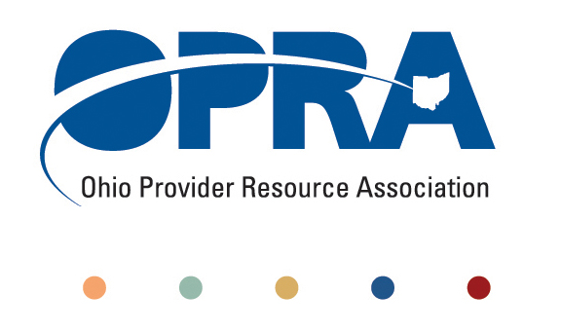
OPRA POLICY COMMITTEE AGENDA
Monday, March 19, 2012
10AM – 2PM
OPRA OFFICE
1152 Goodale Blvd, Columbus, OH 43212

You have several parking options: front of the building on the street, front parking lot adjacent to the right of the building, lot behind the building, lot across the alley behind the building, other legal street parking. Lunch options are a short drive from the office.

- Simplification and Efficiencies Strategic Focus Area
  - Adult Day Services Training Requirements
  - Money Management Guidelines
  - MUI rule
- Waiting List and Unmet Needs
  - Health Homes and Accountable Care Organizations (ACO)
    - Autism, mental health, and access to psychiatric care
- Reimbursement and Direct Support Professional Wages Strategic Focus Area
  - Direct Support Professional Wages, Benefits, Training And Supervision
    - Efficiency dividends
  - OPRA A/R Survey Summary
  - Waiver Reimbursement Update
    - Waiver reimbursement and technology pilot
  - ICF
    - IAF Modernization
    - Outlier payment
    - Transition to DODD
    - ICF Policy Guidelines
- Membership/Member Services
- Employment First
- State budget and Legislative Update
  - March Revenue Report
- Rules Summary
- Constitutionally mandated minimum wage increases
- Other Items
- Schedule:

Next Policy Committee Meeting – Monday, May 14th
- Program Directors Committee Meeting – Thursday, April 12th
- 2012 OPRA Spring Conference – April 17th & 18th

