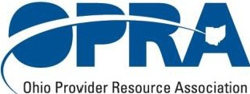

• • • • •

**OPRA POLICY COMMITTEE MEETING AGENDA**

**Monday, December 16, 2019**

1:00-3:00 p.m.

1. Day Array
   1. BEST Implementation
   2. DODD’s Blueprint for Day Services
2. Provider Quality
3. Single Plan
4. OPRA’s ICF and Residential Waiver Committees

Webinar Information:

**OPRA Policy Committee**  
  
**Please join my meeting from your computer, tablet or smartphone.**  
<https://global.gotomeeting.com/join/110975725>  
  
**You can also dial in using your phone.**  
United States: [+1 (872) 240-3412](tel:+18722403412,,110975725)  
  
**Access Code: 110-975-725**  
  
**Join from a video-conferencing room or system.**  
Dial in or type: 67.217.95.2 or inroomlink.goto.com  
Meeting ID: 110 975 725  
Or dial directly: 110975725@67.217.95.2 or 67.217.95.2##110975725