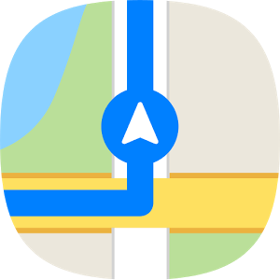

Employment Navigation:

“Discover Discovery”

**Join the Employment Navigation Technical Assistance Liaison team and Capabilities, Inc. for this FREE session focused on how to coordinate, plan and provide “Career Discovery”, one of the new Career Planning Medicaid Employment Services.**

**Lunch will be provided.**

**Attendees will receive:**

**-Information on the benefits of providing Career Discovery for job seekers with disabilities.**

**- Real examples of Career Discovery in action.**

**-Info on how to incorporate Career Discovery within the Person-centered planning process.**

**-A deeper dive into how to complete the Career Discovery process.**

**November 6, 2018**

**10:30am-2pm**

**Chillicothe and Ross County Public Library, Library Annex**

140 South Paint Street

Chillicothe, Ohio 45601

Registration Link:

<http://reg.planetreg.com/E1017123516210878>

**For additional information, please contact Kourtnie Hildreth**

[**kourtnie.hildreth@gwisco.org**](mailto:kourtnie.hildreth@gwisco.org)