Statement from OKDHS/DDSD Administrator Joanne Goin:
Thank you. Americans and Oklahomans, in particular, are so generous. We’ve had two households impacted and both have been rehoused and have all of their current needs met. We have a direct care hero to nominate for awards. She put her consumer in the bathtub and then held on to him. He escaped without harm. She sustained a laceration. We are so thankful for their survival. JoAnne
Information received on possible losses:

1. From Fretzpark Homes (Kelly@fretzpark.org)
I HAVE MEN WHO ARE IN A MOTEL DUE TO LACK OF ELECTRICiTY AND A GAS LEAK WHERE THEY WERE LIVING. We have moved them to a hotel and they could really using financial assistance for their location. I am interested in visiting with them. Thanks
Kelly A. Silla
CEO
Fretzpark Homes, Inc.
4545 North Lincoln Blvd. Suite 105
Oklahoma City, OK 73105
Phone: 405-521-8232
Fax: 405-521-8803
Email: kelly@fretzpark.org
www.fretzpark.org

2. From the Galt Foundation (judy@galtfoundation.org)
Judy,
We at Galt Foundation feel very fortunate that out of all of our field staff statewide, we have one (1) individual in the Moore area whose home is destroyed. We will be working with her and try to help with her needs.
I am sure that all OCP members are thanking for the resources that can be called at times like these.
I received a communication from the State Department of Education today and want everyone to see a comment from Janet Barresi, "There are no words to express our grief. We have faith that the Lord is holding the departed in his arms. We must hold their families in ours,” says Superintendent Barresi.
Judy

3. From Dungarvin (kjones@dungarvin.com)
Judy,
We have had to re-locate a couple of our homes due to power outages. We contacted OU and they are providing a 4 bedroom apartment and 3 meal vouchers a day to our individuals and their staff. The number is 325-2511 for those looking for a safe haven. We have been touched by all the hospitality. Please share this information. Thank you.
Karla Jones, Area Director
Dungarvin, Oklahoma LLC
125 Triad Village Drive
Norman, OK 73071
(405) 329-7830
(405) 329-3047 - fax

4. From BIOS Corporation (emiller@bioscorp.com)
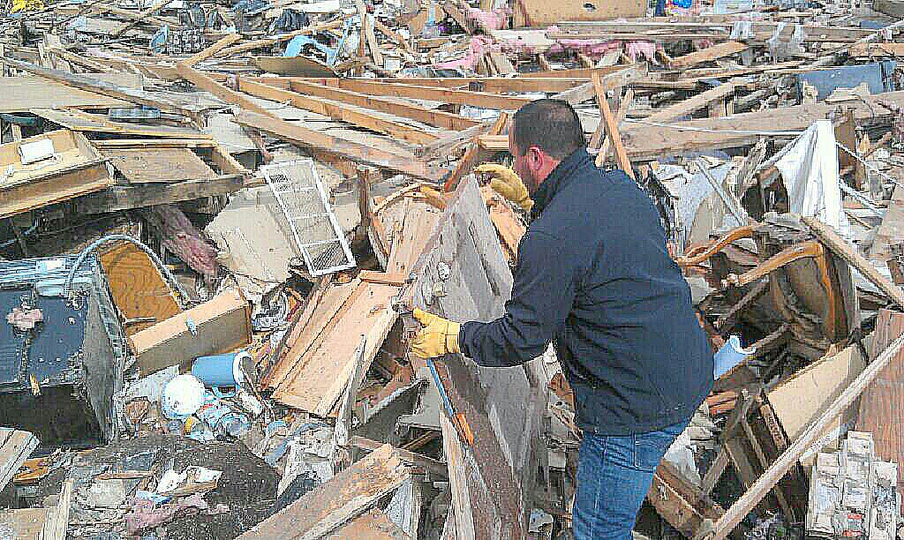

The home of someone we serve, Gordon our area director is standing in front of what used to be the bathroom. Both survived by staying in a closet and bathtub. Please keep them in your thoughts and prayers. Right now everything is taken care of for the person we support and our staff. Basically we just all need to give blood or other donations to various charities in Moore. Thanks for asking, I hope others are well. And yes tornado precautions do save lives, as do drills. Take care.

5. Duncan Group Homes (robin@duncangrouphomes.com)
Judy, if you don’t hear from an agency, I heard of a family/member of DSACO (Downs Syndrome Association of Central Oklahoma) who has a child with down syndrome lost their home. Megan Myers-Winkler is the ED there. You can find her on FB or their website.
Just a thought…

6 Goodwill of Central Oklahoma (Cecelia Morford cmorford@okgoodwill.org)
Judith,
Goodwill of Central Oklahoma has not heard of anyone specifically at this time. You could easily take down their information in case something comes up.
The volunteers have been tremendous and overwhelming!
Goodwill has several Red Cross distribution sites set up (or in the process) and if something comes across we can let you know.
I know on the news last night that two separate families had special needs but have not heard or seen any at this time.
Thank you for asking and letting us know!
Cecelia Morford
Executive Assistant
316 S Blackwelder Avenue
Oklahoma City, OK 73108
cmorford@okgoodwill.org
www.okgoodwill.org
405-278-7116
Fax: 405-278-7171

Agencies and Organizations That Can Help:

1. ANCOR Foundation Cares Fund which has monies that can be directed to direct support staff, people served and individual agencies in need of assistance. Contact Debra Langseth on the ANCOR staff (dlangseth@anocr.org).

2. www.okstrong.ok.gov, a website unveiled just yesterday for information about how to give help, donations, impact map, news and updates from a variety of governmental and non-profit resources.

3. http://www.ok.gov/okstrong/Donation_Information/index.html

4. http://www.news9.com/story/22378669/local-national-businesses-and-organizations-benefit-oklahoma-tornado-relief

5. http://www.news9.com/story/22379237/disaster-relief-agencies-say-cash-is-best-way-to-help-tornado-victims

6. http://kfor.com/2013/05/20/how-to-help-okla-tornado-victims/

7. http://www.abetterlifeokc.com/blog/2013/05/21/the-better-life/lend-a-helping-hand/?utm_source=The+Better+Life&utm_campaign=d2901165dc-The_Better_Life5_21_2013&utm_medium=email&utm_term=0_c2ec5d325f-d2901165dc-300839281

