**“Bad Facts”**

**The Facts about the Bad Things in the Graham-Cassidy Bill**

* Graham-Cassidy proposal contains a new block grant that would cut federal funding currently slated for Medicare expansion and for financial assistance with marketplace coverage.
  + <http://familiesusa.org/product/graham-cassidy-proposal-gigantic-block-grants-and-huge-health-care-cuts>
* Graham-Cassidy block grant would end all funding after 2026, leaving 29 million Americans stranded
  + <http://familiesusa.org/product/graham-cassidy-proposal-gigantic-block-grants-and-huge-health-care-cuts>
* “The Graham-Cassidy proposal would eliminate the block grant entirely after 2026, meaning that in 2027 and beyond, there would be *zero* funding available to replace states’ Medicaid expansions and marketplace tax credits and cost-sharing reductions. As a result, states would face a severe funding cliff that would leave states with *no federal resources* to continue to provide coverage for their low- and moderate-income residents who’ve gained coverage under the ACA’s coverage expansions.”
  + <https://www.cbpp.org/research/health/cassidy-graham-would-deeply-cut-and-drastically-redistribute-health-coverage-funding>
* Graham-Cassidy proposal contains large Medicaid cutbacks like those in health care proposals already rejected by the Senate on a bipartisan basis. The underlying Medicaid program would be cut and restructured, posing serious risks to the more than 70 million Americans who get their health coverage through Medicaid, including seniors and children with special health care.
  + <http://familiesusa.org/product/graham-cassidy-proposal-gigantic-block-grants-and-huge-health-care-cuts>
* Graham-Cassidy proposal contains the elimination of consumer safeguards, like those in health care proposals already rejected by the Senate on a bipartisan basis. State waivers would effectively end important national standards for private coverage, taking away essential benefits from people with preexisting conditions.
  + <http://familiesusa.org/product/graham-cassidy-proposal-gigantic-block-grants-and-huge-health-care-cuts>
* The Kaiser Family Foundation estimated that 27% of Pennsylvania’s non-elderly population, 2,045,000 people, had declinable pre-existing conditions under pre-ACA practices in 2015.
  + <http://www.kff.org/health-reform/issue-brief/pre-existing-conditions-and-medical-underwriting-in-the-individual-insurance-market-prior-to-the-aca/>
* The problem with capping Medicaid funding is that the amount that the federal government would give states under a block grant does not adjust when there are changes in need, such as natural disasters (hurricanes, floods, earthquakes, tornados, wildfires, blizzards, etc.), health care epidemics, or economic recessions. Medicaid would no longer provide additional financial help when need goes up.
  + <https://firstfocus.org/blog/hurricanes-and-medicaid-caps-do-not-mix>
* Under the Graham-Cassidy proposal, no additional funding responds to increased needs, so during future recessions, states would have to choose between denying health coverage and preserving health coverage by raising taxes or cutting other priorities, like education, social services and infrastructure.
  + <http://familiesusa.org/product/graham-cassidy-proposal-gigantic-block-grants-and-huge-health-care-cuts>
* Block grants would prevent states from responding to unexpected health care needs, such as epidemics of infectious diseases, the opioid epidemic or emerging health problems from catastrophic weather events like Hurricane Harvey.
  + <http://familiesusa.org/product/graham-cassidy-proposal-gigantic-block-grants-and-huge-health-care-cuts>
* Under Graham-Cassidy’s Medicaid per capita cap, “federal Medicaid funding for seniors, people with disabilities, and families with children would no longer automatically increase to account for higher per-beneficiary costs such as prescription drug price spikes or rising costs resulting from an aging population. States would be responsible for 100 percent of all costs above the cap.”
  + <https://www.cbpp.org/research/health/cassidy-graham-would-deeply-cut-and-drastically-redistribute-health-coverage-funding>
* “It would replace not just Medicaid but also financial assistance with marketplace coverage for low-wage and moderate-income families. For the first time, states would become accountable for serving millions of privately insured residents who, until now, have been exclusively the federal government’s financial responsibility.”
  + <http://familiesusa.org/product/graham-cassidy-proposal-gigantic-block-grants-and-huge-health-care-cuts>
* Unlike past Republican proposals, the Graham-Cassidy plan would force every state to accept their block grant instead of giving states a choice, even if a state objects that the block grant would do serious harm to it’s population.
  + <http://familiesusa.org/product/graham-cassidy-proposal-gigantic-block-grants-and-huge-health-care-cuts>
* “Other changes to the broad Medicaid program would eliminate federal funding for Planned Parenthood clinics, cut payment for hospital care, and let states impose new paperwork requirements that cause eligible consumers to lose health insurance. “
  + <http://familiesusa.org/product/graham-cassidy-proposal-gigantic-block-grants-and-huge-health-care-cuts>
* The Graham-Cassidy proposal includes proposals to impose a per capita cap on Medicaid for children, people with disabilities, and senior citizens and a full-blown conversion of Medicaid coverage for low-income adults and Obamacare tax credits into block grants to states
  + <https://firstfocus.org/blog/hurricanes-and-medicaid-caps-do-not-mix>
* “The Graham-Cassidy proposal would cause many millions of people to lose coverage, radically restructure and deeply cut Medicaid, increase out-of-pocket costs for individual market consumers, and weaken or eliminate protections for people with pre-existing conditions.”
  + <https://www.cbpp.org/research/health/cassidy-graham-would-deeply-cut-and-drastically-redistribute-health-coverage-funding>
* CBO estimates that the Graham-Cassidy proposal’s cuts to Medicaid, outside of the Medicaid expansion, would equal $180 billion over ten years.
  + <https://www.cbpp.org/research/health/cassidy-graham-would-deeply-cut-and-drastically-redistribute-health-coverage-funding>
* The Graham-Cassidy proposal “includes provisions of the Senate Republican leadership bill that would allow states to waive important consumer protections in the individual market. Under these waivers, which would be subject to near-automatic approval by the federal government, insurers could exclude crucial services such as maternity and mental health care from their plans, impose annual and lifetime limits, and dramatically raise deductibles and other out-of-pocket costs.”
  + <https://www.cbpp.org/research/health/cassidy-graham-would-deeply-cut-and-drastically-redistribute-health-coverage-funding>
* Kaiser Family Foundation’s Larry Levitt says that, “To continue Cassidy-Graham’s block grants after 2026, Congress would have to find $200 billion per year in new revenues to pay for them”
  + <https://twitter.com/i/moments/908703950609641478?utm_campaign=KFF-2017-policy-experts&utm_content=60393035&utm_medium=social&utm_source=twitter>
* Kaiser Family Foundations Larry Levitt says, “Graham-Cassidy would represent a massive devolution of federal money and responsibility to states with few strings attached”
  + <https://twitter.com/i/moments/908015664878673920?utm_campaign=KFF-2017-policy-experts&utm_content=60395938&utm_medium=social&utm_source=twitter>
* “Under the Senate’s latest health care bill, 459,500 veterans would lose Medicaid coverage by 2026.”
  + <https://twitter.com/TalkPoverty/status/909785005945221121>
* Under Graham-Cassidy proposal, insurers would no longer have to provide “essential services”, including: emergency services, hospitalization, pregnancy, maternity, and newborn care, mental health and substance use disorder services, prescription drugs, rehabilitative services and birth control coverage.
  + <https://www.forbes.com/sites/judystone/2017/09/18/graham-cassidy-bill-the-last-ditch-gop-effort-to-deprive-millions-of-healthcare/#399ed1f73b92>
* The employer mandate, which requires larger companies to offer affordable coverage to their employers under the ACA would be eliminated under the Graham-Cassidy proposal.
  + <https://www.washingtonpost.com/graphics/2017/politics/cassidy-graham-explainer/?utm_term=.6193225b5c60>
* “The Graham-Cassidy bill is receiving increasing opposition from a [number of health groups](https://twitter.com/ddiamond/status/908809072794890241): the American College of Physicians, the American Congress of Obstetricians and Gynecologists (ACOG), the American Academy of Pediatrics, the American Academy of Family Physicians, the American Osteopathic Association, the American Psychiatric Association, Planned Parenthood, America’s Essential Hospitals and AARP.”
  + <https://www.forbes.com/sites/judystone/2017/09/18/graham-cassidy-bill-the-last-ditch-gop-effort-to-deprive-millions-of-healthcare/#399ed1f73b92>
* Sixteen patients and provider groups have announced their opposition to Graham-Cassidy bill, including: ALS Association, American Heart Association, National Health Council, National Organization for Rare Diseases, and more.
  + <http://newsroom.heart.org/news/sixteen-patient-and-provider-groups-oppose-grahamcassidy-bill>
* Children’s Hospital Association has announced their opposition the Graham-Cassidy proposal.
  + <https://www.childrenshospitals.org/Newsroom/Press-Releases/2017/CHA-Statement-on-Graham-Cassidy-Repeal-Bill>
  + 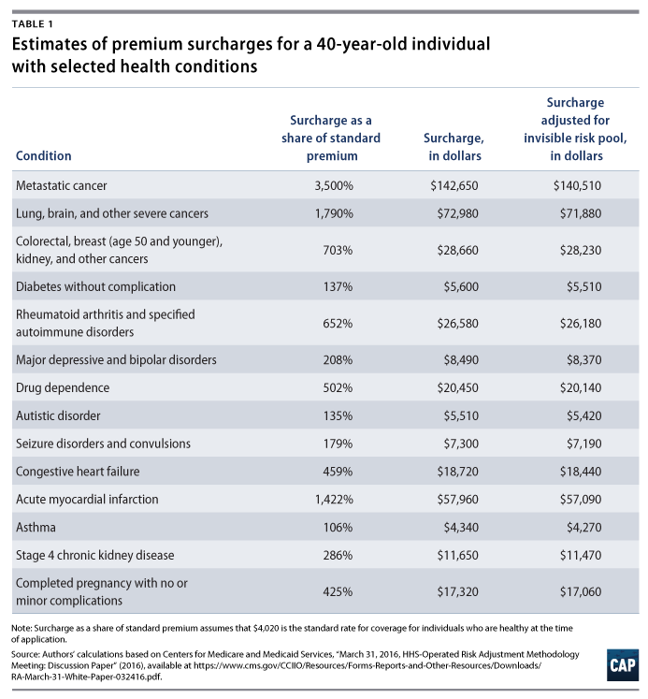<https://www.americanprogress.org/issues/healthcare/news/2017/04/20/430858/latest-aca-repeal-plan-explode-premiums-people-pre-existing-conditions/>