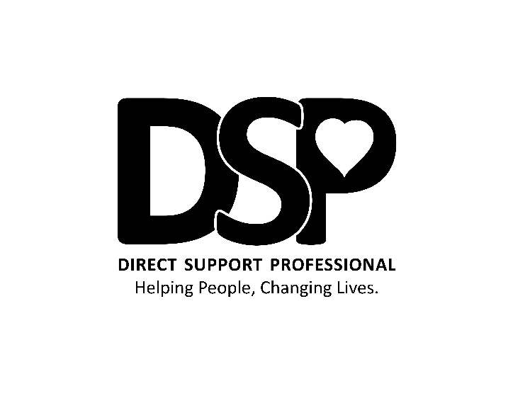

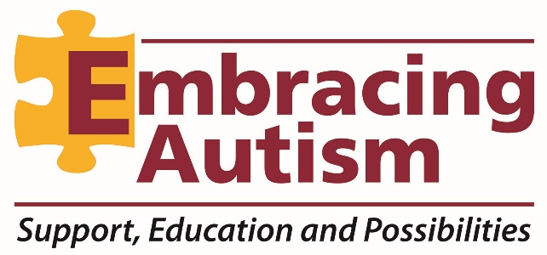

**EMBRACING AUTISM** is looking for a responsible, nurturing, energetic, reliable **DSP** to work with individuals with developmental disabilities in Marysville, Delaware, Sunbury and Columbus areas. The right candidate must have at least 2 years of experience working with individuals with disabilities and be able to work multiple shifts at multiple locations. We are offering a guarantee 40 hours a week, **whether you work 40 hours or not**. This veteran **DSP** will be filling in for call-offs, open shifts and assist with appointments when needed. Some weeks will be lighter than others but you will always receive 40 or more hours per week. Hourly rate will be **$12.00** an hour and will be reimbursed for mileage. If you are searching for a career and want to help people who need our support, then this is the job for you!

**Must pass background check prior to hire.**

**Perferred:** 2 yr exp, **Required**: HS Diploma or GED, valid driver’s license with clean record. Must be certified in or willing to be trained in CPR/1st Aid and Medication Certification.

Please email or call Jessica Martlock to schedule an interview time at **jmartalock@embracing-autism.net** or call **614-559-0077.** You may also visit our website at

**www.embracing-autism.net** to download an application.