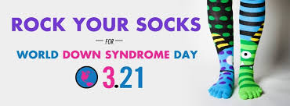

**Help us CELEBRATE World Down Syndrome Day and Developmental Disabilities Awareness Month !**

**On Tuesday, March 21st by wearing your brightest, most unique, colorful mismatched socks!**

**Why mismatched socks and Why March 21st?**

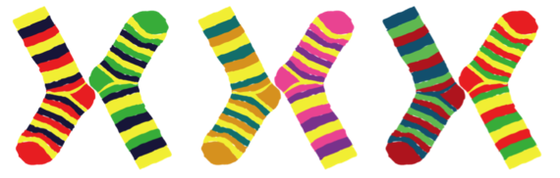

**Trisomy 21 is the technical term for Down Syndrome. Chromosomes made up of DNA exist in every human cell, typically 46 chromosomes or 23 sets of two. In the case of DS, an abnormality occurs, resulting in 47 chromosomes, the third chromosome on the 21st set. 3-21. Hence, March 21 is the perfect day to recognize these extraordinary individuals.**

**Bright and unique mismatched socks not only represent the 47 chromosomes of Down Syndrome but they are a great conversation starter and a way to talk to people about not only Down Syndrome, but people living with developmental disabilities and the importance of inclusion of our community!**



**Join us! ROCK YOUR SOCKS on Tuesday, March 21st!**

**Send your photos on that day to Heather Foll, Community Connections Coordinator at Pickaway County DD –** [**hfoll@pickawaydd.org**](mailto:hfoll@pickawaydd.org) **to be shared on social media!**

***#RockYourSocks***