My Life. My Story.

Storytelling Workshop Marketing Kit | ALL COUNTIES

Use this toolkit to help spread the word and get some great candidates for participation! The toolkit includes a template email to share out with contact lists, a flyer with information on the workshop, links to the landing page and application, the workshop logo, and social media graphics and copy.

**Template email**  
Exciting news for Ohio! Ohio Developmental Disabilities Council (www.ddc.ohio.gov) is thrilled to announce "My Life My Story"—a storytelling Workshop Series for People with Developmental Disabilities. Led by Dr. [Becca Monteleone](mailto:https://acrobat.adobe.com/id/urn:aaid:sc:VA6C2:43765eae-b6ca-41b6-835f-bde377c06e81), Assistant Professor of Disability Studies at the University of Toledo, this free one-day workshop teaches individuals with IDD to craft and perform impactful stories of self-advocacy and personal growth. Space is limited to 12 participants (and supports, if needed) per workshop, with an application required for participation. Selected participants will be contacted two weeks prior to the workshop.

The workshop will take place from June through August, with workshops in all five regions of the state including Putnam, Medina, Morgan, Brown, and Morrow counties.

Learn more at [ddc.ohio.gov/storytellingworkshop](https://ddc.ohio.gov/storytellingworkshop) . Applicants can apply [here.](https://form.jotform.com/241294814400046) Questions can be emailed to [Storytelling.Workshop@dodd.ohio.gov](mailto:Storytelling.Workshop@dodd.ohio.gov).

**Helpful Links**

Storytelling workshop landing page: <https://ddc.ohio.gov/storytellingworkshop>

Online application link: <https://form.jotform.com/241294814400046>

Download and print application: <https://acrobat.adobe.com/id/urn:aaid:sc:VA6C2:3f489a79-b129-494b-8863-0ccc1bb57956>

*Contact information:*

Ohio DD Council | Storytelling Workshop

1810 Sullivant Avenue, Columbus, Ohio 43222

Email [Storytelling.Workshop@dodd.ohio.gov](mailto:Storytelling.Workshop@dodd.ohio.gov)

Rebecca Bates, Storytelling Workshop Team | 614-644-5548

**Social Media graphics and copy**

*Copy*

Join Ohio DD Council & Dr. Becca Monteleone for "My Life. My Story."—a workshop empowering individuals with developmental disabilities to advocate for inclusion. Learn storytelling tools to share what matters to you, ending the day with a performance showcase of your narrative. Learn more and apply at <https://ddc.ohio.gov/storytellingworkshop>

**Instagram graphics**

*Introduction graphics (photo stack of 4)*

*Additional graphics for closer to the date of the event (photo stack of 2 for each county)*

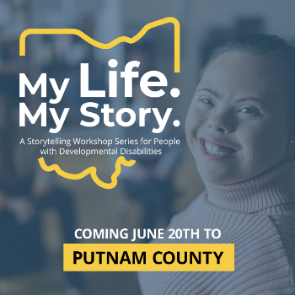*

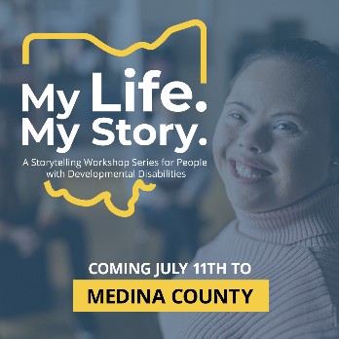 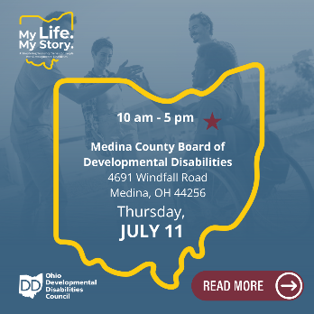

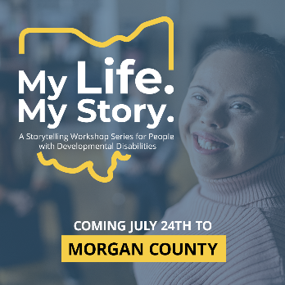 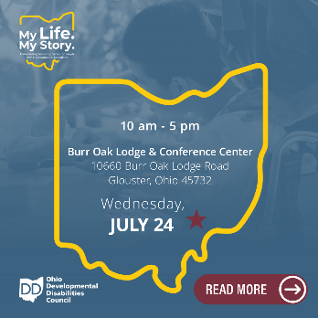

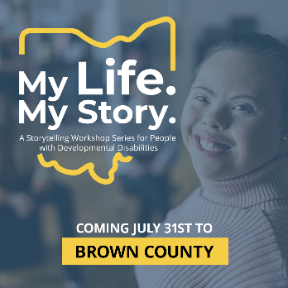 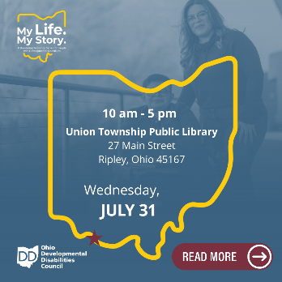

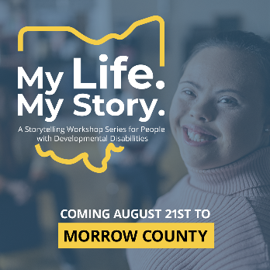 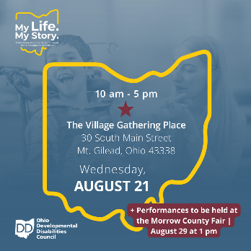

**Facebook and LinkedIn graphic**

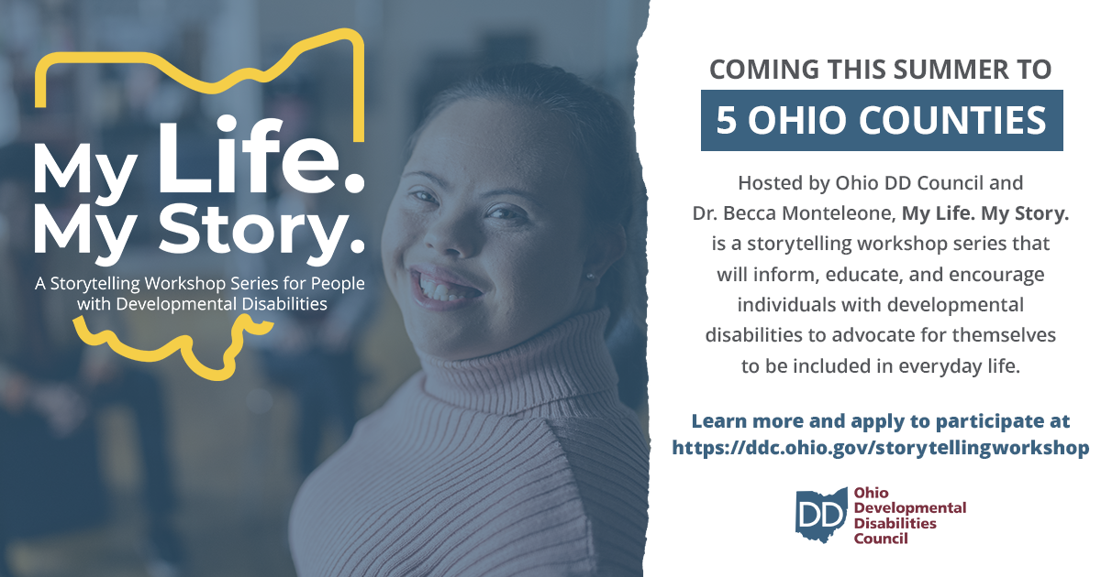

**Workshop logos**

This project is supported by the Ohio Developmental Disabilities Council, under grant number 2301OHSCDD from the Administration for Community Living (ACL), U.S. Department of Health and Human Services (HHS), as part of a financial assistance award totaling $2,846,720 with 96% funded by ACL/HHS and 4% funded by the State of Ohio. Grantees undertaking projects with government sponsorship are encouraged to express freely their findings and conclusions. Points of view or opinions do not, therefore, necessarily represent the official views of, nor an endorsement, by ACL/HHS, or the U.S. Government.