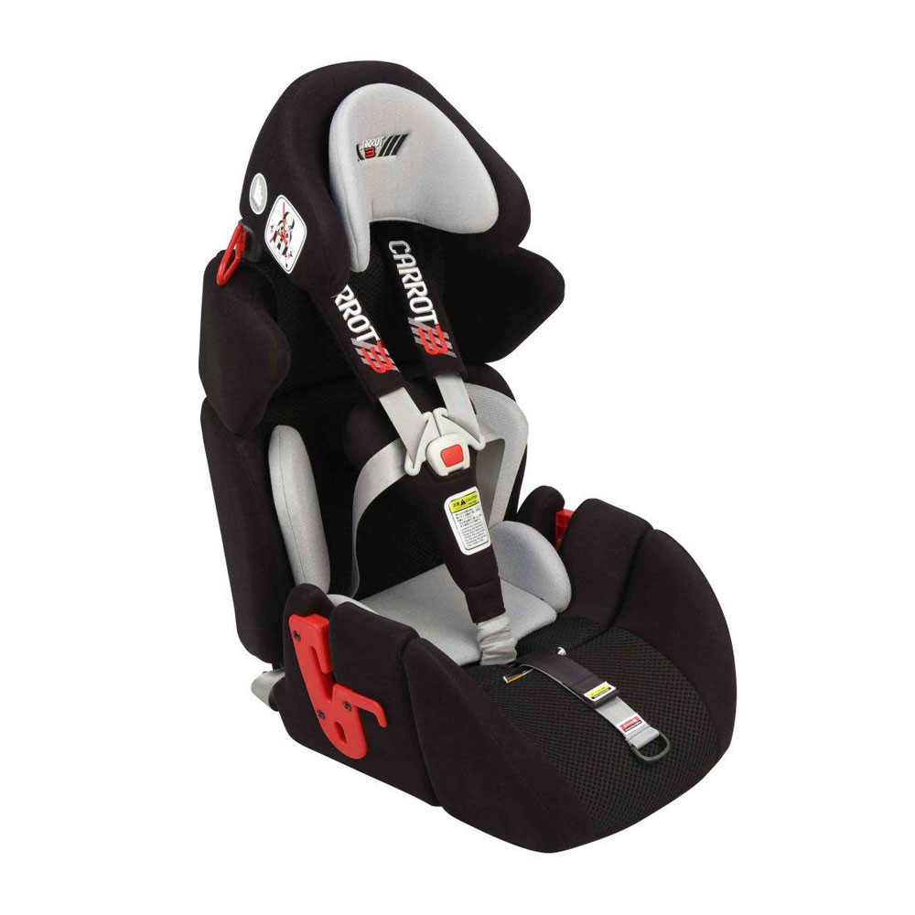

The **Medifab Carrot 3000 car seat** is a comprehensive special needs booster system with various accessories and multi-adjustable features to allow longer use during the child or teen’s life. The Carrot 3000 caters for safety and the importance of keeping the child in a supported posture for travel.

**Maximum seat depth:**40cm

**Minimum seat depth:**25cm (or 28cm)

**User age range:**3-15 years

**User weight range:**13.6kg-49kg

 It has been designed and built to provide optimal positioning and safety for children with insufficient head, trunk, and pelvic stability.

The Carrot 3000’s ‘body contouring’ design holds the child in a centered and secure position to ensure optimum support and safety during transport. The ergonomic head support provides added positioning and security.

Safety is also at the forefront of the Carrot 3000’s design. In the event of a collision, side-impact and centrifugal forces are reduced by the ergonomic wrap-shape head support and extendable Shoulder Protector Wings (an optional safety device for a child with seating height more than 65 cm), holding the body to protect child from side impacts or centrifugal forces. Shock absorbing F1-comfort pads on the shoulder straps add superior support and comfort.

The Carrot 3000 is equipped with ISOFIX Latch Connectors. This is the safest way to secure the Carrot 3000 to your vehicle seat; however the latch installation is only possible if your car is equipped with latch anchors. Consult your car manual and ask your distributor for proper ISOFIX Latch installation.

This is available for pickup in Coshocton, OH It is a year and a half old, it is in perfect condition. Has never been used still in original box.