

**\*\*\*\*\*\*\*\*\*\*\*\*\*\*OPRA LEGISLATIVE ALERT\*\*\*\*\*\*\*\*\*\*\*\*\*\*\***

**January 16, 2015**

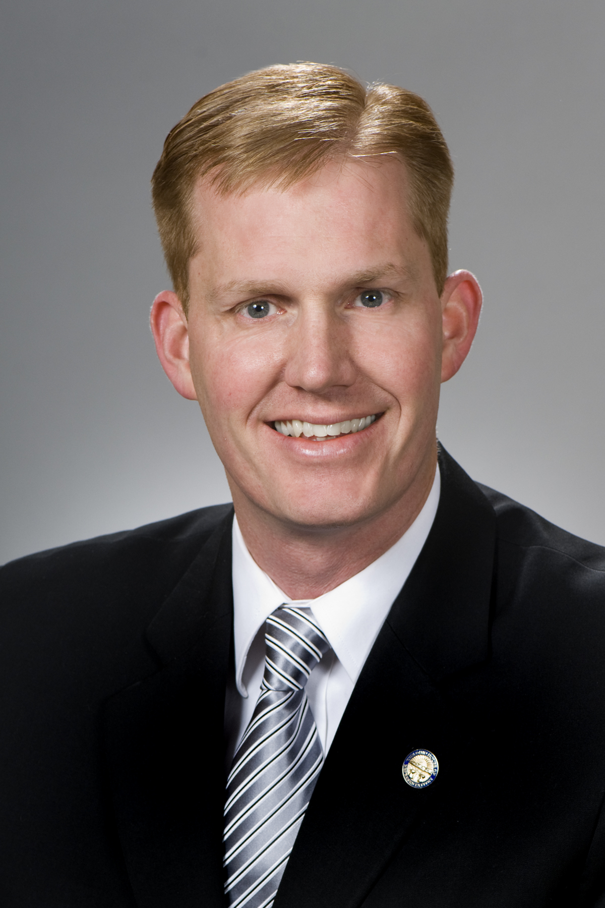***Rep. Ryan Smith named House Finance Chair*** - Long rumored to be in line for the coveted position, Rep. Ryan Smith was officially named to chair the influential House Finance & Appropriations Committee. The announcement from Speaker Cliff Rosenberger (R-Clarksville) marks the first key chair appointment of the 131st General Assembly. "I can think of no one more experienced, more knowledgeable or more honorable to serve as chair of this important committee," Speaker Rosenberger said in a statement. "The amount of work and oversight that takes place in Finance Committee is unmatched and I look forward to what we will achieve in the coming months. Rep. Smith is up to the task and I know he will guide the budget process to ensure that Ohio is made better for its citizens through common-sense initiatives and responsible financial decision-making." Mr. Smith (R-Bidwell), a an appointee in the 129th General Assembly who has now been elected twice to southern Ohio's 93rd House District, served on the Finance Committee last year and also chaired a subcommittee of Health focused on opiate addiction issues. In his new position, he will lead the House's review of Gov. John Kasich's third two-year budget proposal, which is due to the legislature in early February. "I am honored to be appointed as the Finance and Appropriations chairman and I look forward to working with our partners across the state to pass a budget bill that works best for Ohio," Rep. Smith said. "The upcoming budget will provide the state the tools necessary to continue its momentum and will support our job growth agenda." - Gongwer

***The two House leaders jointly announced the slate of committee chairs and ranking minority party members on Monday, January 12, 2015*** - The committee structure includes a new Community & Family Advancement panel to be chaired by Rep. Tim Derickson (R-Oxford). The total number of committees increased by two, as the former Agriculture & Natural Resources Committee was split into an Agriculture & Rural Development Committee and an Energy & Natural Resources Committee. "In order to continue our momentum and to build upon our successes from the last General Assembly, I'm pleased to announce a solid, new committee structure for the 131st General Assembly," Speaker Cliff Rosenberger (R-Clarksville) said in a release. "Along with the addition of two new standing committees, we have added the Minority Affairs Subcommittee, which builds the framework for further bipartisan collaboration. I know all chairs, vice chairs and ranking members stand ready to lead and to guide the pathway of legislation that makes sense for Ohio." Minority Leader Fred Strahorn (D-Dayton) said, "With this committee leadership in place, we have the right people in the right positions to take on the important issues facing Ohioans.

These members have a strong, diverse and focused mix of talents and abilities that will contribute to a higher quality of life for everyday Ohioans. We are in a stronger position to make sure that all Ohioans can feel the promise and opportunity of our state." In a notable development, a black Democrat - Rep. Kevin Boyce (D-Columbus) - was named to chair the Minority Affairs Subcommittee of Community & Family Advancement. It's unusual for speakers to hand the reins of a panel, even a subcommittee, to a member of the opposite party. "The Speaker and Leader Strahorn have been discussing minority affairs issues for the last several weeks and the Speaker wanted to put his words into action that this is not a partisan issue," spokeswoman Brittany Warner said. "This is a very important policy area for Speaker Rosenberger, and it's important to him that the committee process be collaborative and unified in order to ensure that the state legislature is helping to promote upward mobility for all Ohioans."

The House committees and leading members are: **Agriculture & Rural Development**: • Chair: Rep. Brian Hill (R-Zanesville) • Vice chair: Rep. Tony Burkley (R-Payne) • Ranking member: Rep. John Patterson (D-Jefferson) **Armed Services, Veterans Affairs and Public Safety:** • Chair: Rep. Terry Johnson (R-McDermott) • Vice chair: Rep. Rick Perales (R-Beavercreek) • Ranking member: Rep. Hearcel Craig (D-Columbus) **Commerce & Labor:** • Chair: Rep. Ron Young (R-Leroy Township) • Vice chair: Rep. Anthony DeVitis (R-Green) • Ranking member: Rep. Michele Lepore-Hagan (D-Youngstown) **Community & Family Advancement:** • Chair: Rep. Tim Derickson (R-Oxford) • Vice chair: Rep. Tim Ginter (R-Salem) • Ranking member: Rep. Stephanie Howse (D-Cleveland) **Community & Family Advancement Subcommittee:** • Minority Affairs (Chair: Rep. Kevin Boyce, D-Columbus) **Economic & Workforce Development:** • Chair: Rep. Nan Baker (R-Westlake) • Vice chair: Rep. Mark Romanchuk (R-Ontario) • Ranking member: Rep. Kent Smith (D-Euclid) **Education:** • Chair: Rep. Bill Hayes (R-Harrison Township) • Vice chair: Rep. Andrew Brenner (R-Powell) • Ranking member: Rep. Teresa Fedor (D-Toledo) **Energy & Natural Resources:** • Chair: Rep. Al Landis (R-Dover) • Vice chair: Rep. Christina Hagan (R-Alliance) • Ranking member: Rep. Sean O'Brien (D-Bazetta) **Finance & Appropriations:** • Chair: Rep. Ryan Smith (R-Bidwell) • Vice chair: Rep. Kirk Schuring (R-Canton) • Ranking member: Rep. Denise Driehaus (D-Cincinnati) **Finance and Appropriations Subcommittees**: • **Agriculture, Development and Natural Resources** (Chair: Rep. Andy Thompson, R-Marietta; Ranking member: Rep. Sean O'Brien, D-Bazetta) • **Health and Human Services** (Chair: Rep. Robert Sprague, R-Findlay; Ranking member: Rep. Emilia Sykes, D-Akron) • **Higher Education** (Chair: Rep. Mike Duffey, R-Worthington; Ranking member: Rep. Dan Ramos, D-Lorain) • **Transportation** (Chair: Rep. Cheryl Grossman, R-Grove City; Ranking member: Rep. Alicia Reece, D-Cincinnati) • **Primary and Secondary Education** (Chair: Rep. Bob Cupp, R-Lima; Ranking member: Rep. Debbie Phillips, D-Albany) **Financial Institutions, Housing and Urban Development**: • Chair: Rep. Lou Terhar (R-Green Township) • Vice chair: Rep. Steve Hambley (R-Brunswick) • Ranking member: Rep. Christie Bryant Kuhns (D-Cincinnati) **Government Accountability & Oversight:** • Chair: Rep. Tim Brown (R-Bowling Green) • Vice chair: Rep. Bill Blessing (R-Colerain Township) • Ranking member: Rep. Kathleen Clyde (D-Kent) **Health & Aging:** • Chair: Rep. Anne Gonzales (R-Westerville) • Vice chair: Rep. Steve Huffman (R-Tipp City) • Ranking member: Rep. Nickie Antonio (D-Lakewood) **Insurance:** • Chair: Rep. Robert Hackett (R-London) • Vice chair: Rep. Mike Henne (R-Clayton) • Ranking member: Rep. Heather Bishoff (D-Blacklick) **Judiciary:** • Chair: Rep. Jim Butler (R-Oakwood) • Vice chair: Rep. Nathan Manning (R-North Ridgeville) • Ranking member: Rep. Michael Stinziano (D-Columbus) **Local Government:** • Chair: Rep. Marlene Anielski (R-Walton Hills) • Vice chair: Rep. Scott Ryan (R-Granville Township) • Ranking member: Rep. John Rogers (D-Mentor-on-the-Lake) **Public Utilities:** • Chair: Rep. Tim Schaffer (R-Lancaster) • Vice chair: Rep. Kristina Daley Roegner (R-Hudson) • Ranking member: Rep. Mike Ashford (D-Toledo) **Rules & Reference:** • Chair: Rep. Ron Amstutz (R-Wooster) • Vice chair: Speaker Clifford A. Rosenberger (R-Clarksville) • Ranking member: Minority Leader Fred Strahorn (D-Dayton) **State Government:** • Chair: Rep. Ron Maag (R-Lebanon) • Vice chair: Rep. Stephanie Kunze (R-Hilliard) • Ranking member: Rep. Ronald Gerberry (D-Austintown) **Transportation & Infrastructure:** • Chair: Rep. Terry Boose (R-Norwalk) • Vice chair: Rep. Doug Green (R-Mt. Orab) • Ranking member: Rep. Michael Sheehy (D-Oregon) **Ways & Means:** • Chair: Rep. Jeff McClain (R-Upper Sandusky) • Vice chair: Rep. Gary Scherer (R-Circleville) • Ranking member: Rep. Jack Cera (D-Bellaire) The complete committee assignments will be finalized at a later date. -Gongwer

***Medicaid expansion is expected to remain a contentious issue in the upcoming budget cycle*** – New data and program changes could mitigate some concerns lawmakers previously cited in opposing the policy. Having affirmed plans to continue expanded Medicaid coverage in the new biennial budget, Kasich administration officials have undertaken efforts to promote the controversial policy's positive impacts to the General Assembly, as well as to pursue policies focused on "personal responsibility."

While House Republicans, who stripped expansion from the governor's previous budget, have largely remained coy on its chances in the new legislative session, some have expressed interest in efforts that encourage Ohioans to move off the entitlement. Newly elected House [**Speaker Cliff Rosenberger**](http://www.gongwer-oh.com/programming/bio.cfm?nameid=133602&locid=2) (R-Clarksville) told reporters this week that while he remains opposed to Medicaid expansion, there should be a focus on "mobility" and policies to help Ohioans "lift them out of poverty." Mr. Rosenberger, who was removed from the Controlling Board last session prior to the panel's approval of Medicaid expansion funds, added that the legislature needs to look for ways to make the program "more efficient and more effective." "I'm about mobility and making sure that these folks are able lift themselves up and move themselves in a direction that can be helpful," he said, adding that lawmakers "have to ensure that it's reformed, that's it's right, that it's going to work and that, most importantly, they're helping (Ohioans) move on." The speaker said the caucus needs to discuss its position on the issue and whether or not it would be brought to the floor if included in the governor's budget. "We are going to have that conversation and I imagine that we'll see that this is set up in our plan as we move forward in a strategic way," he said. "It's no easy lift, by the way, and it's something we have to have a long-term conversation on for the people of Ohio." [**Rep. Barbara Sears**](http://www.gongwer-oh.com/programming/bio.cfm?nameid=102602&locid=2) (R-Sylvania), who's expected to chair the Joint Medicaid Oversight Committee in 2015, said continuing the current policy will have legs in the new General Assembly if she has anything to do with it. "I'm certainly going to be pressing the issue," she said in an interview. "I think it's critical from a financial position for the state of Ohio to maintain the expansion. I think it's the smartest use of our taxpayer dollars to fund health care for those that need it in a manner that we can measure it and we can look at and demand high outcomes."

Rep. Sears, who was in the minority of her caucus in vocally supporting the issue during the last budget, said she believes an added focus on helping Ohioans move off the program could make continued expansion more palatable for some of the policy's previous opponents. "I think we will have some folks oppose it on philosophical basis, without even bothering to learn it or understand it...pick a segment of government or any subject matter and you have people who will just simply be opposed to it just because of the sound bite," she said. "But I think there are a lot of members that are truly committed to not just talking about improving peoples' lives, but actually wanting to figure out how to do it. And you can't do it - you cannot do it - without the health care component of it. "If you strip Medicaid away, then we go back to the days of throwing millions and millions of dollars into a shredder where we're not meaningfully impacting the health of Ohioans, we're not measuring, we're not demanding good outcomes." Rep. Sears added that while she believes it will be harder for lawmakers "to say 'no' to something that's already in place," the caucus would likely reject continued expansion unless it's presented with concrete evidence to the contrary. Supporters of the policy, therefore, must "document that it is in fact doing what we said it was going to do and it's doing it in a way that's cost effective," she said.

According to the Department of Medicaid, more than 450,000 newly eligible Ohioans had come onto the expanded health entitlement through November. Department of Mental Health & Addiction Services Director Tracy Plouck, in promoting the policy, told lawmakers that at least 17,200 newly eligible individuals had accessed Medicaid behavioral health benefits due to expansion. Pointing to these individuals as the "real flesh and blood progress" of the policy, she argued that unlike the previous budget cycle, the administration would be able to compare its initial estimates and the actual experiences. ODM Director John McCarthy, meanwhile, touted the department's and its sister agencies' success in slowing the annual rate of program growth without cutting the package of services in his preliminary budget request cover letter. A November JMOC report on the Medicaid inflation projected that per member per month rates will see a growth trend of 1.6% to 2.9% in fiscal year 2016 and 2.2% to 4.5% in FY17. The Medicaid director must limit growth in monthly member costs across the program to 2.9% in FY16 and 3.3% FY17 under statute, the report notes.-Gongwer

***ABLE Act Passed By Congress, Signed Into Law* -** The Achieving a Better Life Experience (ABLE) Act cleared Congress on Tuesday as part of a package of tax extenders that the House sent to the Senate last week. The measure passed the upper chamber easily in a vote of 76 to 16 and was sent to the President for signature. ANCOR applauds the bill's passage, and appreciates the overwhelming bipartisan commitment Congress has demonstrated to people with disabilities by supporting the ABLE Act.

*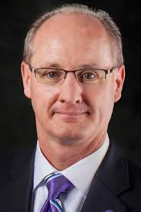****Ohio Legislators Visit OPRA District 2 Meetings*** - At OPRAs’ November District 2 meeting State Senator Bill Beagle (R-representing Miami, Preble and parts of Montgomery County pictured to the right) visited with a large and diverse group of OPRA members at the administrative offices of Choices in Community Living in Dayton. Senator Beagle graciously stayed a full two hours and listened to all the members present about the good things happening in our system and our current challenges. Workforce shortages, low wages for DSPs and front line supervisors, and the challenges and opportunities inherent in the new CMS rules were discussed in detail.

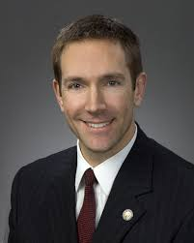Following up the November success District 2 hosted State Representative Jim Butler In December. Representative Butler (R-representing the eastern portion of Montgomery County pictured to the left) met and listened to visiting members outline the current challenges of providing service in Ohio’s developmental disabilities system. Similar to November’s meeting members highlighted workforce, wages, CMS rules and the current structure of Ohio’s DD system as challenges and opportunities. Representative Butler was considerate in providing us his candid assessment of Medicaid, its inherent limitations and his belief in the possibility of reform. He indicated that legislation would be introduced in early 2015 that would offer a blueprint for fundamental reform. OPRA would like to thank Choices in Community Living Executive Director Tom Weaver for hosting both meetings and Senator Bill Beagle and Representative Jim Butler for their kindness and generosity in taking time out of their busy calendars to visit and listen attentively to our members.

***A Benefit To Businesses, Not A Cost -*** Health Insurance Giant Aetna Is Raising Wages For Its Lowest Paid WorkersA common refrain from some in the business community who oppose a minimum wage increase is that higher wages for low-income workers will be costly enough to either force businesses to raise prices for consumers or cause them to lay off workers. Aetna, a Fortune 100 company with nearly 50,000 employees, just made a decision that sharply rebukes that argument. The health insurance giant has announced [it is raising the minimum wage for its workers to $16 per hour](http://app.mx3.americanprogressaction.org/e/er?s=785&lid=164734&elq=cd2b6ea0a4e74085a23c075bf417faad). In doing so, the company specifically cited the business benefits, not the costs, of the move.The raises, which come on the heels of similar wage increases by big name companies like [Starbucks](http://app.mx3.americanprogressaction.org/e/er?s=785&lid=164735&elq=cd2b6ea0a4e74085a23c075bf417faad) and [Gap](http://app.mx3.americanprogressaction.org/e/er?s=785&lid=158630&elq=cd2b6ea0a4e74085a23c075bf417faad), are significant. An estimated [5,700 Aetna employees](http://app.mx3.americanprogressaction.org/e/er?s=785&lid=164736&elq=cd2b6ea0a4e74085a23c075bf417faad) will get a pay bump — an 11 percent increase on average and up to 33 percent for some workers. And it won’t be free: the company expects the move to cost an estimated $14 million this year, and $25.5 million in 2016.

Nonetheless, Aetna CEO Mark T. Bertolini laid out the business case for raising the wages of low-income employees. Here are a few of the reasons he cited, in an [interview to the Wall Street Journal](http://app.mx3.americanprogressaction.org/e/er?s=785&lid=164734&elq=cd2b6ea0a4e74085a23c075bf417faad):

* **Adapting the company for the future:** “We’re preparing our company for a future where we’re going to have a much more consumer-oriented business.”
* **Workforce development:** “[Aetna wants] a better and more informed work force.”
* **Reducing turnover costs:** According to the Wall Street Journal, “Mr. Bertolini said Aetna hopes to reduce its turnover costs of around $120 million a year and improve the quality of job prospects and the engagement of workers who interact with consumers and health-care providers.”

And then there is a broader reason that factored into Mr. Bertolini’s decision: “It’s not just about paying people, it’s about the whole social compact,” Mr. Bertolini said, adding, “Why can’t private industry step forward and make the innovative decisions on how to do this?”

**BOTTOM LINE:** The decision by Aetna to raise wages for their low-income employees demonstrates one of the business imperatives for raising wages. Simply put, investing in workers pays off for companies in more ways than one. We’d thank Aetna for its decision, but we know that the company didn’t make this move because of groups like ours. It made the move because it cares about its workers, and it cares about its bottom line. **Jan 13, 2015** | By [CAP Action War Room](http://app.mx3.americanprogressaction.org/e/er?s=785&lid=156942&elq=cd2b6ea0a4e74085a23c075bf417faad)