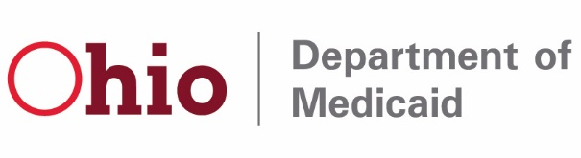

IMPORTANT UPDATE: Advanced payments to be recouped beginning December 22
Dear Medicaid Provider,
In mid-October, Ohio Department of Medicaid providers experienced intermittent connectivity interruptions between the new Provider Network Management (PNM) module and Medicaid Information Technology System (MITS). Out of extreme caution, and to minimize any disruption in funding, the agency issued advance payments to providers that aligned with our normal adjudication cycle.
Advanced payments were applied to any provider that billed through the portal using direct data entry. Impacted entities could include independent providers, private ICF-IIDs, or any group practitioners and providers that bill using direct data entry.
Historical payment data was used to calculate the advance, and any claims submitted successfully between October 1-7 that were set to be paid on October 14 were deducted from the advance payment.
Ohio Medicaid is beginning the recoupment process on these advanced payments. Below is an overview of the method:
- Providers that received an advance payment on October 14, 2022, will see the recoupment on the December 22, 2022, payment. Remittance advices will properly notate the advance payment recoupment, so it is distinguished from the standard claims payment. The recoupment will continue to offset in future payment cycles until it is recovered in full.
- Payments will be made to providers via EFTs or mailed paper checks, consistent with the provider’s normal payment method. If a provider’s recoupment exceeds or equals the claims payments set to be issued on December 22, 2022, a payment will not be received.
We recommend you notify your Accounts Receivable department of the transactions that will appear on the remittance advice and received with the December 22 payment. This will ensure the accounting systems will be ready to recognize these transactions when they are processed that financial cycle.
We appreciate your patience throughout our transition to Ohio Medicaid’s modernized enterprise system. If you have additional questions, please contact Medicaid@medicaid.ohio.gov.

