1. Login to the Ohio Department of Medicaid homepage at: <http://medicaid.ohio.gov/>. Click on Providers at the top. You will see a screen with a large blue box to the right that says MITS PORTAL. Click on this box. You’ll see the screen below. **Click Here to Login**

# 

1. **Enter a User ID and Password**

Read the User agreement, check the box, and select **Login.**

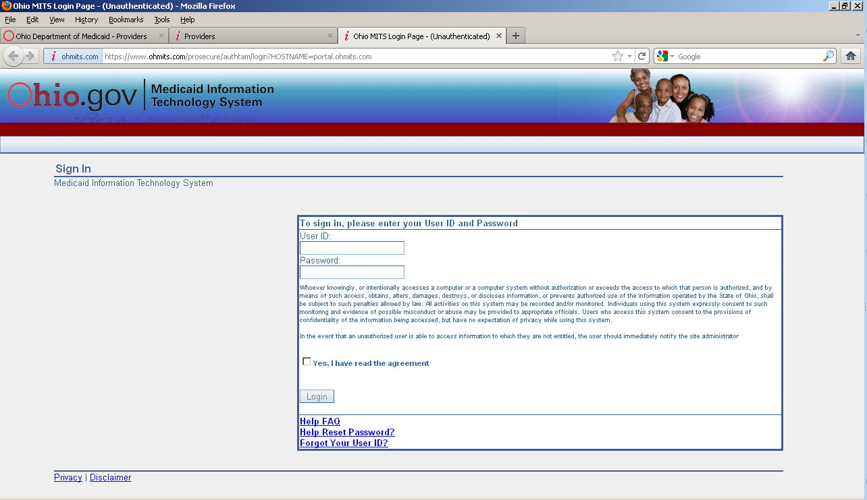

1. You will see the screen below. Click on Providers, demographic maintenance, Location Name Address.

* Under the blue Provider Information bar, verify your **Medicaid Provider ID**.
* Under the blue Location Name Address bar, select HOME OFFICE, and verify the following information: **Name (of provider),** **Address, City, State, Zip or Zip + 4, and Phone.** Add your **contact name** in the box indicated.

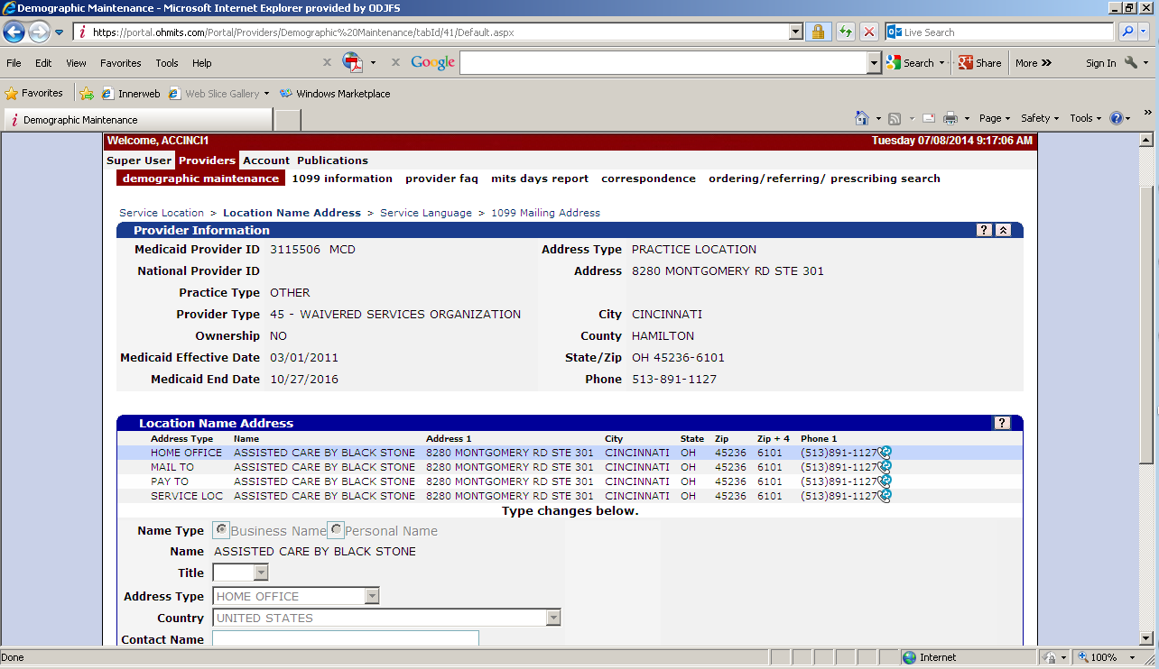

1. Scroll to the bottom of the screen. Enter and confirm your **E-mail** address. Select Save. Your ARCS Username will be sent to this email address.

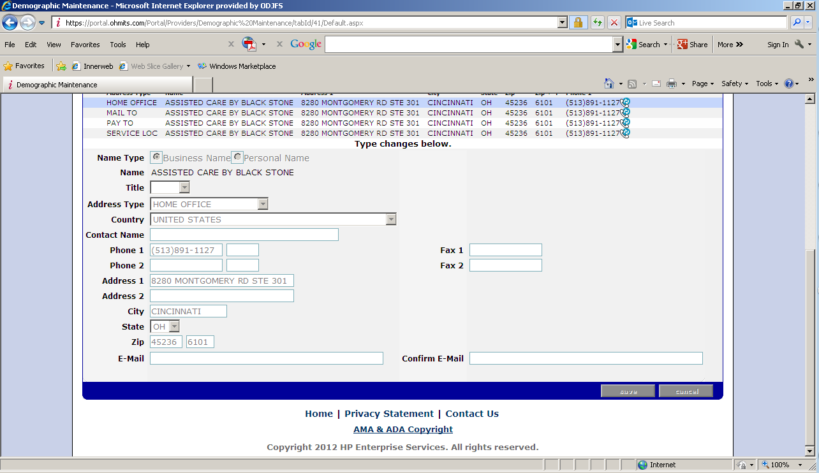

Once you have verified that your MITS information is current and complete, you can close out of MITS. If you need assistance, please contact the **MITS help line number: 1-800-686-1516. To speak with a support agent, select the following options: 3,3,3,1,1,3,0 (make sure you wait until the talking starts again), then select 0.**