Hierarchy of hazard control

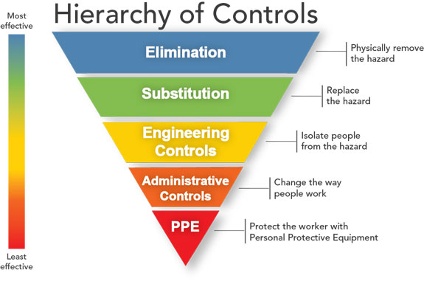One of the keys to a safe workplace is evaluating, identifying, and eliminating hazards. There is a step-by-step process available called the “Hierarchy of Controls”. The hierarchy of controls can be an effective tool to reduce the frequency and or the severity of injuries at your workplace and ultimately help reduce workers’ compensation costs. This 5-step process was created in the 1950’s and is still used today.

The chart identifies the preferred way to control a hazard from the most effective which is elimination. Then the order follows the next preferred method using Substitution, then Engineering Controls, Administrative Controls then the least effective, Personal Protective Equipment (PPE).

Let’s take a deeper look into each “Hierarchy of Control”.

1. Elimination – This is where the hazard is removed. This can be achieved by either changing the work process like removing a sharp or heavy object. As you can see this is the preferred control method because it completely removes the hazard from the employee.
2. Substitution – The second preferred method relies on substituting the hazard with a safer alternative. For example, eliminating a chemical by using those made from eco-friendly or plant-based products. If you choose substitution be sure to review and understand the new potential risks of the product, if there are any.
3. Engineering Controls – This option prevents or reduces the hazard from coming into contact with the employee. Some examples of engineering controls are workspace or equipment modification, creating protective barriers or installing ventilation.
4. Administrative Controls – This option for reducing workplace hazards relies on work practices that reduce duration, frequency, or intensity of the job. Examples include work process training, job rotation, adequate rest breaks or adjusting line speeds.
5. Personal Protective Equipment – The last option which is the least effective is PPE. This is where employees are required to wear items, such as safety glasses, gloves, hearing protection, hard hats, and respirators. Many times, PPE will be used temporarily while other controls are under development.

Before implementing the “Hierarchy of Controls”, you must first identify the hazards. A good way to achieve this is to create a team with areas of expertise (Maintenance, Department Managers/Supervisors, Employees, EHS, etc.). Once the hazards are identified, the team should discuss the “Hierarchy of Controls” and identify the most effective means of dealing with the hazard. Then, work your way down until you find a solution. Remember to periodically re-evaluate the control method as new technology may allow you to implement a more effective control means.

For more information, please contact Sedgwick’s Andy Sawan at 330.819.4728 or andrew.sawan@sedgwick.com