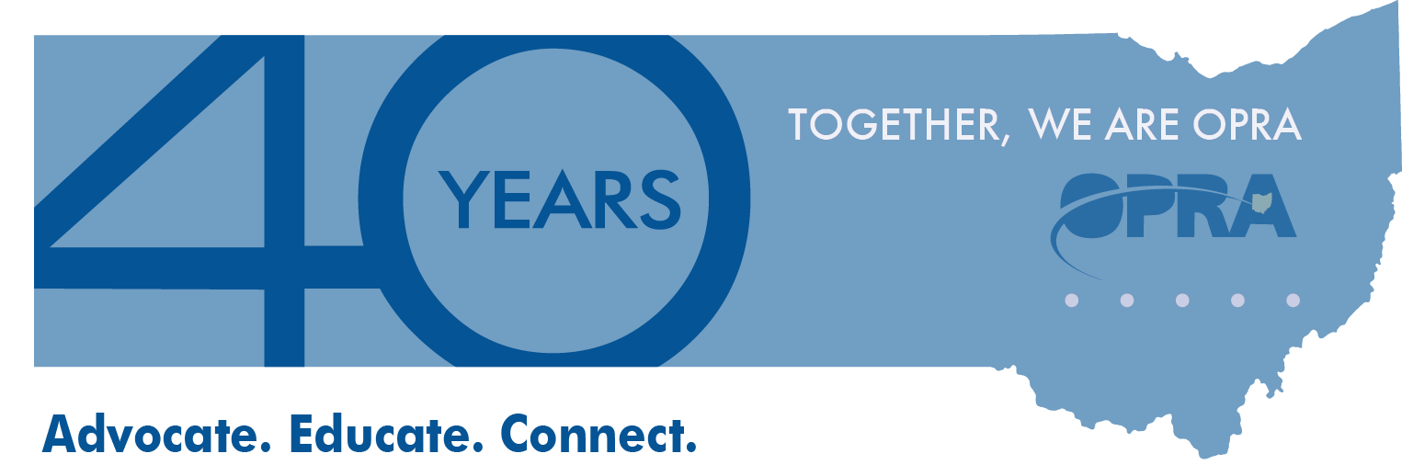

Please Join Us for an OPRA/PAC Reception Honoring

**Representative Robert Sprague**

*State Representative for the 83rd House District*

**Tuesday, October 7th, 2014**

5:30pm - 7:00pm

**The Inn at Ohio Northern University**

401 West College Avenue | Ada, OH 45810

**Suggested Donation: $75 per person**

*Please make checks out to Sprague for State Representative*

*Please RSVP to Jeff Davis at   
614-579-9957 or jdavis@opra.org*