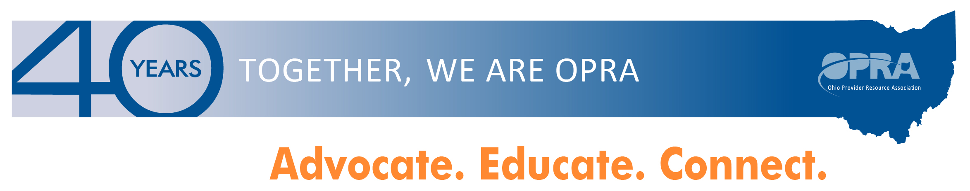
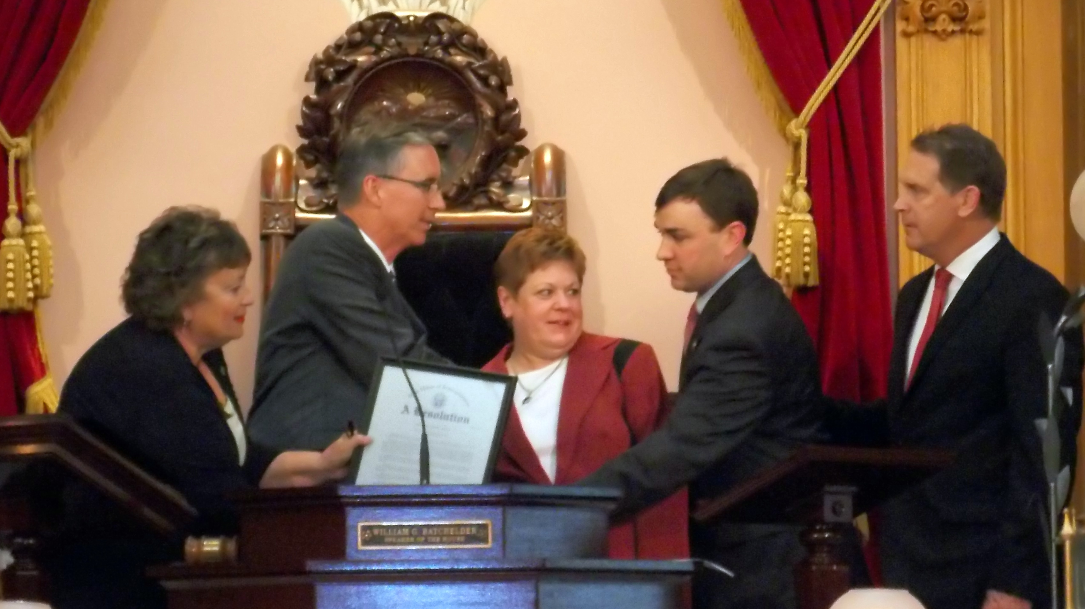
Ohio House Resolution- Representatives Cheryl Grossman and Michael Stinziano sponsor resolution celebrating OPRA’s 40th year! – OPRA President Mark Davis, Board Chair Janice Hall and Director of Government Relations Jeff Davis visited the House Chambers to receive a resolution in recognition of OPRA’s outstanding efforts for over 40 years on behalf individuals with developmental disabilities and the providers who support them.
In this weeks edition:
- Ohio House Resolution - Representative Cheryl Grossman & Michael Stinziano sponsored a House Resolution honoring of OPRA 40th Anniversary
- Disability Rights Ohio Meeting Summary – May 27, 2014
- Overview DODD Transition Plan Committee Meeting Minutes May 27, 2014
- Companionship Exemption Letter to the Labor Secretary RE: Implementation of the Final Rule, “Application of the Fair Labor Standards Act to Domestic Service,”
- OPRA Assists in Coordinating Stakeholder Support for Automated Background Checks (RAPBACK) Amendment in Mid Biennial Budget (HB483)
- Ancor names Mohamed Conde as 2014 Direct Service Support Professional of the Year
- OPRA hires new Policy Analyst
- CCHS to replace Executive Director after 34 years
- Save The Date


Job Bank
Click here for details

Upcoming Meetings
Click here for details
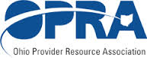
Fall Conference October 21 & 22, 2014
Click here for details

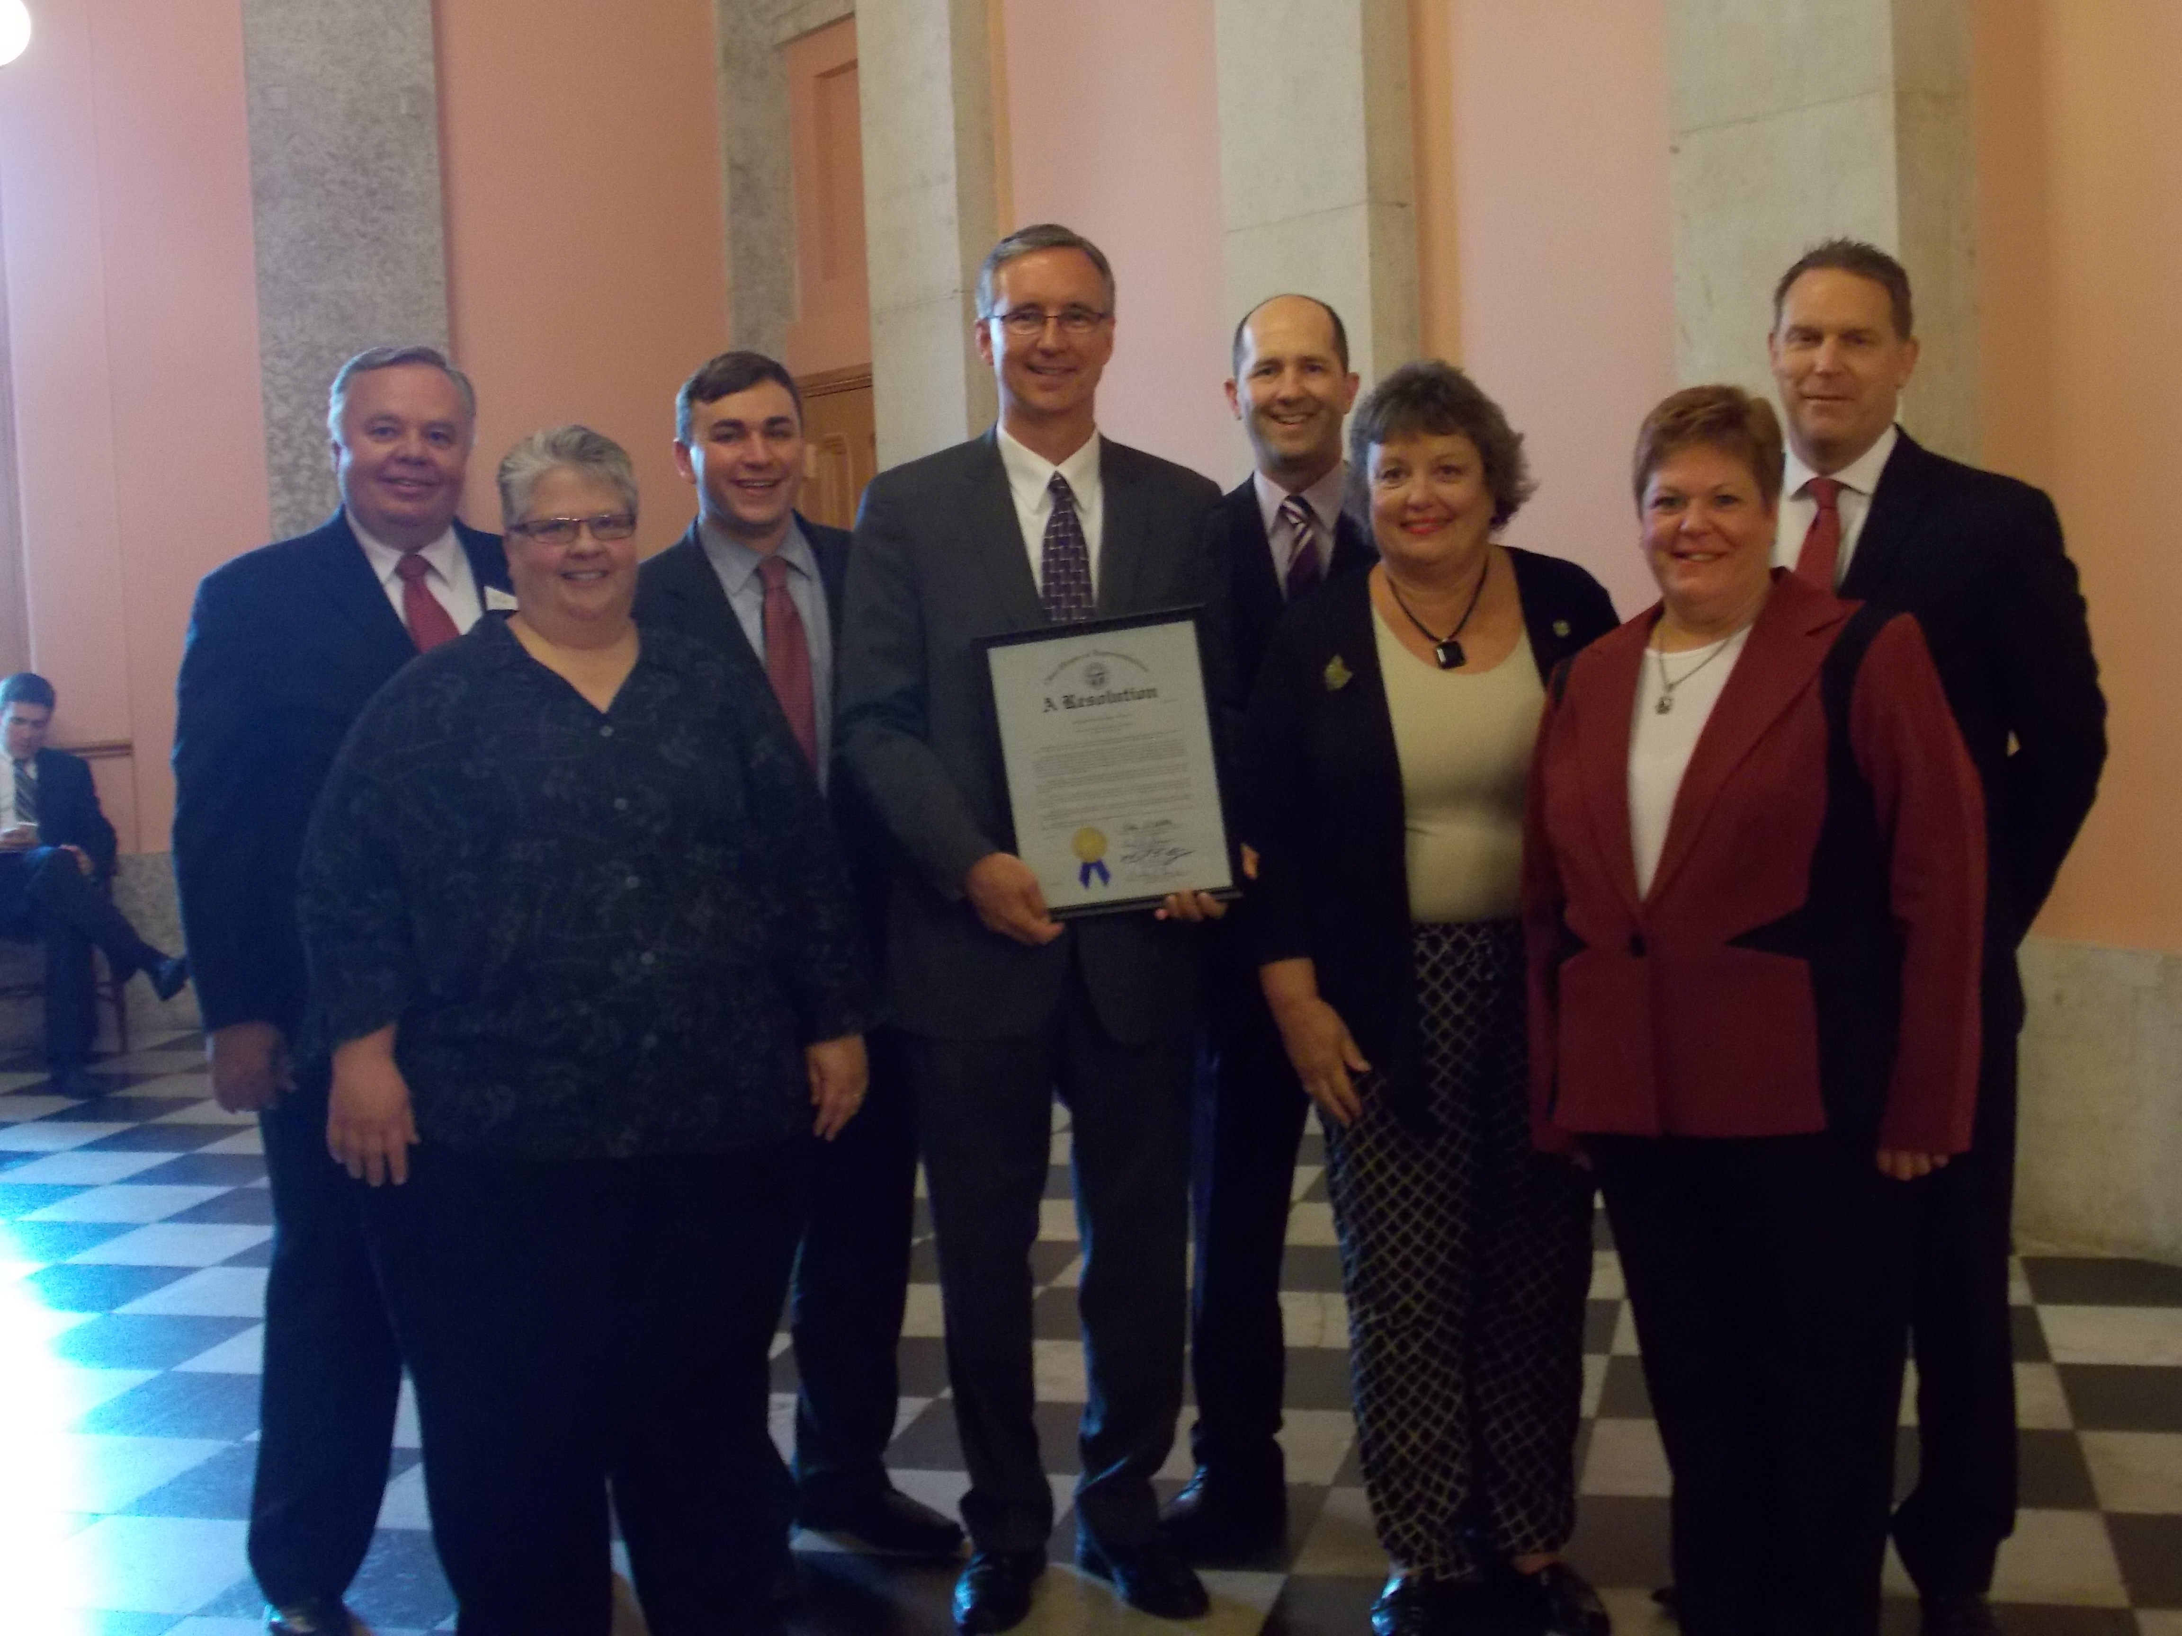
In accepting the resolution, OPRA President Mark Davis thanked the sponsors and all House members for their current and historic support of OPRA efforts and reminded all in the room that it is really about the individuals served.

“Individuals with disabilities want the same life of fulfillment as everyone else. And it is our responsibility as providers to help them achieve that.” (Bottom pictured left to right) Gary Tonks (ARC), Teri Derry (OPRA), Rep. Michael Stinziano, Mark Davis (OPRA), Mike Toman (OPRA Lobbyist), Rep. Cheryl Grossman, Janice Hall (OPRA Board Chair) & Jeff Davis (OPRA)

Disability Rights Ohio Meeting May 27, 2014 - Several members of OPRA and staff met with Disability Rights Ohio (DRO). DRO requested the meeting and asked OPRA for input into DRO's "investigation of the segregated nature of the service system for individuals with developmental disabilities, both in residential and day/employment services.” For this investigation, DRO is collaborating with attorney and law professor Sam Bagenstos (formerly a Principal Deputy Assistant Attorney General in the Civil Rights Division of the DOJ) and with attorneys Cathy Costanza and Sam Miller of the Center for Public Representation in Massachusetts, who have extensive experience in evaluating and litigating integration claims.” Click here for more details
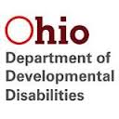
New CMS HCBS Regulations and DODD Transition Plan Committee Meeting
The new CMS HCBS regulations will impact Ohio’s DD and aging waiver systems. The regulations cover the definition of “community”, clarifying what will be eligible for HCBS Medicaid reimbursement and what will not. The regulations also include a requirement for “conflict-free case management” and allow states to combine waiver target populations (such as combining DD and aging populations). OPRA has had several conversations with CMS about the intent of these new regulations. We will continue to work with CMS, ANCOR and other organizations to determine the possible impacts on Ohioans.
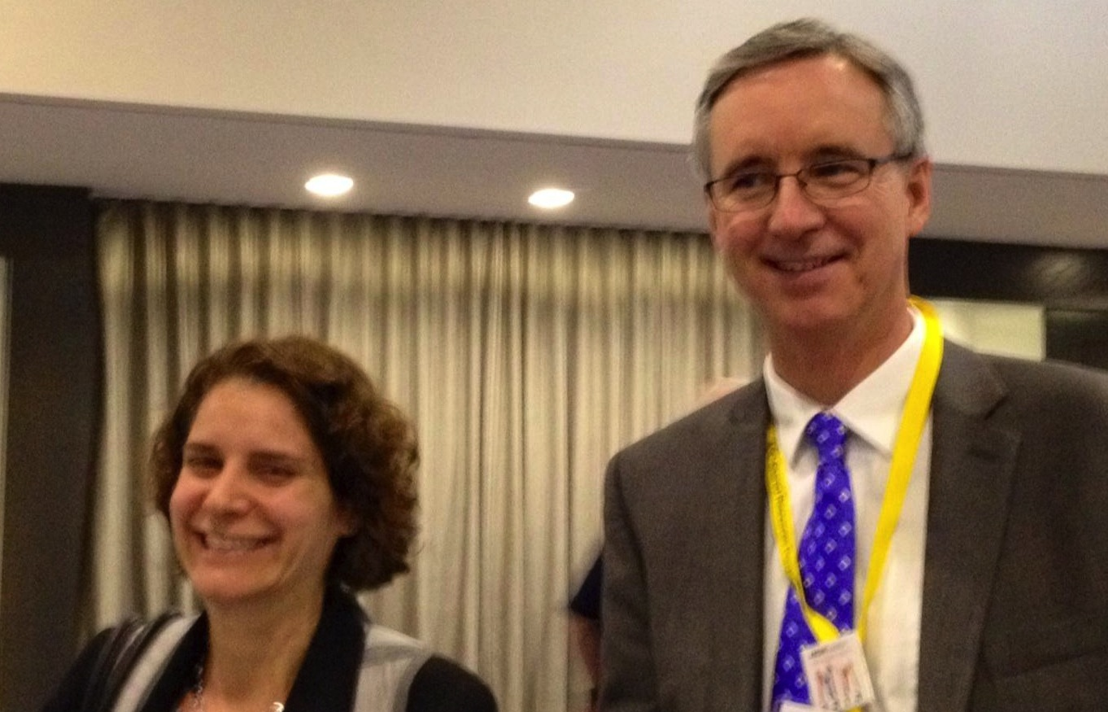
The DODD Transition Plan Committee’s purpose will be to act like a steering committee/advisory board on DODD’s Transition Plan to address the new Centers for Medicare and Medicaid Services (CMS) Regulation that defines Home and Community Based Service (HCBS) Settings. OPRA representatives are Board Chair, Janice Hall and President, Mark Davis. This rule became effective on March 17, 2014, but Ohio has approximately a year to submit a Transition Plan to CMS. Some of the questions the group should look at are, “How will the new regulation affect Ohio?” and “How will it play out in real-life situations?” This group will need to make a judgment about what all of this means, and to look at what the opportunities are. (Mark Davis talks with Alison Barkoff, CMS/DOJ/DOL, about the new CMS HCBS regulations)
Click here for more details


Companionship Exemption Letter to the Labor Secretary RE: Implementation of the Final Rule, “Application of the Fair Labor Standards Act to Domestic Service,” RIN 1235-AA05
A number of national organizations recently sent US DOL Secretary Perez a letter requesting more time to comply with the new companionship exemption rule. Here is their letter:
“The undersigned organizations are writing to respectfully request that the Department of Labor (DOL) extend the implementation period for the final rule, “Application of the Fair Labor Standards Act to Domestic Service” (RIN 1235-AA05). We request that the DOL extend the effective date for compliance for an additional 18 months. We commend the DOL for working collaboratively with stakeholders throughout the rulemaking process, as well as for continuing to actively engage in dialogue to develop guidance, educate, and assist in implementation of the rule. We appreciate the DOL’s recognition that a standard 30 or 60-day implementation period would be impractical for this rule. We are concerned that the current effective date of January 1, 2015, fails to provide sufficient time for the federal agencies and state partners to understand the policy and operational issues, develop workable solutions on key components and determine an appropriate course of action if a feasible solution cannot be identified…” Click here for more details

OPRA Assists in Coordinating Stakeholder Support for Automated Background Checks (Rap Back) Amendment in Mid Biennial Budget (HB483)
OPRA led a coordinated stakeholder effort to support the inclusion of the Kasich Administration’s amendment to allow private providers to participate in Rap Back. The amendment would allow private providers that are required to perform background checks to participate in BCI&I’s existing “rap back” service, which uses stored fingerprint records to track new criminal information. Once an applicant undergoes an initial fingerprint check, the rap back service provides an automated notification to the employer if that person is later convicted of a prohibited offense, immediately after the court enters the conviction in the system. A coalition of Associations including OPRA, Ohio Health Care Association, Leading Age Ohio, Midwest Care Alliance, The Arc of Ohio and the Ohio County DD Boards Association signed the below linked letter to Conference Committee Conferees and lobbied in concert with the Administration for inclusion.
The amendment was ultimately adopted in Conference Committee and included in the final bill (HB 483) as passed. Given that the proposed amendment will become effective immediately upon the Governor’s signature indication from the Administration and the Attorney General’s Office is that a pilot run of the program for private providers may happen as soon as this summer and full implementation as early as this fall. More to come! Read Letter from Stakeholders Click here for more details

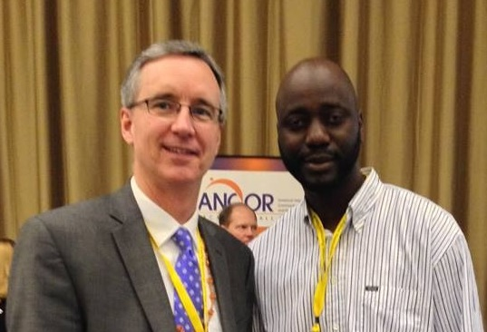
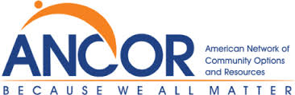
ANCOR Names Mohamed Conde as 2014 Direct Support Professional of the Year for Ohio - Honoring work in support of community living for people with disabilities. Miami, FL. — On May 6, the American Network of Community Options and Resources (ANCOR) recognized MOHAMED CONDE of DUNGARVIN OHIO in Columbus, Ohio as the 2014 Direct Support Professional of the Year for OHIO. “We at Dungarvin are very proud of Mohamed. Mohamed has been a faithful and dedicated employee for 10 years. Mohamed has provided care, support, guidance, and friendship to a young man for several years. As a result of Mohamed’s consistent and loving presence in his life, this young man has progressed from someone who could not be in the community without significant behavioral challenges, to someone who is a social butterfly and is actively engaged in many community activities, including Special Olympics. This award recognizes the commitment Mohamed has shown to support people with disabilities and reflects the quality of services provided by Dungarvin,” said Jennifer Gulley, Dungarvin Senior Director. “The award was presented at the 2014 ANCOR Conference: Beyond the Envelope in Miami, FL.” . (ANCOR’s Ohio DSP of the Year, Mohamed Conde and Mark Davis)
Click here for more details

OPRA hires new Policy Analyst - Mark Watson joined the OPRA team as their Policy Analyst. This new Policy Analyst position replaces the Executive Assistant position. Most recently, Mark worked with Public Children's Service Association of Ohio (PCSAO) where he spent two years assisting their staff and members with research, policy and procedures, member concerns, legislative issues and advocacy efforts for children and families throughout Ohio. Click here for more details

CCHS to replace Executive Director after 34 years -

Columbus Center for Human Services Inc. (CCHS) Board of Trustees is pleased to announce that Becky Sharp will succeed Dona England- Afek as Executive Director on October 1st, 2014. Dona is retiring after 34 years of service and was one of the original founders of the company that provides services to individuals with Developmental Disabilities. Miss Sharp has over 19 years of experience with CCHS. Becky started working as a direct care provider in one of CCHS’s divisions. CCHS has a long history of promoting from within the organization for key positions and fostering talent. Miss Sharp rose to key positions throughout her years of service and was promoted to Waiver Services Administrator in 2012, an executive position. Dave McCarty, Vice President of the Board of Trustees for CCHS says, “Becky was the clear choice. She has extensive experience and knowledge of CCHS internal functions in all divisions. Becky’s leadership abilities and passion for individuals with developmental disabilities and their families make her the right choice to lead CCHS into the future.” Miss Sharp was instrumental in the creation of the Open Door Art Studio, the Career and Activity center, and CCHS’s T-shirt Company, as well as developing a partnership within Union County Board of developmental disabilities. Miss Sharp was also responsible for the expansion of residential services in Franklin, Union and Delaware Counties. Miss Sharp has a Bachelor’s degree in Health Administration with a Minor in Human Resource Management from Wright State University/ Kennedy Western University.
Miss Sharp is excited about the new challenge and is eager to start.


SPECIAL ANNOUNCEMENTS! SPECIAL ANNOUNCEMENTS! SPECIAL ANNOUNCEMENTS!
- We have received confirmation that Director Martin from DODD and Director Miller from OOD will be in attendance to give opening remarks at the OPRA Employment First meeting on June 23. Additionally, Kristen Helling and Joe Kowalski from DODD will be presenting.
If you haven’t emailed your RSVP yet and are interested in attending, please do so now to secure your seat: Jason Umstot, jumstot@opra.org
The new venue is: Monday, June 23, 10am to 2pm at Goodwill Columbus, 1331 Edgehill Rd., Columbus, OH 43212 (Parking is limited so please arrive a little early!)
Refreshments will be served. Advanced orders for boxed lunches will be available for purchase. Info will be provided once we close registration. This is a FREE event for OPRA members.
- Planning at OPRA is underway for the 2014 Fall Conference, October 21 - 22, at the Embassy Suites Hotel in Dublin, Ohio. Please mark your calendars and plan now to attend – as always, it will be a great time!
As you may already know, OPRA Conferences are THE place to network, engage around the latest issues facing providers, find resources to benefit your organization - and learn from first-rate speakers. If there’s a topic you’re keen to learn more about, or a speaker you’ve been told is a "must-hear," please contact me, 614-224-6772. If you yourself are interested in speaking, please submit a proposal!
Proposals are due Thursday, July 3, 2014, so please send in your ideas and proposals as soon as possible.
For a listing of all the Upcoming OPRA Events click here

Mark Davis, President (614) 224-6772 ext.113
Anita Allen, Vice President (614) 224-6772 ext.110
Teri Derry, Director, Training & Professional Development (614) 224-6772 ext.116
Jeff Davis, Director, Governmental Relations (614) 224-6772 ext.114
Jason Umstot, Director, Employment Services (614) 224-6772 ext.117
Emily Bach, Solutions Strategist (614) 224-6772 ext.115
Mark Watson, Policy Analyst (614) 224-6772 ext.111
Pete Thompson, Account/Bookkeeper (614) 224-6772 ext.112 Visit us at http://www.opra.org

