ASSESSMENT TESTING FEEDBACK

Participants

|  |  |
| --- | --- |
| Role | # Surveys |
| SSA | 87 |
| Family/Guardian/Close Friend | 67 |
| Waiver Provider | 39 |
| Person who receives DD services | 33 |
| QIDP | 26 |
| Other (please specify)* | 24 |
| ICF Staff (other than QIDP) | 21 |

*\*Program Director (2), ADS supervisor (2), Quality Assurance Manager (1),Registered Dietician (1), Q Supervisor (1), Nurse (3), TPW (1), RCS (1), ADS provider (2), Team – Q, Director, Nurse, Manager (1), LPN (1), DSP (1), Principal (2), Assistant Program Director (1), Girlfriend (1), Program Coordinator (1), ADWS (1), SSA/Behavior Support Specialist (1)*

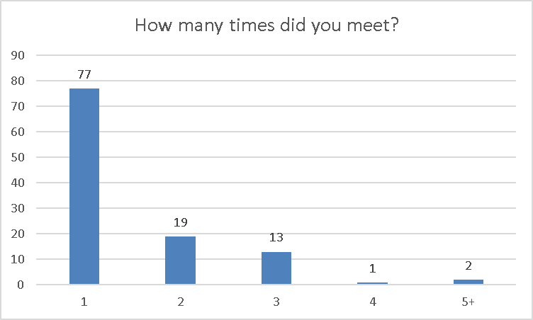

Average

1.5 times

Average

4.5 hours

COMMUNICATION

Highlights

* Communication chart is redundant, confusing, and directed toward non-verbal individuals
* Need a way to capture that in order to understand the individual (verbally, through actions, etc) you need to know them
* A lot of questions are repetitive when the individual is verbal
* Suggested to make the question “How does the person communicate?” multiple choice
* Ask “Is the person verbal or non-verbal?” then ask certain questions based on that
* Repetitive Questions
  + How does the person communicate? and How does the person want others to communicate with him/her?
* Questions/Topics to Add
  + Technology. Do they need assistance? Do they use it to communicate?
  + Receptive Communication
  + Reading/Writing

CITIZENSHIP & ADVOCACY

Highlights

* Dislike of the word citizenship – suggested Advocacy & Decision Making
* Dislike of the word talent – suggested strength or ability
* The question, “Does the person need help to understand/prepare for additional rights as an adult,” doesn’t apply to everyone
  + Suggested to modify or only ask to certain age range
* Add “What other safety skills do they need to learn?” to the question, “How does the person keep himself/herself safe?”
* Suggest making “Is the person able to identify risks and benefits of various services and provide informed consent without support?” open-ended
* Provide examples instead of asking about “legal sanction”
* Individuals didn’t understand what it means to advocate for themselves – suggested “How do you let people know what you think when you do/don’t agree with them?”
* Topics don’t apply to children
  + Voting, self-advocacy, training staff, history of things tried, citizenship issues, etc
* Not sure what the question “Explain the history of things that have been tried” is asking for
* Suggested an option to skip this section for individuals with limited cognitive abilities
* Seemed vague and unclear to ask, “”are there things that are important to the person for the team to know” after “Does the person make routine choices?”
* Dislike of the question, “Is the person able to identify risks and benefits of carious services and provide informed consent without support?”
  + Confusing, vague, not sure what services would be “risky”
* Asking what rights a person does not understand is too broad
* Unsure of how to answer behavioral add-on questions if the individual doesn’t have restrictions

SAFETY & SECURITY

Highlights

* Individuals didn’t understand “self-help skills” – suggested “What do you do to make yourself feel better when you’re worried or upset?”
* Seemed strange to ask someone what they like to do for fun then ask if they’re able to do it – suggested asking if there’s anything they’d like to try but haven’t been able to then addressing barriers
* First 3 questions under the Behavioral Well-being section could be combined to say, “What supports are needed to keep the person safe?”
* Questions repetitive with questions in other sections
* “How does the person handle being upset or worried?” and “What supports are needed?” and “What self-help skills does the person use when upset or worried?” are repetitive
* Add questions about when and where to “Does the person feel safe and secure?”
* Add location/time prompts to, “What level of supervision does the person need to be safe in different places and at different times?”
* Dislike the question about the best thing to ever happen – difficult for people to answer
* Don’t assume a person feels isolated, afraid, or powerless – Ask if they ever feel that way before asking what they do
* Add a question about carrying keys and locking/unlocking their house
* Add a question about alone time
* Questions should be more specific to gather more detail
* Difficult section to complete for individuals with sever/profound I/DD

SOCIAL & SPIRITUALITY

Highlights

* Ask “Does the person date?/Do they want to date?” If yes, “Do they have the opportunity to date?” to eliminate unnecessary dating-related questions
* Not sure what “culture” is referring to in the question, “What cultural considerations are important to the person?”
  + Also may need to separate from routines/rituals depending on what’s meant
* Questions, other than the Friends & Family section, seemed targeted toward higher-functioning individuals
* Dislike the “favorite person” question
* Combine “How does the person stay in touch with people in their life?” and “Does the person visit with friends and family?” and “What activities does the person do with friends and family?”
* Some felt questions were invasive

DAILY LIFE & EMPLOYMENT

Highlights

* Ask if the individual wants to have a job so that employment questions can be skipped if not applicable
* Add questions about attending a ADS or VocHab programs – the questions didn’t capture what someone does during the day if they don’t attend school or work
* Ask certain questions based on age range and/or if the person is currently in school
* Add in a question asking for the name of their payee/person in charge of finances
* Doesn’t seem to include Path to Employment
* Add a place to list employment/volunteer history with likes/dislikes
* Questions not applicable to children, people at lower functioning levels, and people in ICFs
* Repeat Questions
  + “What are the strategies that help a person learn?” and “How does the person learn best?”
  + “How does the person make money?” and “What type of income to they receive?” and “Does the person receive any benefits?”
  + “Does the person understand how to use money?” and “Does the person need money management skills or support?” and “Is the person able to take care of their own finances?” and “What kind of support, if any, does the person need to make sure their bills are paid on time?”
* Unsure if “Does the person have a job?” only applies to community employment
* Daily Living and Employment should be two different sections – this section is mostly about employment and finances

COMMUNITY LIVING

Highlights

* Individuals didn’t understand: “maintaining the household,” “barriers,” and “safe and reliable way”
* Questions not applicable to all ages and/or individuals who live with family
* Some questions not relevant to sever/profound population
* Ask where the individual lives now – some questions may become irrelevant based on this
* Ask “What assistance do you need to keep your home cleaned?” after “Does the person need help maintaining their household?”
* Split up the question, “Describe any routines necessary to help the person through their day,” into sections such as morning, getting to work, after work, bedtime, holidays, weekends, etc.
* Dislike the question “How do you like your home decorated?” – unnecessary, doesn’t apply to children, individuals indicated they can’t afford
* The last few questions are repetitive
* Clarify, “Are there any challenges to the person moving to a more community based home?" because ICFs are community-based homes

HEALTHY LIVING

Highlights

* Individuals and Teams weren’t sure what was meant by “self-care routine”
* Add “What type of assistance/Who provides?” to “Does the individual need help obtaining/taking medications?”
* Questions/Topics to Add
  + Questions about alternative nutrition (G-tubes, etc.)
  + How the individual obtains and take meds
  + PT/OT
  + Adaptive devices
  + Doctor names and contact information
  + Type of assistance needed to complete daily living skills
* Change “Does the person ever go see a doctor/dentist?” to “What type of doctors/specialists do they see and how often?”
* Seems out-of-place to ask their favorite food
* Dietary questions are repetitive
* People had trouble incorporating self-med assessment in the document and/or other outside assessments that weren’t part of the original form
* Questions in this section were too broad

OVERALL

Highlights

* A lot of questions seemed repetitive – within and between sections
* It was difficult to get to the level of detail needed to individuals with lower cognitive functioning
* There were a lot of questions that did not apply to all individuals (school, employment, finances, etc.)
  + Many suggestions for skip patterns
* Rewording of questions was needed for many individuals
* Drop-down boxes/checklists would be nice in some areas
* Some questions may be “sensitive” to parents/families of individuals who will never be able to do the things that are being asked about