PPE 4.13.20





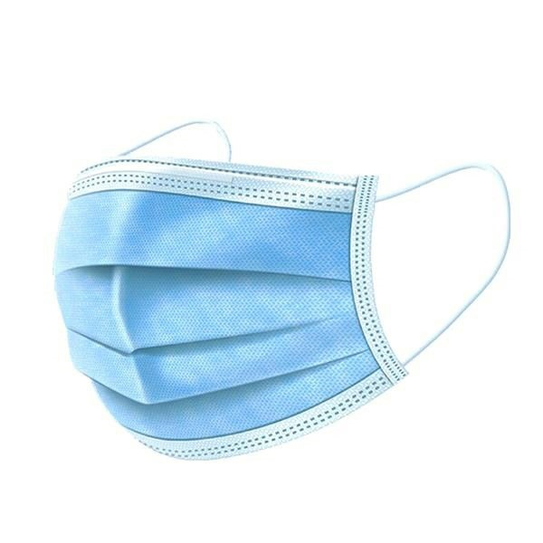

# **Product Name** Standard 3-Ply Face Mask

**Description** FDA registered face mask with 3‐Ply construction and an inner layer of highdensity melt‐blown polypropylene. Anti‐dust and anti‐droplets makes the mask comfortable and breathable. One size fits all. Adjustable nose bridge and elastic ear loops. Not intended for medical use, for personal protection only.

**Material** PP‐Meltblown‐PP

**CPN** 552779477

**Color** Light Blue

**Size** 1 " x 1 " x 1 "

**Production** 12 days

|  |  |  |  |  |  |
| --- | --- | --- | --- | --- | --- |
| **Quantity** | **150** | **2000** | **4000** | **10000** | **50000** |
| **Price** | $1.25 | $0.80 | $0.76 | $0.74 | $0.69 |

**Price Includes** shipping extra

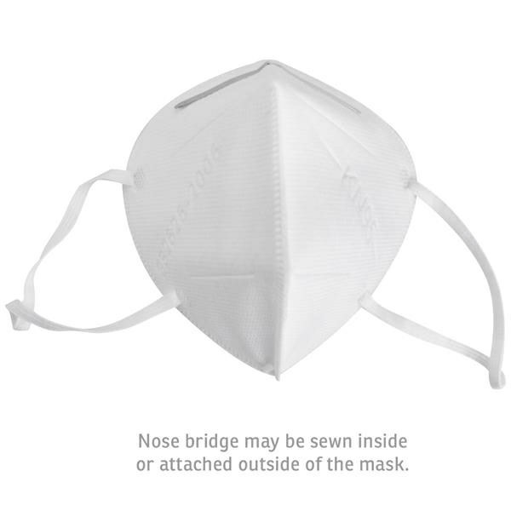

# **Product Name** KN95 Respirator Mask

**Description** FDA registered face mask with 4‐Ply construction and an inner layer of highdensity melt‐blown polypropylene. 95% filtration for particles larger or equal to 0.3 microns. One size fits all. Adjustable nose bridge and elastic ear loops. Complies with China Standard GB2626‐2006 and European Standard EN149:2001A1:2009. Not intended for medical use, for personal protection only.

**Material** Non Woven‐Meltblown

**CPN** 552779476

**Color** Medium White

**Size** 1 " x 1 " x 1 "

|  |  |  |  |
| --- | --- | --- | --- |
| **Quantity** | **1000** | **5000** | **10000** |
| **Price** | $3.82 | $3.62 | $3.40 |

# **Product Name** NIOSH N95 RESPIRATOR MASK 4 SH

**Description** N95 MASK ,NIOSH N95 APPROVED. 400PCS/CTN 6.5KG/CTN

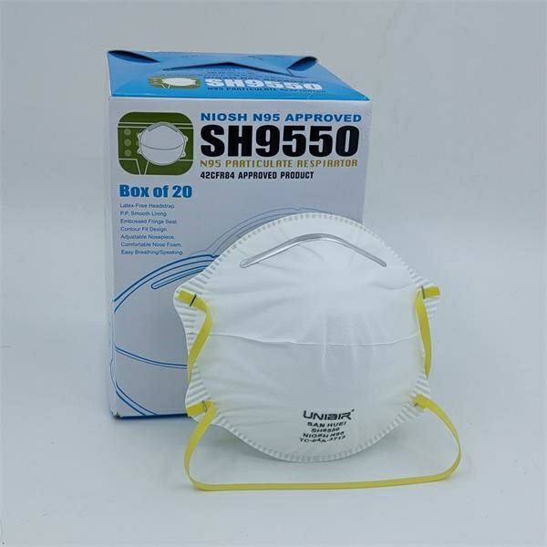**CPN** 552787229

**Color** White

**Size** 15 cm x 11 cm x 5 cm

|  |  |
| --- | --- |
| **Quantity** | **50000** |
| **Price** | $6.99 |

# **Product Name** Protective cotton Cloth Face

**Description** Keep your Customers safe with our Reusable Protective Cloth Face Mask w/ 2 Layers! This essential hygiene product is made of 2 high‐quality layers designed to protect you from

dust, germs and infectious disease. Made of 50% Polyester and 50% Cotton, these can be washed and reused multiple times. washable and reusable

**Material** Cotton & Polyester

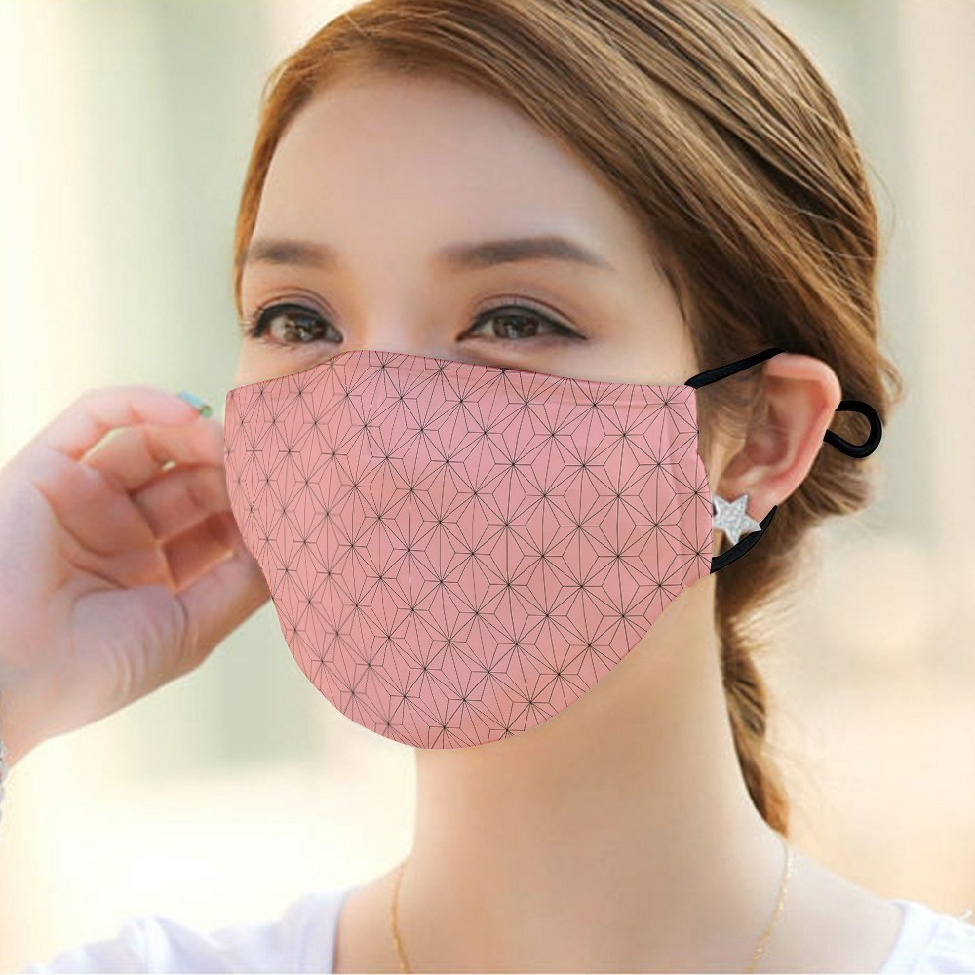**CPN** 552783961

**Size** 25 cm x 10 cm

|  |  |  |
| --- | --- | --- |
| Standard Production | | |
| **Quantity** | **500** | **1000** |
| **Price** | $4.99 | $4.10 |

**Price Includes** Fully Sublimated imprint. Shipping free

# **Product Name** Disposable lightweight Isolation Gowns - Level 1

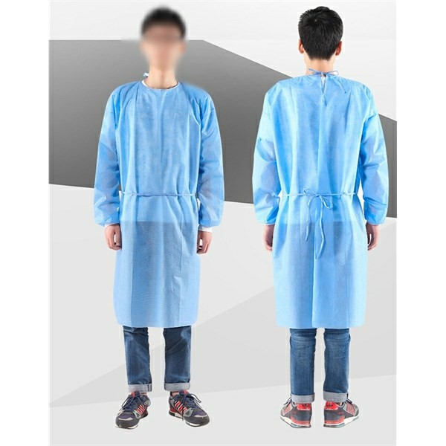**Description** Disposable isolation gowns offer practical and dependable protection against fluids, particulates, and other contaminants. Constructed from a single layer of light, pliant, and breathable nonwoven (polypropylene) fabric. With generous amounts of fabric and long neck and waist ties, our disposable isolation gowns are designed to comfortably cover most individuals without impeding movement.Choose from gowns with stretchy elastic cuffs or soft knit cuffs. Full length to maximize coverage. Available in a wide range of bright colors: blue, green, white, and yellow.

**Material** Non‐woven fabric

**CPN** 552783016

**Size** 52 " x 44 "

|  |  |  |  |  |  |
| --- | --- | --- | --- | --- | --- |
| **Quantity** | **1000** | **5000** | **10000** | **25000** | **50000** |
| **Price** | $4.99 | $4.85 | $4.65 | $4.45 | $4.19 |

**Price Includes** Shipping to 1 location in the US

# **Product Name** Disposable medium weight Isolation Gowns level 2

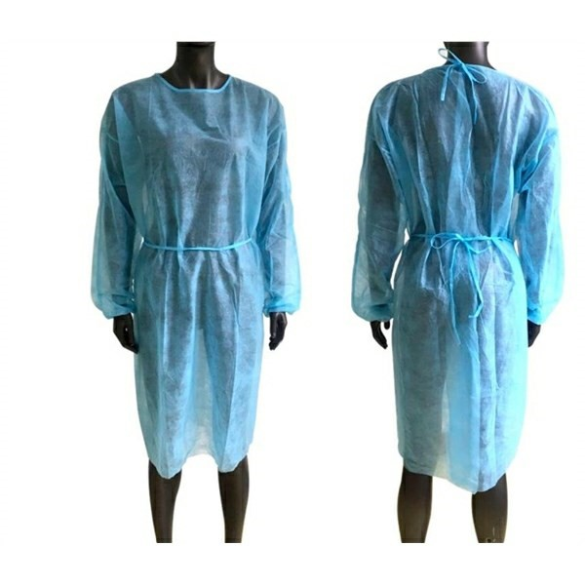**Description** Disposable medium weight isolation gowns level 2 offer practical and dependable protection against fluids, particulates, and other contaminants. Constructed from a single layer of medium, pliant, and breathable nonwoven (polypropylene) fabric. With generous amounts of fabric and long neck and waist ties, our disposable isolation gowns are designed to comfortably cover most individuals without impeding movement.Choose from gowns with stretchy elastic cuffs or soft knit cuffs. Full length to maximize coverage.

**Material** Non‐woven fabric

**CPN** 552783016

**Size** 52 " x 44 "

|  |  |  |  |  |
| --- | --- | --- | --- | --- |
| **Quantity** | **2000** | **10000** | **25000** | **50000** |
| **Price** | $9.69 | $9.44 | $8.50 | $7.93 |

**Price Includes** Shipping to 1 location in the US

# **Product Name** Disposable Isolation Non-woven Gowns Level 3

**Description** FDA approval.Disposable Isolation Gowns are made of non‐woven. It is oilproof and dustproof, which can provide long‐lasting protection. Price includes shipping cost!

**Material** nitrile

**CPN** 552789710

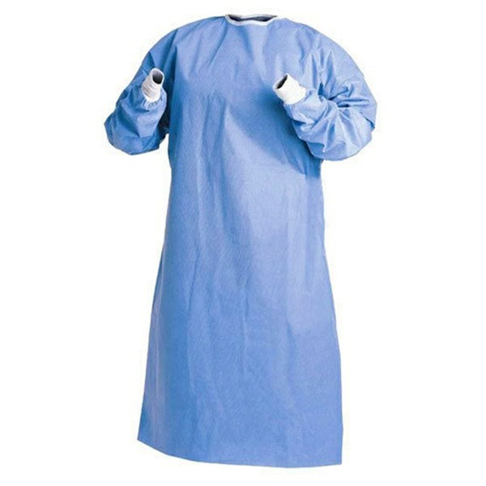**Color** Blue



|  |  |
| --- | --- |
| **Quantity** | **50000** |
| **Price** | $12.25 |

Chargeable Overrun/underrun allowance of

4/10/2020 | Page: 8 5%‐10% applies to orders unless stated otherwise.

# **Product Name** Economy Isolation Suit Protective Non-Woven Medical Gown

**Description** Protect your clients with our Protective Medical Economy Isolation Suit NonWoven Medical Gown! This disposable bodysuit is made of Water repellant Non‐Woven material. Our medical gowns are waterproof, dust‐proof and protects against chemical liquid and blood contamination. Order these PE coated Medical Gowns today and make a splash among your customers! **Material** PE Coated Non‐Woven

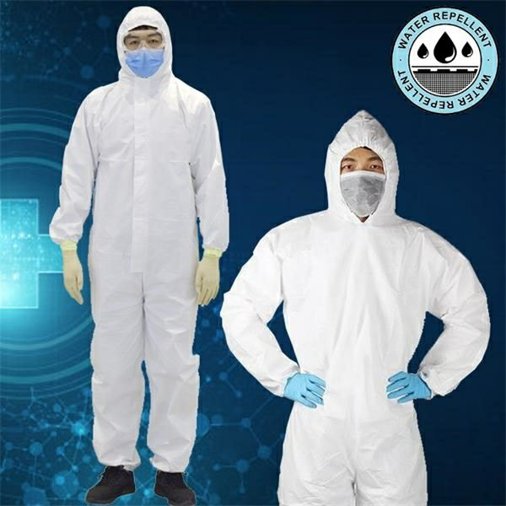**Shape** Shirt



**CPN** 552778821

**Color** White

**Size** 187 cm

|  |  |  |  |  |  |  |  |  |
| --- | --- | --- | --- | --- | --- | --- | --- | --- |
| Standard Production | | |  |  |  |  |  |  |
| **Quantity** | **50** | **100** | **250** | **500** | **1000** | **2500** | **5000** | **10000** |
| **Price** | $15.29 | $14.39 | $14.11 | $13.75 | $13.66 | $13.49 | $13.46 | $13.43 |

**Price Includes** Blank

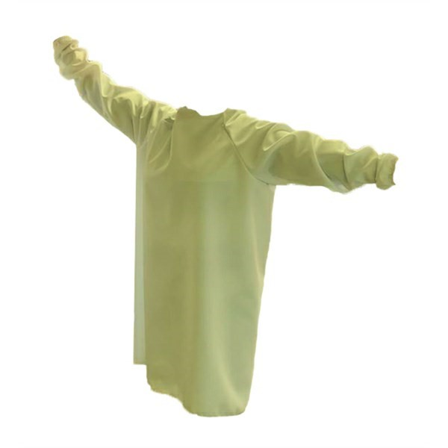

# **Product Name** Reusable Protective Isolation Gown

**Description** Reusable protective isolation gown with elastic sleeves and neck & waist ties; 6 oz. liquid repellent poly poplin. 30+ Wash/Dry cycles. USA Cut and sew as well as imported options. **Material** Poly Poplin

**CPN** 552788927

**Color** Yellow

|  |  |
| --- | --- |
| **Quantity** | **25** |
| **Price** | $24.00 |

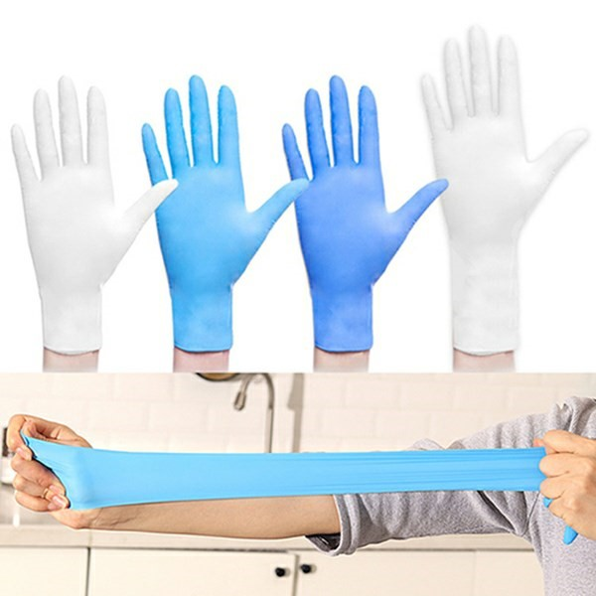

# **Product Name** Powder free Nitrile Disposable Gloves

**Description** The disposable gloves can effectively prevent virus and bacteria during the work. It's comfortable ,stretchable durability and puncture resistance. Contact us for more details! **Material** Latex

**CPN** 552759644

**Color** Blue, White

**Size** S, M, L

|  |  |  |  |  |  |  |
| --- | --- | --- | --- | --- | --- | --- |
| Disposable Gloves price per pair | | | |  |  |  |
| **Quantity** | **300** | **500** | **1000** | **5000** | **25000** | **50000** |
| **Price** | $1.29 | $1.15 | $1.04 | $0.84 | $0.74 | $0.60 |

# **Product Name** Protective Goggles Dustproof Safety Glasses AntiFog Medical

**Description** Keep your customers safe from contamination with our Protective Goggles Dustproof Safety Glasses Anti‐Fog Medical Eyewears! This trendy eyewear is made of tough Anti‐fog PVC material and can sustain High Impacts. They are dustproof and can protect you from chemical spills, germs and bacterias. With an Elastic Rubber band, you can keep this safety goggles firmly in place. Order these popular safety equipments today and stay safe!

**Material** Transparent PVC

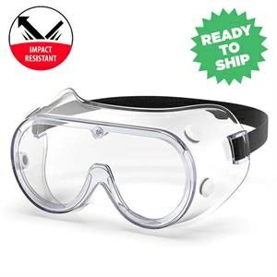**Shape** Glass



**CPN** 552779097

**Color** Clear

**Size** Standard, Standard Adult Size

|  |  |  |  |  |  |
| --- | --- | --- | --- | --- | --- |
| Standard Turnaround | | |  |  |  |
| **Quantity** | **50** | **100** | **250** | **500** | **1000** |
| **Price** | $8.92 | $8.50 | $8.07 | $7.82 | $7.65 |

**Price Includes** Blank

# **Product Name** Safety Glasses

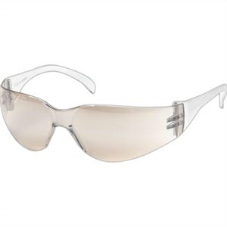**Description** Get the most protection for your eyes with these safety sunglasses. These durable, transparent safety glasses are made with polycarbonate lens and are ANSI Z87, American National Standards Institute, approved for safety. Great for visitors and employees. These safety glasses are guaranteed to provide all the armor you need no matter what kind of work you may be doing. Case not included.

**Material** Polycarbonate

**CPN** 4911758

**Color** Clear

|  |  |  |  |  |
| --- | --- | --- | --- | --- |
| **Quantity** | **25** | **100** | **250** | **500** |
| **Price** | $4.44 | $4.34 | $4.26 | $4.11 |

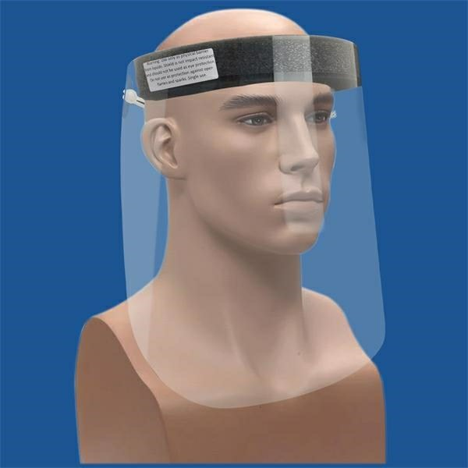

# **Product Name** Face Shield

**Description** Protect Yourself Gary Plastic / Garyline has converted production in our NY factory to produce Personal Protective Face Shields. The best protection is to maintain social distance, wash hands regularly and avoid touching your face. Face Shields provide protective cover when in public and restrict touching with your hands These single‐use shield are made from fog‐resistant PETE (0.012" thickness) with a comfortable foam forehead rest Elastic band to fit most. Great for grocery, food service take out and other service employees

**CPN** 552784343

**Color** Clear

|  |  |  |  |  |
| --- | --- | --- | --- | --- |
| **Quantity** | **100** | **200** | **500** | **1000** |
| **Price** | $4.98 | $4.72 | $4.47 | $4.21 |

**Price Includes** Blank Goods

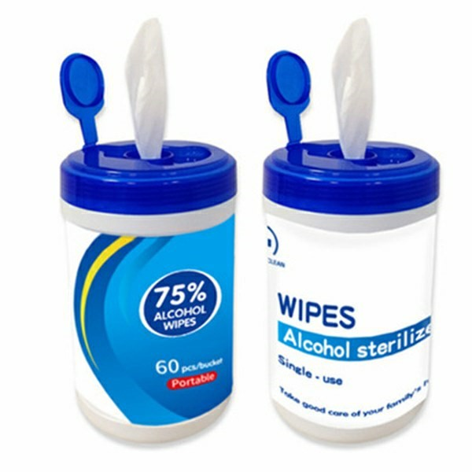

## **Product Name** 60PCS PACK 75% Alcohol Disinfectant Wipes

**Description** 60PCS IN A PACK. High‐quality spunlace cloth, pure water, containing 75% alcohol . easy to carry,.Rush services is available. High‐quality spunlace cloth



**Material** Non‐woven Fabric

**CPN** 552789756

**Color** White

|  |  |  |
| --- | --- | --- |
| 7 days production shipping ocean 25 days | | |
| **Quantity** | **1000** | **10000** |
| **Price** | $7.33 | $6.87 |

## **Product Name** Sanitizer Gel Packet

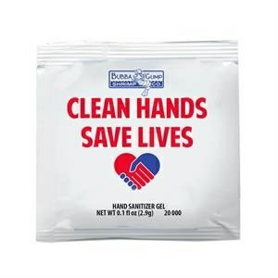**Description** Made in the USA our single use gel packets contain 62% alcohol‐based hand sanitizer. Available in your choice of white or silver packets. Customers want sanitizing solutions NOW to fight germs. Solution: Hand Sanitizer Gel Packets. Same sanitizing power as gel bottles. Single use, disposable packet. Portable, easily fits in purse or pocket. Customizable with your logo.

**CPN** 552756016

**Color** White, Silver

**Size** 2 1/8 " x 2 1/8 "

|  |  |  |  |  |
| --- | --- | --- | --- | --- |
| **Quantity** | **500** | **1000** | **2500** | **5000** |
| **Price** | $0.84 | $0.80 | $0.77 | $0.73 |

## **Product Name** 1 Gallon Sanitizer Gel

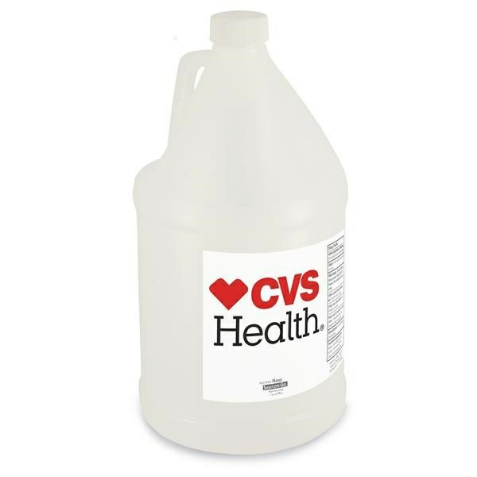**Description** Bulk 1‐gallon antibacterial sanitizer gel fight germs with 62% alcohol. Gel is enriched with moisturizers to leave skin feeling soft and refreshed. Imprint is on white label. Made in USA. Active Ingredients Ethyl Alcohol 62% Inactive Ingredients Water, Dimethicone Copolyol, Carbomer, Aloe Juice,Triethanolamine. 144 gallons per pallet. Must ship in full‐pallet increments of 144 gallons.

**CPN** 552787014

|  |  |
| --- | --- |
| **Quantity** | **576** |
| **Price** | $99.06 |

## **Product Name** Antibacterial Alcohol Wipes

|  |  |
| --- | --- |
| Disinfection alcohol wet Wipe | |
| **Quantity** | **1000** |
| **Price** | $2.93 |

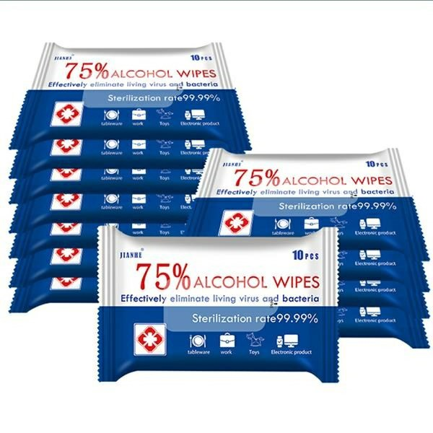**Description** High‐quality spunlace cloth, pure water, containing 75% alcohol . easy to carry, Easy to stack, space saving pack allows you to take disinfecting wipes anywhere including on the go. Suitable moisture content, prolonged freshness time, better sterilization effect.

**Material** Non‐woven

**CPN** 552769043

**Color** White

**Size** Standard, 10pcs