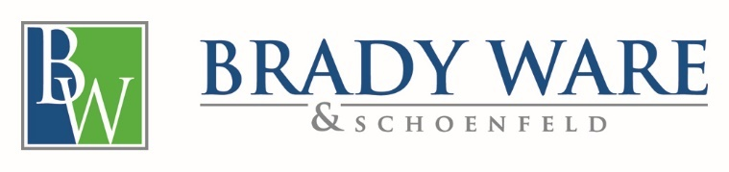

March 30, 2020

Thank you for choosing Brady, Ware & Schoenfeld Inc (“BWS”, “us,” “we”, or “our”) to provide advisory services. This letter, including the attached General Terms and Conditions, constitutes our understanding of the terms and objectives of our engagement, and the nature and limitations of the services we will provide for you.

Scope of Services

BWS will be available to provide services in conjunction with the Small Business Administration (“SBA”) Paycheck Protection Program (“PPP”) application on an as-requested basis. Our services will include various consulting services, including assistance with the application, the gathering of supporting documentation, and the assembly of the application package for submission as requested.

As the SBA application is facilitated through a local SBA Lender, this engagement letter will also serve as the Client authorization for BWS to submit Client data directly to the SBA Lender as well as to use the Client information provided for tax return preparation and/or review/compilation work for purposes of completing the PPP application. Authorization includes all information obtained in the course of preparing tax returns. In certain instances, personal individual tax information will be required.
The financial information used to complete the application is owned by the Client and BWS is not responsible for the accuracy of such data. The information contained within the application as well as any accompanying supporting documentation will be reviewed by Client prior to submission and accuracy of the application is owned by the Client. BWS does not guarantee the approval of the SBA PPP loan application.
Further, each SBA Lender will provide their own Terms of Use for the application process. BWS avails themselves of the same Terms of Use during the application process.
Engagement Fees

Fees for consulting services will be based on actual time spent at our standard hourly rates and out-of-pocket expenses and are not contingent upon the results of our services. However, fees might also reflect other factors deemed relevant, including the level of skill required to perform the accounting, tax, or consulting services; time limitations imposed either by you or the circumstances; and the expertise, experience, and ability of the people assigned to the engagement.

Invoices for our services will be rendered each month as work progresses and are payable upon presentation.



Acceptance

This engagement letter, together with the General Terms and Conditions constitutes the entire agreement (“Agreement”). This agreement may not be amended except by mutual written agreement of the parties.
If the foregoing sets forth our mutual understanding, please sign this letter and return via email at EL@bradyware.com.
We appreciate this opportunity to work with you.
Sincerely,

BRADY, WARE & SCHOENFELD, INC.

Gary Brown, Director, CPA

Acknowledgement:

This letter correctly sets forth the understanding of

________________________________________
Signature

________________________________________
Title

________________________________________
Date

