**Subject: Improved Member Benefits To Help You Thrive!**

**Sub: Ohio’s trusted energy manager is OPRA’s newest partner**

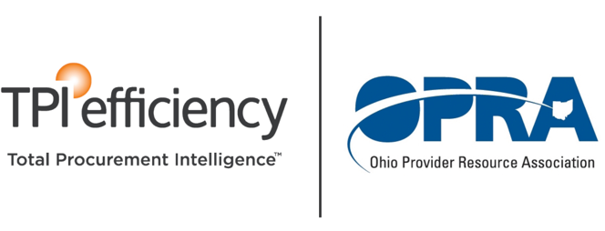

Dear OPRA Member,

For over ten years, our newest partners at TPI Efficiency have been helping Ohio’s largest service providers THRIVE!

“TPI is a valued and trusted advisor on all matters of energy… Because of our partnership over the last several years, Hattie Larlham has discovered tens of thousands of dollars in recovery and savings.”

– Darryl E. Mast, COO Hattie Larlham (Ret.)

TPI has a proven track record of helping provider organizations stretch funding dollars, finance infrastructure improvements, and achieve budget certainty through reduced expenses and increased energy efficiency.

How?

Their team of industry experts constantly monitor hundreds of suppliers, products, and delivery platforms, and sit on your side of the negotiating table to ensure the most competitive pricing and terms for electricity, natural gas, and LED lighting. The best part is that when we negotiate lower rates for OPRA Members, our suppliers pay our fees, not you!

An HQ in Cleveland and service centers throughout Ohio means you get hands-on assistance throughout the entire process from strategy and contract negotiation to filing for rebates and incentives, product installation, and proven ROI.

Every TPI client gets the red-carpet treatment. TPI continuously monitors accounts, provides Executive Portfolio Management, and a single point of contact familiar with your strategy and historical data. Your personal Client Account Manager will do whatever it takes to keep you aware of any changes or opportunities in the marketplace and insure your goals are met year-over-year.

**For objective advice, unparalleled customer service,   
and access to hundreds of tier-1 vendors,   
OPRA members trust TPI Efficiency!**

**Get started today!**

**Contact Chuck Valenches at 877.244.0182   
or chuck.valenches@TPIefficiency.com.**

