**How to Filter Excel Document**

1. Open Excel document

2. Highlight **CELLS A1 through C1**

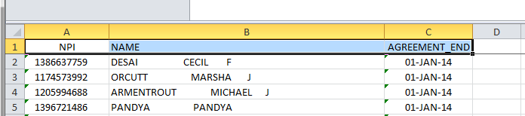

3. Click on the **DATA** tab and choose **FILTER**

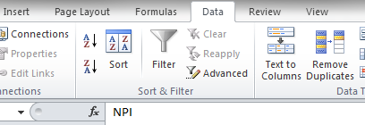

This will create arrows in each cell. Click on the arrow in the **NAME** (B1) cell



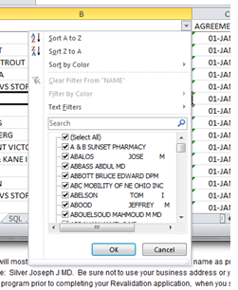4. Type your name or company name in the search box

6. Check the box of the one that matches your search and click OK – this will filter everything else out and you can easily find if you are on this list.

