Community Connections Career Partnership - Ohio
Volume 3, Issue 1 June, 2019pril, 2017

C3P(O) Students Attend OPRA Spring Conference
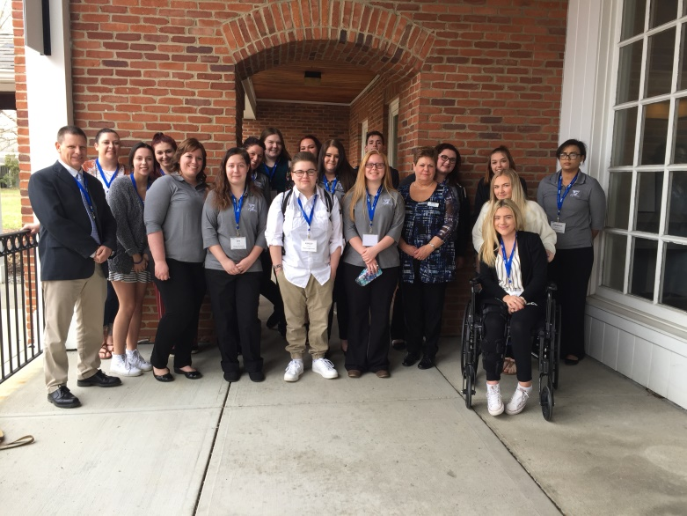

OPRA hosted the C3P(O) students from Medina High School and Vanguard Sentinel Career and Technology Center at the Spring Conference held in Lewis Center, OH on April 4. Unfortunately, it was testing week in the South-Western City School District and the students from Franklin Heights High School were unable to attend.

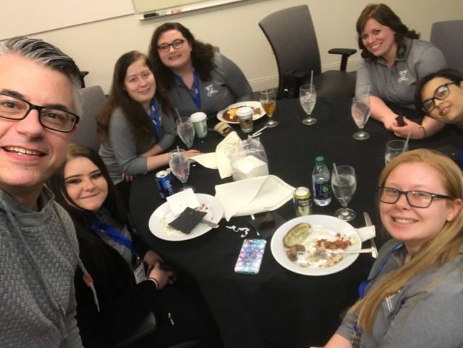

A special “thank you” to our speaker – Scott Osterfeld!
OPRA Receives Proclamation from Governor Dewine for C3P(O) Program

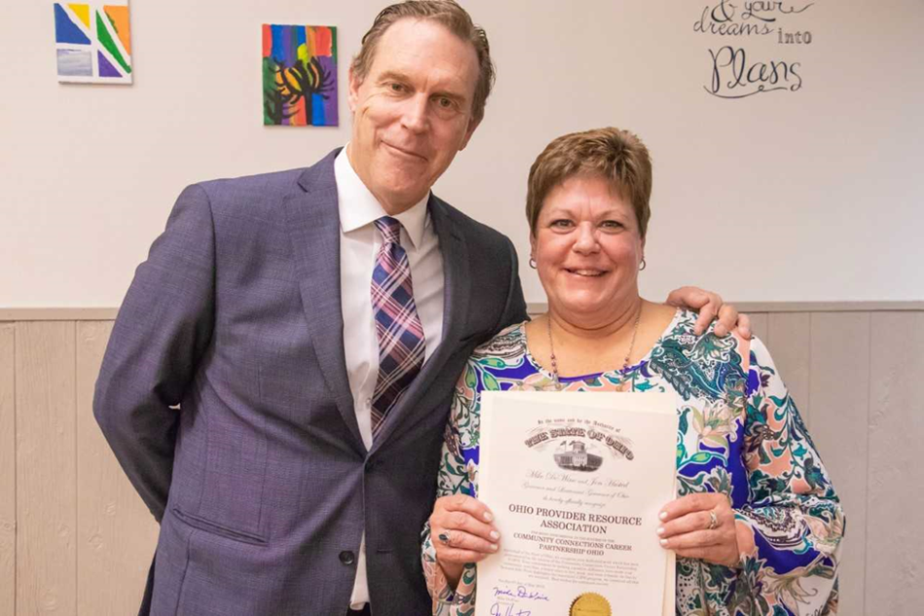
Pictured are Jeff Davis, Director of the Ohio Department of Developmental Disabilities and Janice Hall, Special Projects Manager for OPRA.

The Ohio Department of Developmental Disabilities hosted an event for In-Demand Jobs Week on May 9, 2019 at ViaQuest Day and Employment Services in Grove City, which highlighted the C3P(O) program. Speakers included: Amy Schakat, Coordinator of Career and Technical Education for the South-Western City School District; Rich Johnson, President and CEO of ViaQuest; Kelsey Goodman, C3P(O) graduate and employee at Columbus Center for Human Services; Jeff Davis, Director of the Ohio Department of Developmental Disabilities; and Dr. Jerry Farley, Vice-President of Career Technical Education for Oakmont Education. At the event, Director Davis presented proclamations from Governor DeWine to the South-Western City School District, ViaQuest, and OPRA for their roles in the C3P(O) program.

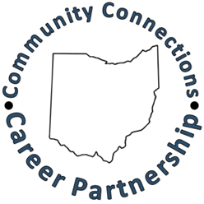

C3P(O) Students Awarded Credentials and Certifications

Vanguard Sentinel Career & Technology Center
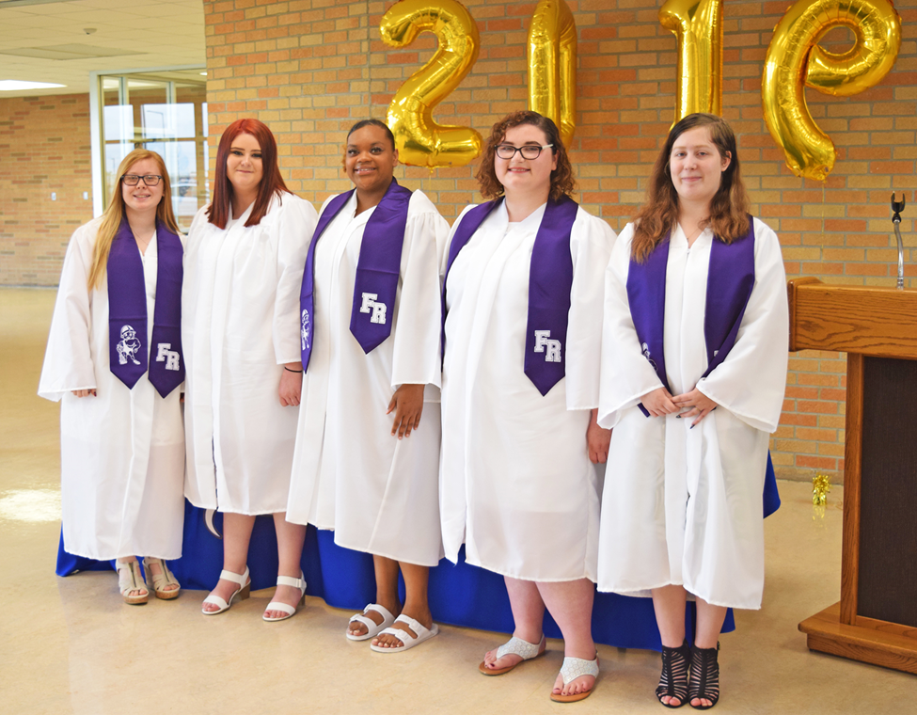

On May 13, Seniors Katelyn Haubert, Katelynn Gibson, Brooklyn Jones, Madison Haubert and Ivy Price received their Certificate of Initial Proficiency (CIP) at an award ceremony at Vanguard Sentinel Career and Technology Center in Fremont, Ohio.

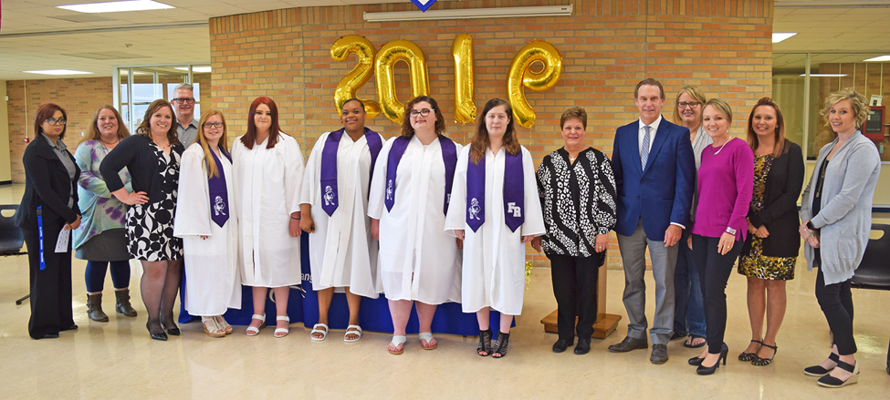

A special “thank you” to all who helped make this first year successful: Sandusky County Board of Developmental Disabilities; Sandco Industries; and Wynn-Reeth.
Medina High School
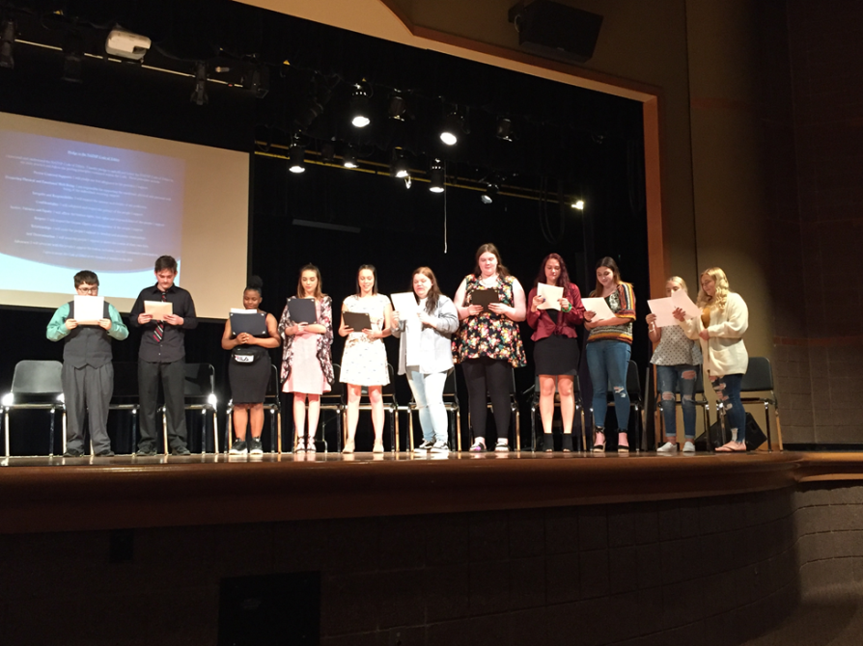
At the ceremony held on May 16 at Medina High School, C3P(O) students recited the Pledge to the NADSP Code of Ethics.

Congratulations to the following students: Shelby Coffee (CIP); Angel Cooper (CIP); Brittney Thompson (CIP); Breanna Blachowski (CAP); Avery Feldman (CAP); Hailey Pacifico (CAP); Madison Wallace (CAP). The following students received OADSP’s Basic Certificate at the ceremony while the their Certificate of Initial Proficiency portfolios were still under review: Ashley Cooper; Eric Justice; Edward Marandola; Lajaia Marshall; and Shelby Gast.

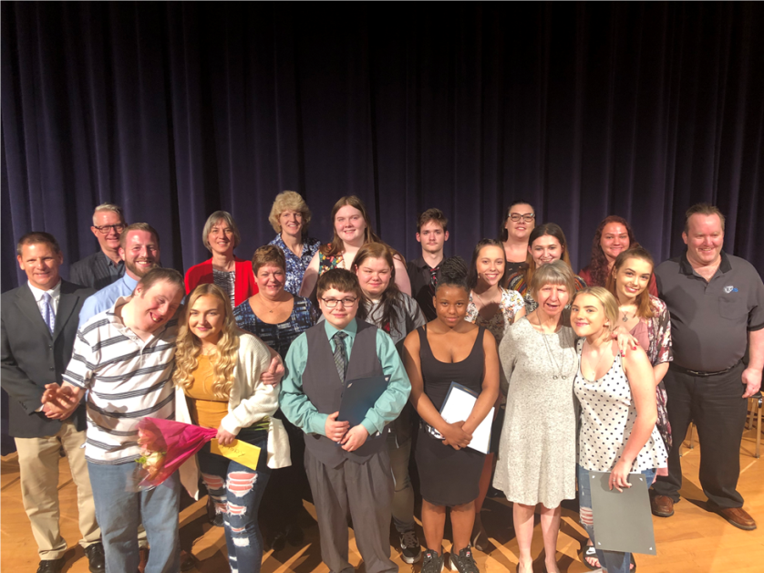

Thank you to all of our partners who have made this third year at Medina High School successful: Medina County Board of Developmental Disabilities; SHC/The Arc of Medina County; and Transitional Living Centers.
Franklin Heights High School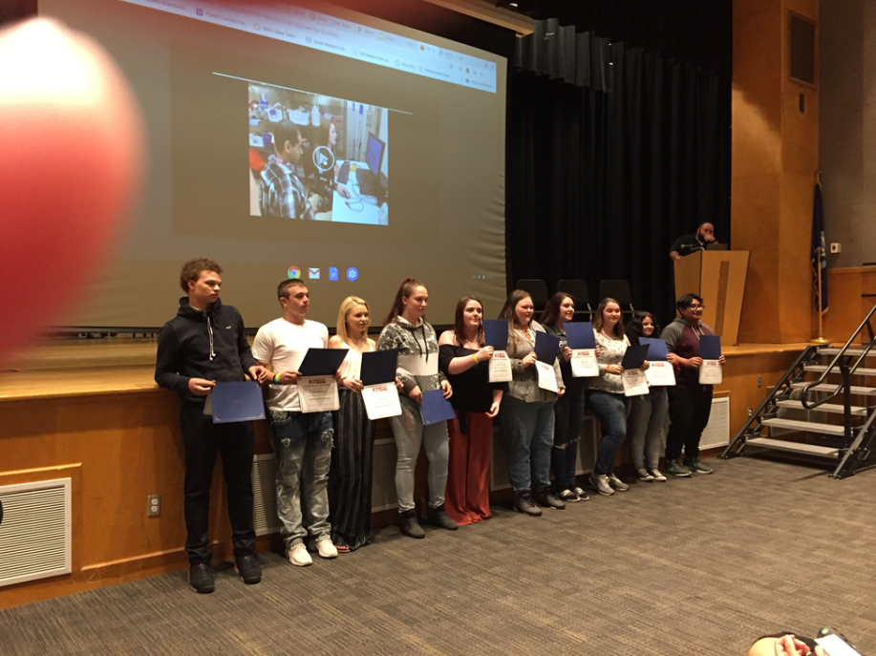

On May 21, ten students received the Certificate of Initial Proficiency at an award ceremony at Franklin Heights High School in Grove City: McKenzie Bailey; Devin Buchanan; Ruben Clemente; Alyssa Ferguson; Donovan Garrard; Lauren Brook-Hall; Alyssa Jones; Kayla Kidwell; Amber Kocher; and Sheyla Littler.

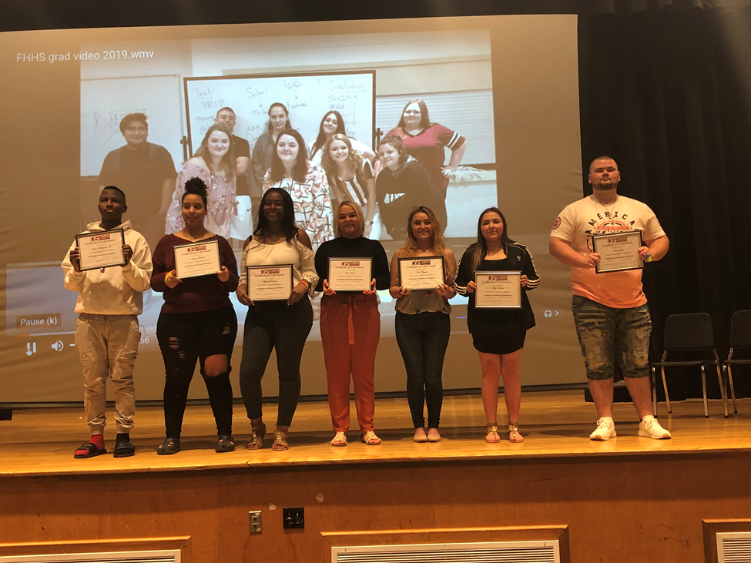

These seven seniors received the Certificate of Advanced Proficiency: Antwni Richardson, Jr., Amaya Haselrig, Bianca Robinson, Sara Smith, Abbie Flattinger Ruby Medina and James Ryan.
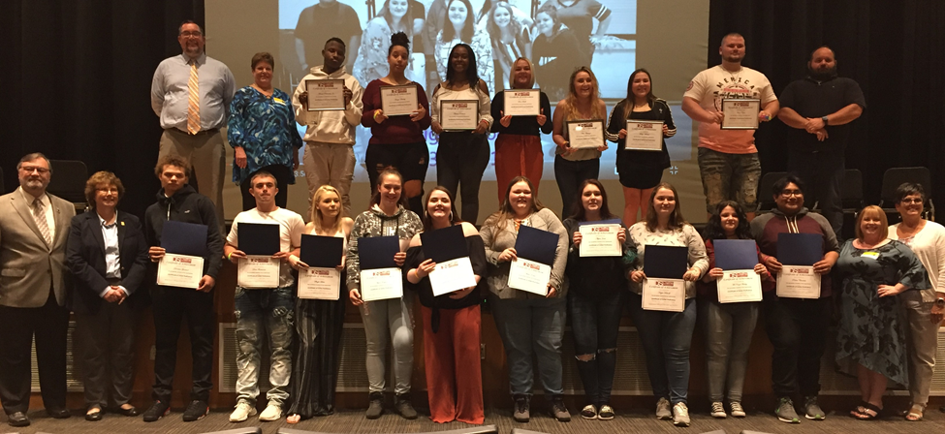

Thank you to everyone at ViaQuest, Boundless and Goodwill Columbus who helped to make this a great fourth year with the South-Western City School District.



A FEW FUN FACTS ABOUT C3P(O)

In the four years of the program, OADSP has presented 82 students with the Certificate of Initial Proficiency and 34 students with the Certificate of Advanced Proficiency.

Over the past three years, 50 students who completed the program and received either the CIP or the CIP and CAP were seniors. Of these 50 seniors, 100% also received their high school diploma.

There are at least 16 C3P(O) graduates currently working in the field of developmental disabilities.

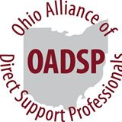

For more information, contact Janice Hall at jhall@opra.org

