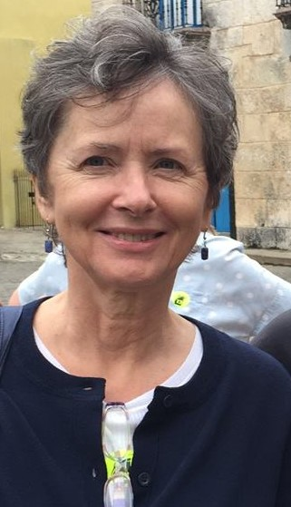**CHAMPIONS TOGETHER**

An Anat Baniel Method

NeuroMovement

Practitioner Works With

Special Needs Children

And Their Parents

A Documentary by Linda Taylor

**Free Screening and Q & A with Joan Taylor, ABM Practitioner**  Saturday, May 25, 2 PM Upper Arlington Public Library, 2800 Tremont Rd

Anat Baniel: “To improve physical functioning, the brain needs to change—taking advantage of ‘brain plasticity’ to form new neural connections and patterns in the brain”

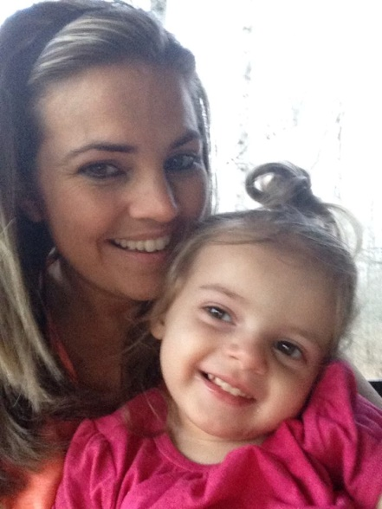 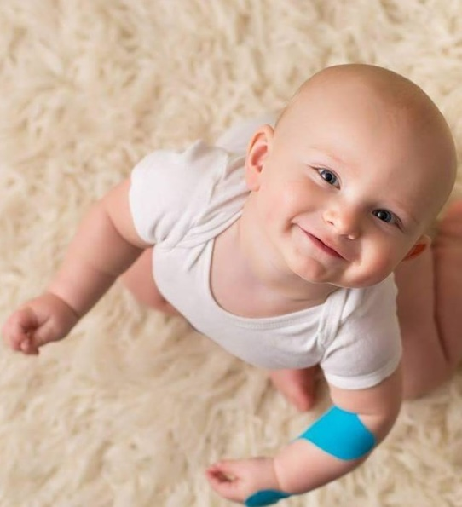

5 minute trailer available on YouTube: “Champions Together Documentary”

***Champions Together*—about the documentary:**

The Center for Disease Control and Prevention (CDC) estimates that about 15% of children in the US aged 3 – 17 years have one or more developmental disabilities: “Developmental disabilities are a group of conditions due to an impairment in physical, learning, language or behavior areas. These conditions begin during the developmental period, impact day-to-day functioning, and usually last throughout a person’s lifetime.”

Anat Baniel, the founder of the Anat Baniel Method NeuroMovement, has a developed a movement-based clinical approach that she calls “NeuroMovement” to help children with ‘special needs’ improve physical, emotional and cognitive functioning. She has identified fundamental principles of brain function that she calls the “Nine Essentials” making it possible to communicate with the brain, helping it to change for the better. Scientists and clinicians at the forefront of the brain plasticity revolution support Anat’s theoretical approach and method.

**Director’s Statement by Linda Taylor:**

Joan Taylor is an Anat Baniel Method NeuroMovement Practitioner with a Certification for working with ‘special needs’ children.

I have an MFA in Film and Television Production from New York University and a background in public radio. I had the good fortune to take a documentary video production class at the Ohio State University through Program 60 with Professor Janet Parrott, Chair of the OSU Department of Theatre. An assignment that began as an interview with Joan Taylor (my brother’s wife) about her work with ‘special needs’ children has become a 45 minute documentary. With the help of my Director of Photography, Sheldon Gleisser, I was able to video Joan’s work with two ‘special needs’ children: Brentlee, age 6 months, who had a brachial plexus birth injury resulting in a paralyzed left arm; and Myka, age 3, who has cerebral palsy.

The purpose of the documentary is to provide an overview of the Anat Baniel Method NeuroMovement, based on principles of ‘brain plasticity,’—and also to demonstrate some of the practical methods of using those principles.

The documentary’s title *Champions Together* reflects the reality that improving functioning for ‘special needs’ children is a team effort between the ABM Practitioner, the child, and their parents.

It is my hope that this documentary will create greater awareness and understanding of the Anat Baniel Method NeuroMovement among the parents of ‘special needs’ children, the medical community and the public at large.