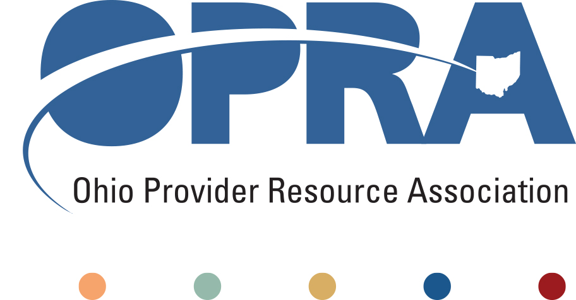

**OPRA Proposed FY 2020-2012 Operating Budget Amendment**

**Current Appropriations**

The state funding for most of the waiver services comes from this line item GRF (General Revenue Funds) 653407 Medicaid Services. For fiscal year (FY) 2020, Governor DeWine and Director Davis plan to spend $654,394,484 on the Medicaid Services line item (GRF 653407). For FY 2021 the Governor and Director Davis plan to spend $655,368,800 on the Medicaid Services line item (GRF 653407). This is reflected in the highlighting below.

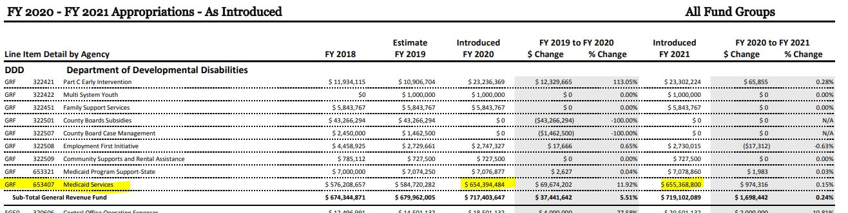

**Amendments**

As of 4/11/2019, the various House of Representative Committees are finishing up public hearings on the proposed budget. After hearings are finished, the Committees will share their suggestions to amend the budget with the House of Representatives Leadership and the Speaker of the House. The general public can also submit amendments to the budget to the Speaker of the House. OPRA anticipates the House of Representatives Leadership will have to review at least 800 amendments to this biennium budget.

**OPRA’s Proposed Amendment**

OPRA is supportive of Governor DeWine and Director Davis’ budget proposals. OPRA submitted the following language to the Speaker of the House as an amendment to the budget. These proposed amendments are meant to build upon the Governor and Director Davis’ budget ask and assumes the proposed budget numbers are not changed by the Legislature.

1. **Increase appropriation line item GRF (General Revenue Fund) 653407 by $13.75 million (state matching funds) in each year over As Introduced Version of HB 166.**

1. **Of the ALI 653407 increase in 1 above, $11 million (state matching funds) in each fiscal year shall be utilized to increase the rate for Medicaid homemaker personal care services so that direct care wages reach a statewide average of $13 per hour.**
2. **Of ALI 653407 increase in 1 above, $2.75 million (state matching funds) in each year shall be utilized to increase Medicaid payment rates for day programs serving individuals with intellectual and developmental disabilities in order to comply with federal community integration mandates.**
3. **Note to Legislative Service Commission: Increase total Medicaid appropriation authority (state and federal) in ALI 653654 commensurate with FMAP index**

**What would OPRA’s amendment do?**

1. **Increase appropriation line item GRF (General Revenue Fund*) 653407 by $13.75 million (state matching funds) in each year over As Introduced Version of HB 166.**
   1. In FY 2020, this would increase GRF (General Revenue Fund) 653407 from DODD’s proposed $654,394,484 to 654,394,497.75.
   2. In FY 2021, this would increase GRF (General Revenue Fund) from DODD’s proposed $655,368,800 to $655,368,818.75.

1. **Of the ALI (Appropriation Line Item*) 653407 increase in 1 above, $11 million (state matching funds) in each fiscal year shall be utilized to increase the rate for Medicaid homemaker personal care services so that direct care wages reach a statewide average of $13 per hour.** 
   1. In FY 2020, $11 million of the $13.75 million will be directed to the H/PC rate to support an average wage of $13 per hour for DSPs providing H/PC.
   2. In FY 2021, $11 million of the $13.75 million will be directed to the H/PC rate to support an average wage of $13 per hour for DSPs providing H/PC.
   3. This increase is an increase in state funds. It does not represent the total amount of funds that will be pulled down into Ohio’s system through federal match funds and may not reflect the rates paid by county boards who offer waivers with only levy funds.

1. **Of ALI 653407 (Appropriation Line Item*) increase in 1 above, $2.75 million (state matching funds) in each year shall be utilized to increase Medicaid payment rates for day programs serving individuals with intellectual and developmental disabilities in order to comply with federal community integration mandates.** 
   1. In FY 2020, $2.75 million of the $13.75 million will be directed to the various day service rates to be used to support community integration during day programming.
   2. In FY 2021, $2.75 million of the $13.75 million will be directed to the various day service rates to be used to support community integration during day programming.
   3. This increase is an increase in state funds. It does not represent the total amount of funds that will be pulled down into Ohio’s system through federal match funds and may not reflect the rates paid by county boards who offer waivers with only levy funds.
2. **Note to Legislative Service Commission: Increase total Medicaid appropriation authority (state and federal) in ALI (Appropriation Line Item*) 653654 commensurate with FMAP* index**
   1. If the FMAP changes, the funding appropriated by the legislature will have a commensurate change as well.

**\*Quick Reference Definitions:**

**Appropriation Line Item, or Line Item (ALI):** a six-digit numeric code (in the format xxxyyy) used to identify and account for amounts appropriated for the activities of an agency. The first three digits identify the administering agency, division, or activity responsible for the specific purpose. The last three digits indicate the specific purpose.

**Federal Medical Assistance Percentages (FMAP)**: the percentage rates used to determine the matching funds rate allocated annually to certain medical and social service programs by the Centers for Medicare and Medicaid Services (CMS).

**General Revenue Fund / Budget Fund Group (GRF):** The General Revenue Budget Fund Group consists of the General Revenue Fund that accounts for all financial resources except those required to be accounted for in another fund. Primary sources of revenue include personal income tax, the sales and use tax, commercial activity tax, and the public utilities tax as well as reimbursements from the federal government (which are not specifically directed to another fund) that primarily support human service programs. The law allows for broad discretion in the purposes for which the General Revenue Fund is used. For example, expenditures support education, health and human services, general government, and property tax relief.