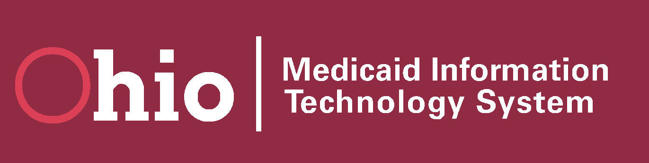
 | Communication Campaign Release
 | # 01.10
 | Subject: The New MITS
220 days until Go-Live, Dec 7, 2010! | Release Date: 05/01/2010

New Medicaid Information Technology System (MITS) Coming in December 2010!
In December 2010, Ohio Medicaid will replace its 20+ year old Medicaid Management Information System (MMIS) for claims processing with the enhanced Ohio Medicaid Information Technology System (MITS). Also included as part of MITS is the new enhanced MITS Web Portal. Progress continues on the development and testing of this new system, which will bring Ohio Medicaid into the 21st century! With state-of-the-art technology and business processes, claims will be processed accurately, timely and in "real time" for providers and other stakeholders.

What does this mean for providers and stakeholders, and what changes are in store for you?
Here is a high-level preview of some of the changes that will take place when MITS goes live in December 2010:
The new enhanced MITS Web Portal will:
- Allow claims submission for professional, institutional and dental claims;
- Process online provider enrollment applications;
- Allow Web submission of prior authorization requests; and
- Allow providers to conduct claims inquiry, adjustments, and re-submissions online.
Implementation of newer versions of paper claim forms:
- Change to the UB04 from the UB92.
- Change to the ADA 2006 from the ADA 2000.
Utilization of complete diagnosis (ICD-9) codes:
- The complete ICD-9 code set will be used to provide the highest specificity for the diagnosis.
Addition of a clinical claims editor:
- Claims processing will include the review and editing of diagnostic and medical procedure codes.
- Health care industry standard guidelines will be used to prevent inappropriate payment for duplicate, re-bundled, mutually exclusive, and incidental and pre/post-operative care.
Formatting changes and updated look for remittance advices:
- Providers will bill with HIPAA adjustment and reason codes (ARC).
- The TCN (transaction control number) assigned to claims in adjudication will be referred to as the ICN (interchange control number).

What you need to know to start planning for December 2010
- Begin discussion with your leadership and staff about the changes that will be coming.
- Work with the Provider Enrollment Unit to update your group membership, including any additions and separations of Medicaid-enrolled providers. Questions? Contact the ODJFS Medicaid Provider Enrollment Unit at 1-800-686-1516.
- Bookmark the MITS Web site for updates and detailed information on the many changes and enhancements at http://jfs.ohio.gov/mits/info.stm.
- If you bill on paper, plan for the conversion to new paper forms.
  - Institutional providers currently using the UB92 will use the UB04.
  - Dental providers currently using the ADA version 2000 will use the ADA version 2006.
  - Professional providers will continue to use the CMS 1500.
- Start a conversation now with your software vendors so they are aware of the changes that will be up coming.

When will providers and other stakeholders be trained?
- An extensive statewide outreach and training strategy is in development, with training to begin this fall.
- Watch for news on the MITS Web site, http://jfs.ohio.gov/mits/info.stm, about training and registration, and make plans for you and your staff to attend a seminar or webinar.

If you are an ODJFS trading partner,
- The 835 EDI remittance advice will continue to be sent once a week.
- Companion guides for the 835, as well as other EDI transactions, will be made available online in the near future.
- For all of the latest updates and news, go to http://jfs.ohio.gov/OHP/tradingpartners/info.stm.

Keep informed and keep in touch
Again, this is a high-level preview of some of the changes that will take place when Go-Live occurs in December 2010. We appreciate all you do to provide quality services to Ohio’s Medicaid consumers! ODJFS is committed to working closely with you during the transition and successful implementation of our new MITS. For the most up-to-date information about the MITS Web Portal, as well as information on functionality, tools and how the replacement system will impact you as a provider, log on to http://jfs.ohio.gov/mits/info.stm.

