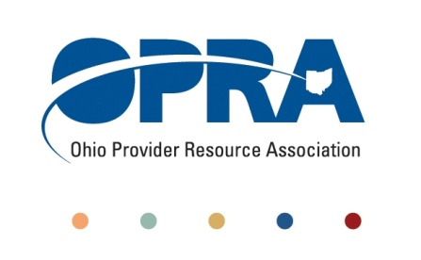

IT Workgroup Agenda

1152 Goodale Blvd, Columbus

Tuesday, June 5

10:30 – 2 PM

1. Welcome and Introductions
2. Advanced Billing and Consulting – ewebschedule – Gary Ward
3. Discussion items
   1. ANCOR Tech Summit – Mark Davis
   2. Matrix
      1. 2 vendor presentations per session?
      2. Data collection issues
   3. Membership
4. Conference Update
5. Miscellaneous

\*We will have lunch at some point during the meeting. You may bring your lunch or bring cash to order in.