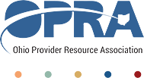OPRA Human Resources Committee

Thursday, March 21st, 2024

10am-12pm

**Agenda**

1. Welcome and Introductions
2. Guest: Nick Castellano, Castle Benefits Consulting Group
   1. Employee health insurance- fully funded plans v self-funded plans
3. Guest: Diane Evans, MyHIPAA Guide
   1. MyHIPAA Guide Dashboard Demonstration
4. Hot Topics
   1. Conference
   2. Salary Survey