OPRA is working with Wells Fargo Insurance to consider creating a group health insurance stop-loss captive exclusively for OPRA members.

What is a Captive and how does it work?

- A group captive is an insurance company formed and controlled by its owners to diversify risk, negotiate premium, cut administrative expenses, reduce taxes, and share in the underwriting profits.

- Captive participants may purchase their own levels of specific stop loss insurance and create their own plan design.

- About half of the premiums will go into the pooled captive layer to spread risk and allow for potential returns. The remaining premium is used to purchase stop-loss coverage to protect the captive from exposure to large claimants.

- At the end of each year, any remaining funds in the captive layer will be distributed by to the shareholders, allowing participants to share in underwriting profits.

- On average, group captive participants save 12%-18% annually on medical spend.

- Participants have more transparency, decision-making authority, and control over costs. Initiatives like wellness programs to improve overall costs will have a direct impact on the captive profitability.

- Group captive arrangements have been around for a long time, but companies looking to avoid new taxes and regulations resulting from Obamacare are embracing this funding strategy.
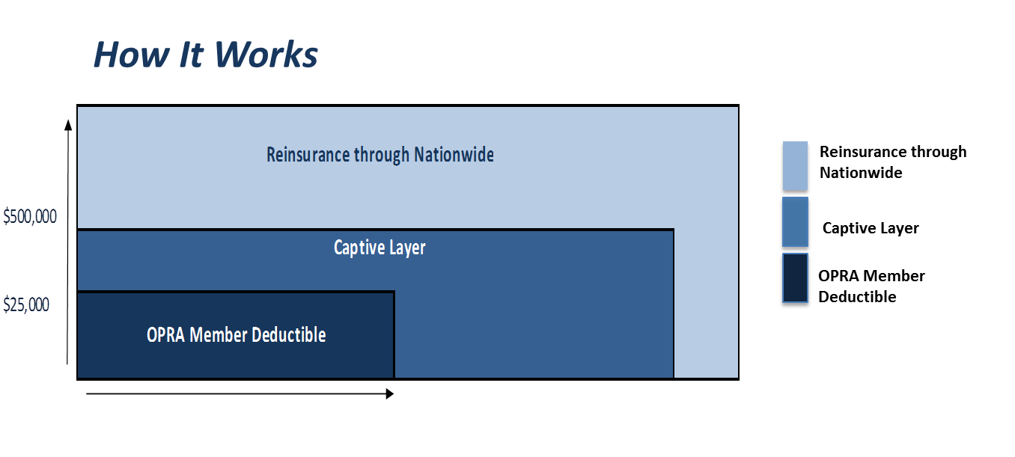

In this example, the participating OPRA member assumes the risk of $25,000 in claims per individual. Once the claimant exceeds $25,000, the captive will cover the claim up to $500,000. Once the claim exceeds $500,000, Nationwide provides stop-loss coverage. By creating a captive layer, participants are able to obtain more affordable stop-loss rates while creating a pool to distribute any leftover funds back to the shareholders.

