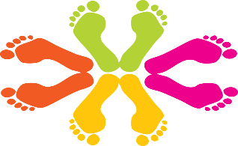
Shoe gear recommendations
A shoe should typically have at least a “thumb’s width or two” from the tip of the end of the shoe. It should fit in width so the foot has room to move. The sole should be thick enough to support the weight of the patient and the foot. The shoe should not be overly bendable. If you have bunions or hammer toes or a wide foot you should try to have a soft top tennis shoe with mesh or spandex to allow room for the hammer toes/bunions.
New Balance tends to have varying sizes and varying widths that may be ordered. Some examples are:
- Unisex New Balance 9060 2. New Balance Fresh Foam X 860v13
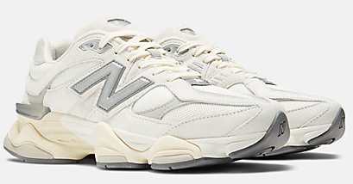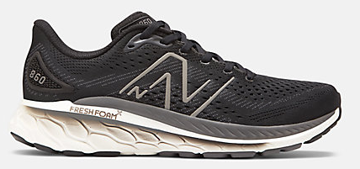
- New Balance Fresh Foam X 880v14
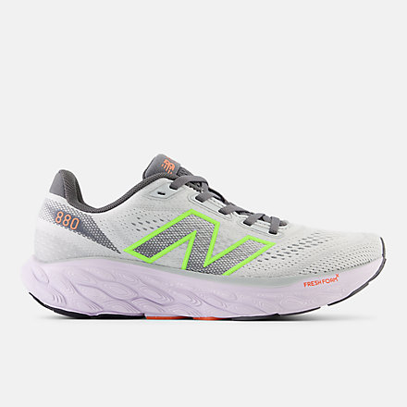
Other shoe brand options that tend to have good support and varying widths depending on the brand are: Brooks, Saucony, Asics, and Hoka

**** Skip Lace technique if you have top of the foot pain related to a “bump on the foot” or a high arch:
