

BI360 – ERP Budgeting Solution

Table of Contents
Project Scope and Estimate 3
Assumptions 4
Training Agenda 5
Day One or Session 1: Basic Reporting 5
Day Two or Session 2: BI360 Portal and ERP Budgeting Workshop 5
About the Model 6
Profit and Loss Budget Template 6
Line Item Details 8
Spreading 8
Profit and Loss Budget Reports 9
Project Management 10

Project Scope and Estimate
The implementation, for the BI360 ERP Budgeting Solution, includes the following:
- Installation
  - Installation of BI360 ERP Budgeting software into one environment.
  - Installation of metadata and configuration of connection to ERP data source.
  - Enabling budgeting capabilities on ERP database(s).
- Training
  - Remote Training
    - All remote training will be billed four (4) hours per day unless otherwise specified during signing of the SOW. Limited to 8 hours.
  - BI360 Report Designer Training
    - Overview of report writing. How to create reports which incorporate ERP Budgeting information.
  - ERP Budgeting Configuration.
  - Using the BI360 Web Portal for Budgeting.
- Forms and Reports
  - Configuration of one (1) Profit and Loss input template to Client’s chart of accounts.
  - Configuration of one (1) Profit and Loss Budget Report:
    - Profit and Loss Budget (department, location, division or similar across columns)
  - All forms and reports will be configured for and tested against a single ERP database.
- Testing
  - Client will be responsible for testing and validating all work prior to going live. It is recommended that the Client have, at minimum, one week to do thorough testing prior to going live so that Solver will have sufficient time to make requisite changes and still provide time for retesting and validation.
- Other
  - Project Management limited to scheduling of Solver consultants
- Out of Scope
  - Configuration of any ERP Budgeting forms or reports outside of the Profit and Loss input template.
  - Multi-Currency budgeting.
  - Creation of assignments – Client can be taught with additional training or refer to BI360 User Guides. Note that the post implementation consulting can be used towards this.
  - Setup of security – Client can be taught with additional training or refer to BI360 User Guides. Note that the post implementation consulting can be used towards this.
  - Modification or customization of purchased Solver Module(s), features and/or functionality.
  - Connecting to sources other than those listed above.
  - Infrastructure issues and setting up SQL Server.
  - Specific end-user procedure manuals or documentation beyond the standard documentation provided with the application (installation and user guides).
  - Installation of the product on the end-users workstations.

Total implementation Cost: $5,000

If additional work outside of the implementation scope is requested, a separate estimate and change order will be processed. This includes modifications to the input form, additional training, or additional reports.

** Note: Additional classes and training videos are available. For further details, please discuss with your Project Manager or contact pmo@solverusa.com.

Assumptions
Below are the assumptions required to keep the project within scope:
- ERP included in the estimate is either GP, SL, or NAV.
- Multi-currency is not enabled. All data uses the same currency.
- If multiple ERP databases are used, all databases have the same chart of accounts structure and same fiscal calendar.
- Microsoft SQL Server is already installed. SQL server tasks are the responsibility of the Client.
- The consultant is given remote access to the BI360 ERP Budgeting software.
- All Dynamics databases are located on one server.
- The input template cannot be modified outside of changes required to conform to Client’s chart of accounts structure.
- The implementation, including the training, will be completed within three weeks.
- Client will provide account mapping information to configure the Profit and Loss input form.
- Client’s employees will be reasonably available to assist throughout the project to answer questions, discuss requirements, and/or test the system.
- Client will assign a project leader who will have overall responsibility for the project and finalizing design decisions within the organization. If resources are not available as needed, or there are organizational changes, it may affect the project completion date, and/or the amount of Solver consulting resources required, which may require a change order.
- Client and Solver are mutually responsible for system testing. The goal of systems testing is to confirm that the delivered system applications function as designed. Processing through the actual business flows that were intended to be supported by the system application performs system testing.
- Client will provide a resource for the duration of the project to handle the responsibility of Windows and SQL administration.
- BI360 is installed and tested prior to the start of the training for all users by the Client.

Training Agenda

Day One or Session 1: Basic Reporting
This class is recommended for query users, report designers and power users.
1. Introductions and overall review of BI360
A. Background of the instructor(s)
B. Name, title, report writing background and expectations of each trainee
C. Architecture and system overview

2. Introduction to BI360 Reporting—Report Designer
- Overview.
- Getting familiar with the Report Designer interface.
- Trial Balance

3. Exercises using Report Designer
- Profit and Loss Report
- Column modifications of the Profit and Loss Report
- Additional features, such as multi-tab, drill-down, parameter controls, options, locking workbook
- Additional report exercises as time permits (A/P, SOP, Balance Sheet or similar)

6. Open Discussion #2

Day Two or Session 2: BI360 Portal and ERP Budgeting Workshop
This class is recommended for power users and budget administrators.
- Portal Administration and End User Usage
- User Management and Security.
- Customizing the View.
- Running Reports.
- Drilling Down.
- Recent, Archived, and Shared Reports.

- ERP Budgeting Configuration
  - Overview of ERP Budgeting & Template
  - Initial Configuration of Template with BI360 Consultant.
- Open Discussion and Discussion of Next Steps and Testing Plans.

About the Model
Each ERP Budgeting model consists of a standard template in the structure Profit and Loss report. This template pulls comparative actuals live from the ERP and stores back General Ledger budget or forecast information. Before deployment, the template will need to be configured for the Client’s chart of accounts. Additionally, two (2) profit and loss reports which summarize budget information will be configured. These reports provide a complete overview of stored budget information as well as a more detailed view by department (or similar dimension).

Profit and Loss Budget Template
This Profit and Loss template consists of the natural accounts down the rows with the budget or forecast periods across the columns. Additional dimensions such as Department, Location, Product, or Division will be configured as parameters which the end user will be able to select at runtime. The input form brings in prior year’s actual data for comparative purposes (to the right of the columns seen in the picture below). The BI360 Planning window is available as well, which allows line-item detail, trending, spreading, and comparison to the prior year’s actuals.
The below screenshot shows an unexecuted version of the template. The row subtotals and totals show the groupings that will be defined as part of the configuration process. These groupings can be renanmed to fit each company’s profit and loss report structure.
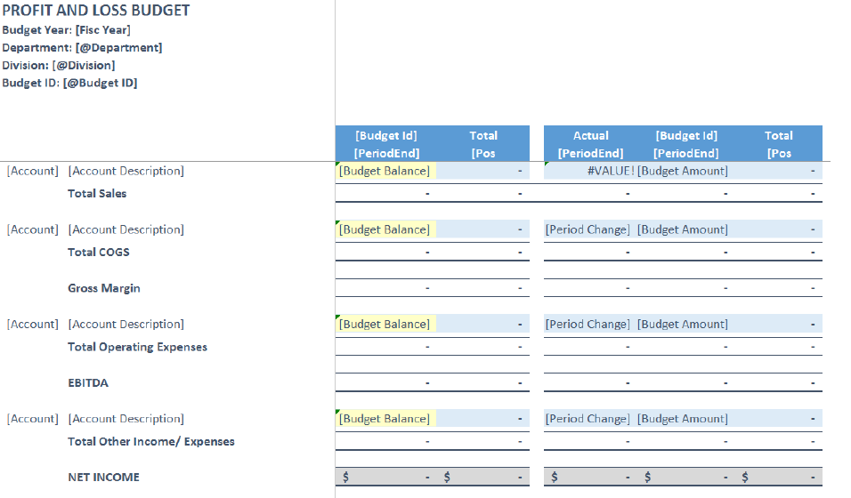
Once configuration of the form has been completed, it will be uploaded to the BI360 Portal for testing. The template will now be active and allow the user to run the template for their selected parameters and give the user the ability to save the data back to the ERP by using the control buttons in the window. The live template will also include line-item detail and spreading capabilities as shown below.

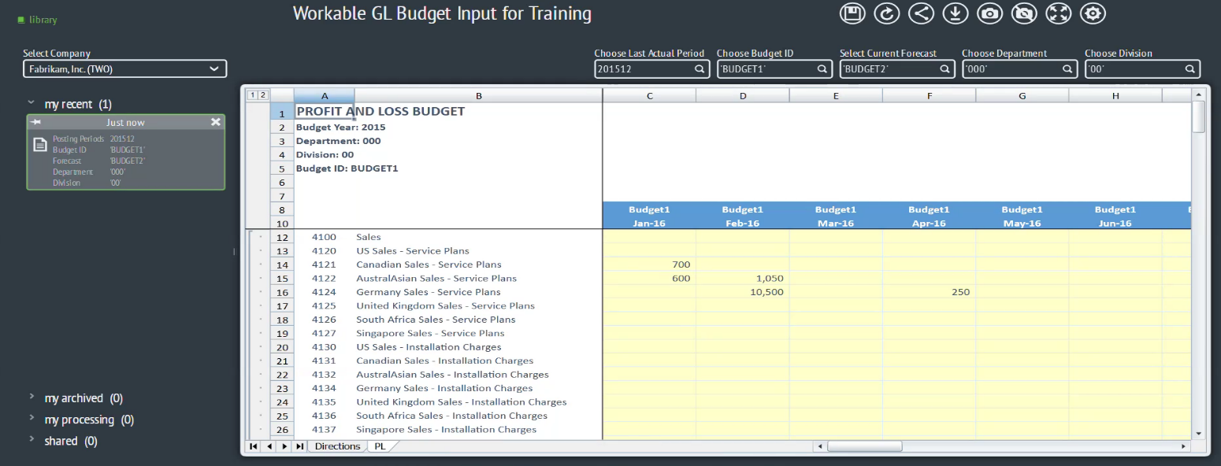

Line Item Details
Line-Item Detail entries (LIDs) are configured within the Profit and Loss template. With LID entries, the user may enter comments and individual budget line-items below the General Ledger account level. Simply right-click the input cell to create LID entries and a new input window will pop-up.

Spreading
The spreading tool offers automated distribution of annual budget numbers into each period using various calculation methods, e.g. even spreading, quarterly spreading, and historical spreading.
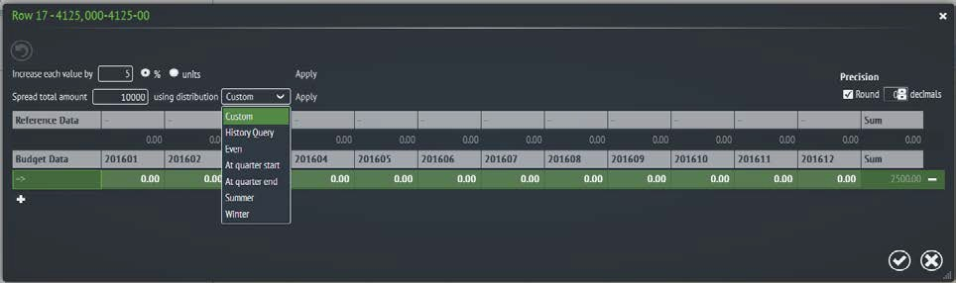

Profit and Loss Budget Reports
Report 1: Profit and Loss Budget
The Profit and Loss Budget report provides a summarized view of the total budget by period. This report is a multi-tab report which consists of a consolidated summary sheet and individual expanding tabs for a department level detail (or similar field).
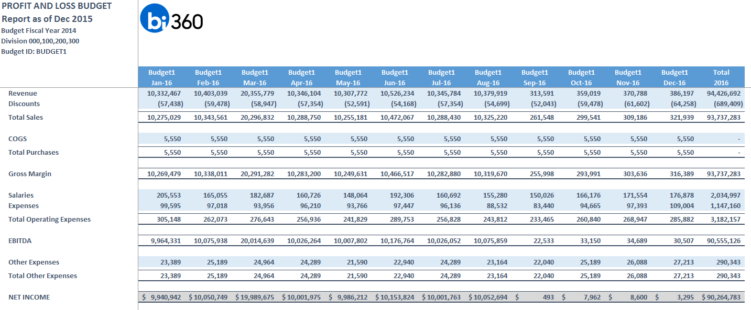

Project Management
A Project Manager will be assigned to provide project oversight for the duration of the implementation. The Project Manager will be responsible for the following tasks:
- Managing and coordinating project resources.
- If tasks or services not defined within the scope of this project are identified, the Client will be advised of such tasks or services by the Solver Project Manager and a Change Order outlining such tasks or services will be prepared.

