Jed W. Morison

Superintendent

**Franklin County Board of Developmental Disabilities**

2879 Johnstown Road • Columbus, Ohio 43219 • 614-475-6440 • www.fcbdd.org

***Helping people to live, learn and work in our community***

**Franklin County**

**Developmental**

**Disabilities**

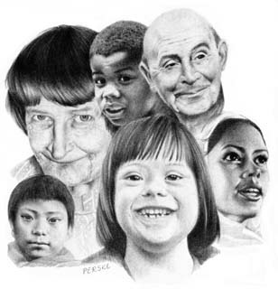

Perske

|  |  |
| --- | --- |
| To: | Community Resources and Organizations |
| From: | Lilian Beck, FCBDD Transition Coordinator |
| CC: | Joni Sparks, FCBDD Administration |
| Date: | 11/30/16 |
| Re: | Franklin County Provider Fair – April 12, 2017 |
| Memo: | We would like to invite you to our upcoming Provider Fair! Similar to previous fairs, there will be providers of all waiver services, and therefore we hope to attract a large crowd of individuals, families and community members. This year we hope to host the largest number of community resources ever, so please join us!  The Provider Fair will be **Wednesday, April 12th, from 12:00 pm – 5:00 pm**, at the Ohio Fairgrounds/Expo Center in the Lausche Building. Free parking will be available to all guests and vendors.  If you can attend, please complete and return the attached form to ensure we have the correct information for your organization. There is no fee to participate, however you may order a boxed lunch using the attached form and pricing.  Your tables will be in a separate section than the waiver providers, but will also be organized with balloons in order to call attention to your wonderful resources!  Please call with any questions or concerns.  Thank you!  Lilian Beck  Transition Coordinator, FCBDD  614-342-5272  Lilian.Beck@fcbdd.org |